**Day in the Life of the Hudson River 10/30/14 Data**

**(Salt Front not recorded for 10/30 – 10/28 it was 61.1 and 11/1 it was RM 59.9)**

**RIVER MILE 5**

**Pier 1 - 59th Street/Riverside Park**

**N 40.76408 W-74.001893**

**Kimberly Schwab, Speyer Legacy School Plus 3 adults**

**50 students - 7th graders sampling and sharing data with 6th graders who are giving tours to 2nd graders - 8 adults**

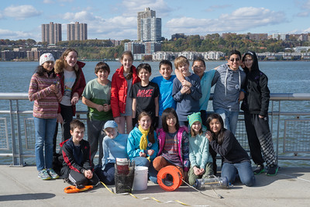

**Seventh grade sampling team**

Location: Pier i, New York NY

Area: Restored former railroad pier

Surrounding Land Use: Urban/residential 100%

Sampling Site: Except for seining and taking core samples, all sampling took place on pier i.

Plants in area: no submerged aquatic plants in the water but lots of plants on shore

Water depth: Varied by location on the pier and by tide

River Bottom – sandy/muddy bottom

Plants in area: Varied native and introduced plants in Riverside Park South

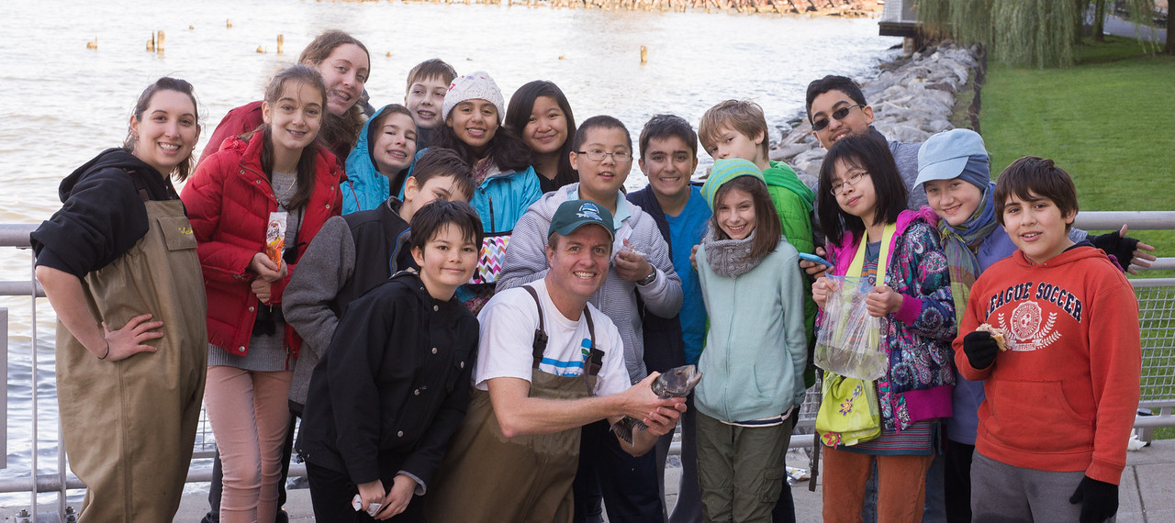

**Seventh graders sampling with DEC Runners stopping by**

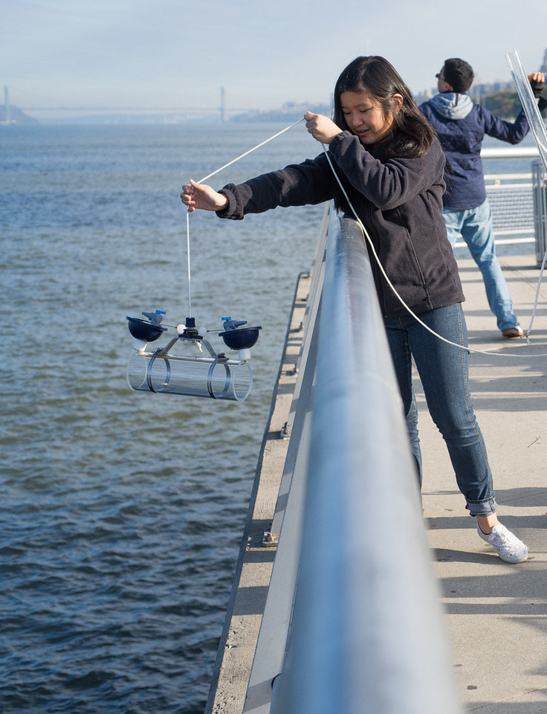

**Speyer students used a niskin bottle to collect samples from the surface and depth to do a comparison in water chemistry**

|  |  |  |  |  |  |  |
| --- | --- | --- | --- | --- | --- | --- |
| ***ITEM*** | ***Time*** | | ***Readings*** | |  |  |
| ***Physical*** |  | |  | |  |  |
| Air Temperature | 10:05 AM | | 10°C | | 50°F |  |
| Wind Speed | 10:05 AM  10:37 AM  10:52 AM  12:22 PM  12:27 PM | | Beaufort 3  Beaufort 2  Beaufort 3  Beaufort 3  Beaufort 3 | |  |  |
| Cloud Cover | clear | |  | |  |  |
| Weather today | Clear and warm | |  | | ***Water surface*** |  |
| Weather recently | Cool with rain off and on for last 2 wks | | | | | |
| ***Water Temperature*** | Forgot thermometer |  | | |  |  |
| ***Turbidity***  ***Short site tube*** | **Time** | **Reading** | | | **Average** | **End of Pier** |
|  | 9:20 AM  10:15 AM  12:48 PM | 40  44  48 | | | 35.5 cm  25.5 cm  22.8 cm |  |
| ***Chemical*** | **Time** | **mg/l** | | | **Temp** | **% Sat** |
| *Water sampled at surface and at depth with niskin bottle reported in two separate sets of readings below. Depth for bottom samples ranged from surface to depth | | | | | | |
|  | **TIME** | **SURFACE** | | | **BOTTOM** |  |
| DO - Hach – | 9:30 AM  10:10 AM  10:40 AM  12:30 PM  1:10 PM | Not read  6 mg/l  6 mg/L  7 mg/L  6 mg/L | | | 6 mg/L  6 mg/L  6 mg/L  6 mg/L  6 mg/L |  |
| pH  kit as above | 9:30 AM  10:00 AM  10:30 AM  11:30 AM  12:00 PM  12:30 PM  1:00 PM  1:30 PM  2:00 PM | 6.5  8  7.5  7.5  8  8.5  7.5  8  8 | | | 6  8.5  8  8  7.5  8  7.5  8  7.5 |  |
| Salinity – | SURFACE refractometer (R) | SURFACE Glass Hydrometer (H) | | | DEPTH refractometer (R) | DEPTH Glass Hydrometer (H) |
| 10:09 AM  10:12AM  11:10AM  12:25 PM  12:35 PM  12:50 PM  12:52 PM  12:53 PM  12:55 PM  1:00 PM  1:24 PM  2:05 PM | 13 ppt -R  14 ppt – R  n/r  n/r  n/r  14 ppt  n/r  n/r  n/r  14 ppt  14 ppt  14 ppt | 15 ppt H  n/r  17 ppt  n/r  n/r  n/r  n/r  n/r  12 ppt  13 ppt  12 ppt  14 ppt | | | n/r  n/r  n/r  15 ppt  22 ppt  n/r  17 ppt  n/r  n/r  n/r  17 ppt  14 ppt | 17 ppt – H  n/r  14 ppt  20 ppt  n/r  n/r  n/r  15 ppt  n/r  n/r  15 ppt  14 ppt |
| ***Fish Catch – minnow traps*** | ***Number*** | ***Species*** | | | ***Size*** | ***Time*** |
| ***MACROS-***  ***On pier*** | 9 | Snails | | |  | 10:00 AM |
|  | Many | Comb Jellies | | |  |  |
| ***Crab Traps*** | 1 | Blue crab | | | 70 cm |  |
| ***\*** | 1 | Blue crab | | | 100 cm |  |
|  | 1 | Blue crab | | | 110 cm |  |
|  | 2 | Blue crab | | | 130 cm |  |
|  | 1 | Blue crab | | | 140 cm |  |
| ***Total Macro*** | ***15 + comb jellies*** | ***Diversity 3*** | | |  |  |
| ***FISH - Seine – only ¼ unfurled -*** | 100 | Atlantic Silversides | | |  | 1:00 PM |
| ***Lots of trash washed into net*** | 1 | y-o-y striped bass | | |  |  |
| ***Total Fish*** | **101** | ***Diversity 2*** | | |  |  |
| ***Tides (from pier to water)*** | ***Total Depth (Meters)*** | ***Distance to water surface*** | | | ***Tide Depth*** | ***Flood or Ebb*** |
| 9:39 AM | 13.54 | 4.52 | | | 9.32 | ebb |
| 10:05 AM | 11:40 | 4:52 | | | 6.88 | ebb |
| 10:19 AM | 11.53 | 4.52 | | | 7.01 | still |
| 10:38 AM | 11.51 | 4.52 | | | 6.99 | still |
| 11:00AM | 11.53 | 4.52 | | | 7.01 | still |
| 12:07 PM | 10.62 | 3.61 | | | 7.01 | Flood |
| 12:45 PM | 10.9 | 3.61 | | | 7.29 | Flood |
| ***Currents*** | ***Time*** | ***Meter/sec*** | | | ***Cm/sec*** | ***Ebb/Flood*** |
| 9:36 AM | 1858 | 61.93 cm/sec | | | 1.2038 | Ebb |
| 10:05 AM | 2043 | 68.1 cm/sec | | | 1.3238 | Ebb |
| 10:14 AM | 2072 | 69.07 cm/sec | | | 1.3424 | Ebb |
| 10:16 AM | 1920 | 64 cm/sec | | | 1.2441 | Flood |
| 10:50 AM | 1066 | 35.53 cm/sec | | | 0.6907 | Still |
| 12:00 AM | 44 | 1.23 cm/sec | | | 0.0239 | Still |
| 12:15 PM | 305 | 10.17 cm/sec | | | 0.1976 | Flood |
| 12:27 PM | 610 | 23.33 cm/sec | | | 0.4535 | Flood |
| 12:40 PM | 450 | 15 cm/sec | | | 0.2916 | Flood |
| 1:42 PM | 915 | 30.5 cm/sec | | | 0.5929 | Flood |
| **Sediment Cores** | **Length** | **H2S smell/oil** | | **Rare** | **Common** | **Abundant** |
| **1:30 PM**  **location 1** | 4 cm – hard to penetrate | No | |  | Mud, pebbles | Sand, gravel, pebbles |
| **1:30 PM**  **location 2** | 4 cm – hard to penetrate | No | | Glass | Pebbles | Sand |
| **SHIPPING** | **Time** | **Name** | | **Color** | **North/South** | **Full/Empty** |
|  | 9:42 Am | Motorboat | | Yellow | Southbound | full 2 people |
|  | 9:45 AM | Ferry NY Waterway | | White | Southbound | Unknown |
|  | 9:47 AM | Yacht | | White | Southbound | unknown |
|  | 9:51 AM | Ferry NY Waterway | | White, blue | Southbound | Passengers |
|  | 9:55 AM | Ferry NY Waterway | | White | Northbound | Passengers |
|  | 9:56 AM | Sailboat “Salsa” | | Red w. black sail | Northbound | Passenger |
|  | 10:01 AM | Ferry NY Waterway | | White | Northbound | Passengers |
|  | 10:03 AM | Ferry NY Waterway | | White, blue | Southbound | Passengers |
|  | 10:05 AM | Speedboat | | Red, white,black | Northbound | 1 passenger |
|  | 10:07 AM | Cargo  “Hunts Point” | | White, black | Northbound | Full |
|  | 10:10 AM | Tugboat | | Blue | Southbound |  |
|  | 10:10 AM | Barge pulled by tug above | | Brown | Southbound | Lots of garbage/cargo |
|  | 10:37 AM | Ferry NY Waterway | | White | Northbound | Passengers |
|  | 10:40 AM | Speedboat  Very fast! | | White | Northbound | Passenger |
|  | 10:45 AM | Cargo boat | | White | Northbound | Full |
|  | 12:05 PM | Sailboat | | Green | Northbound | Passengers |
|  | 12:06 PM | Ferry NY Waterway | | White | Southbound | Passengers |
|  | 12:20 PM | Ferry NY Waterway | | White | Northbound | Passengers |
|  | 12:24 PM | Circle Line | | White | Southbound | Passengers |
|  | 12:31 PM | Ferry NY Waterway | | White | Northbound | Passengers |
|  | 12:42 PM | NYPD Boat | | White, blue | Northbound | Passengers |
|  | 1:01 PM | Cruise | | White | Southbound | Passengers |
|  | 1:20 PM | Cruise | | White | Southbound | Passengers |
|  | 1:30 PM | Cargo | | Black & white | Northbound | Full |
|  | 2:04 PM | Tugboat  no barge | | White | Northbound |  |

HRECOS SCREEN CAPTURES FROM PIER 84 SITE

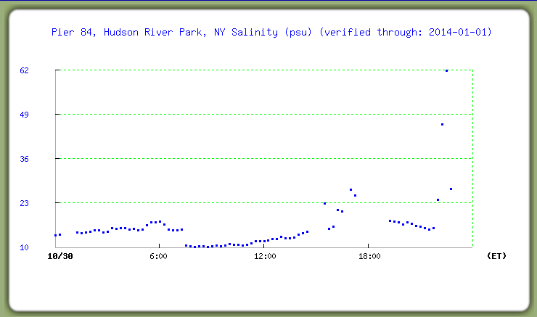During Sampling time salinity on 10/30/14 ranged between 10 and17 ppt (psu)

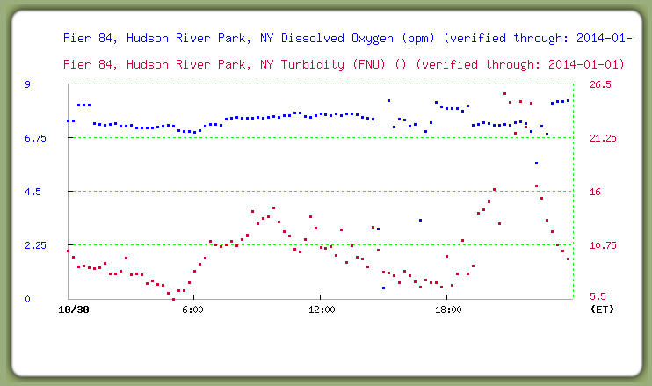

During Sampling time DO ranged from 6.75 to 8 ppm

During Sampling time Turbidity ranged from 0 to 4 NTU

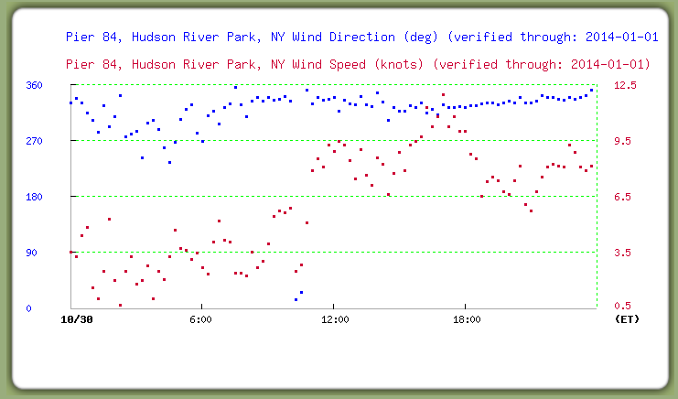Wind During Sampling Time

Tides During Sampling Time