Day in the Life of the Hudson River 10/23/14 Data
(Salt Front RM 61.1)
RIVER MILE 58a
Plum Point/Kowawese, New Windsor, Orange County, NY
Jennifer Merriam, Orange County Community College
9 Undergraduate Students, 1 Adult
GPS Latitude 41°27’46.49”N Longitude 74°00'42.75"W

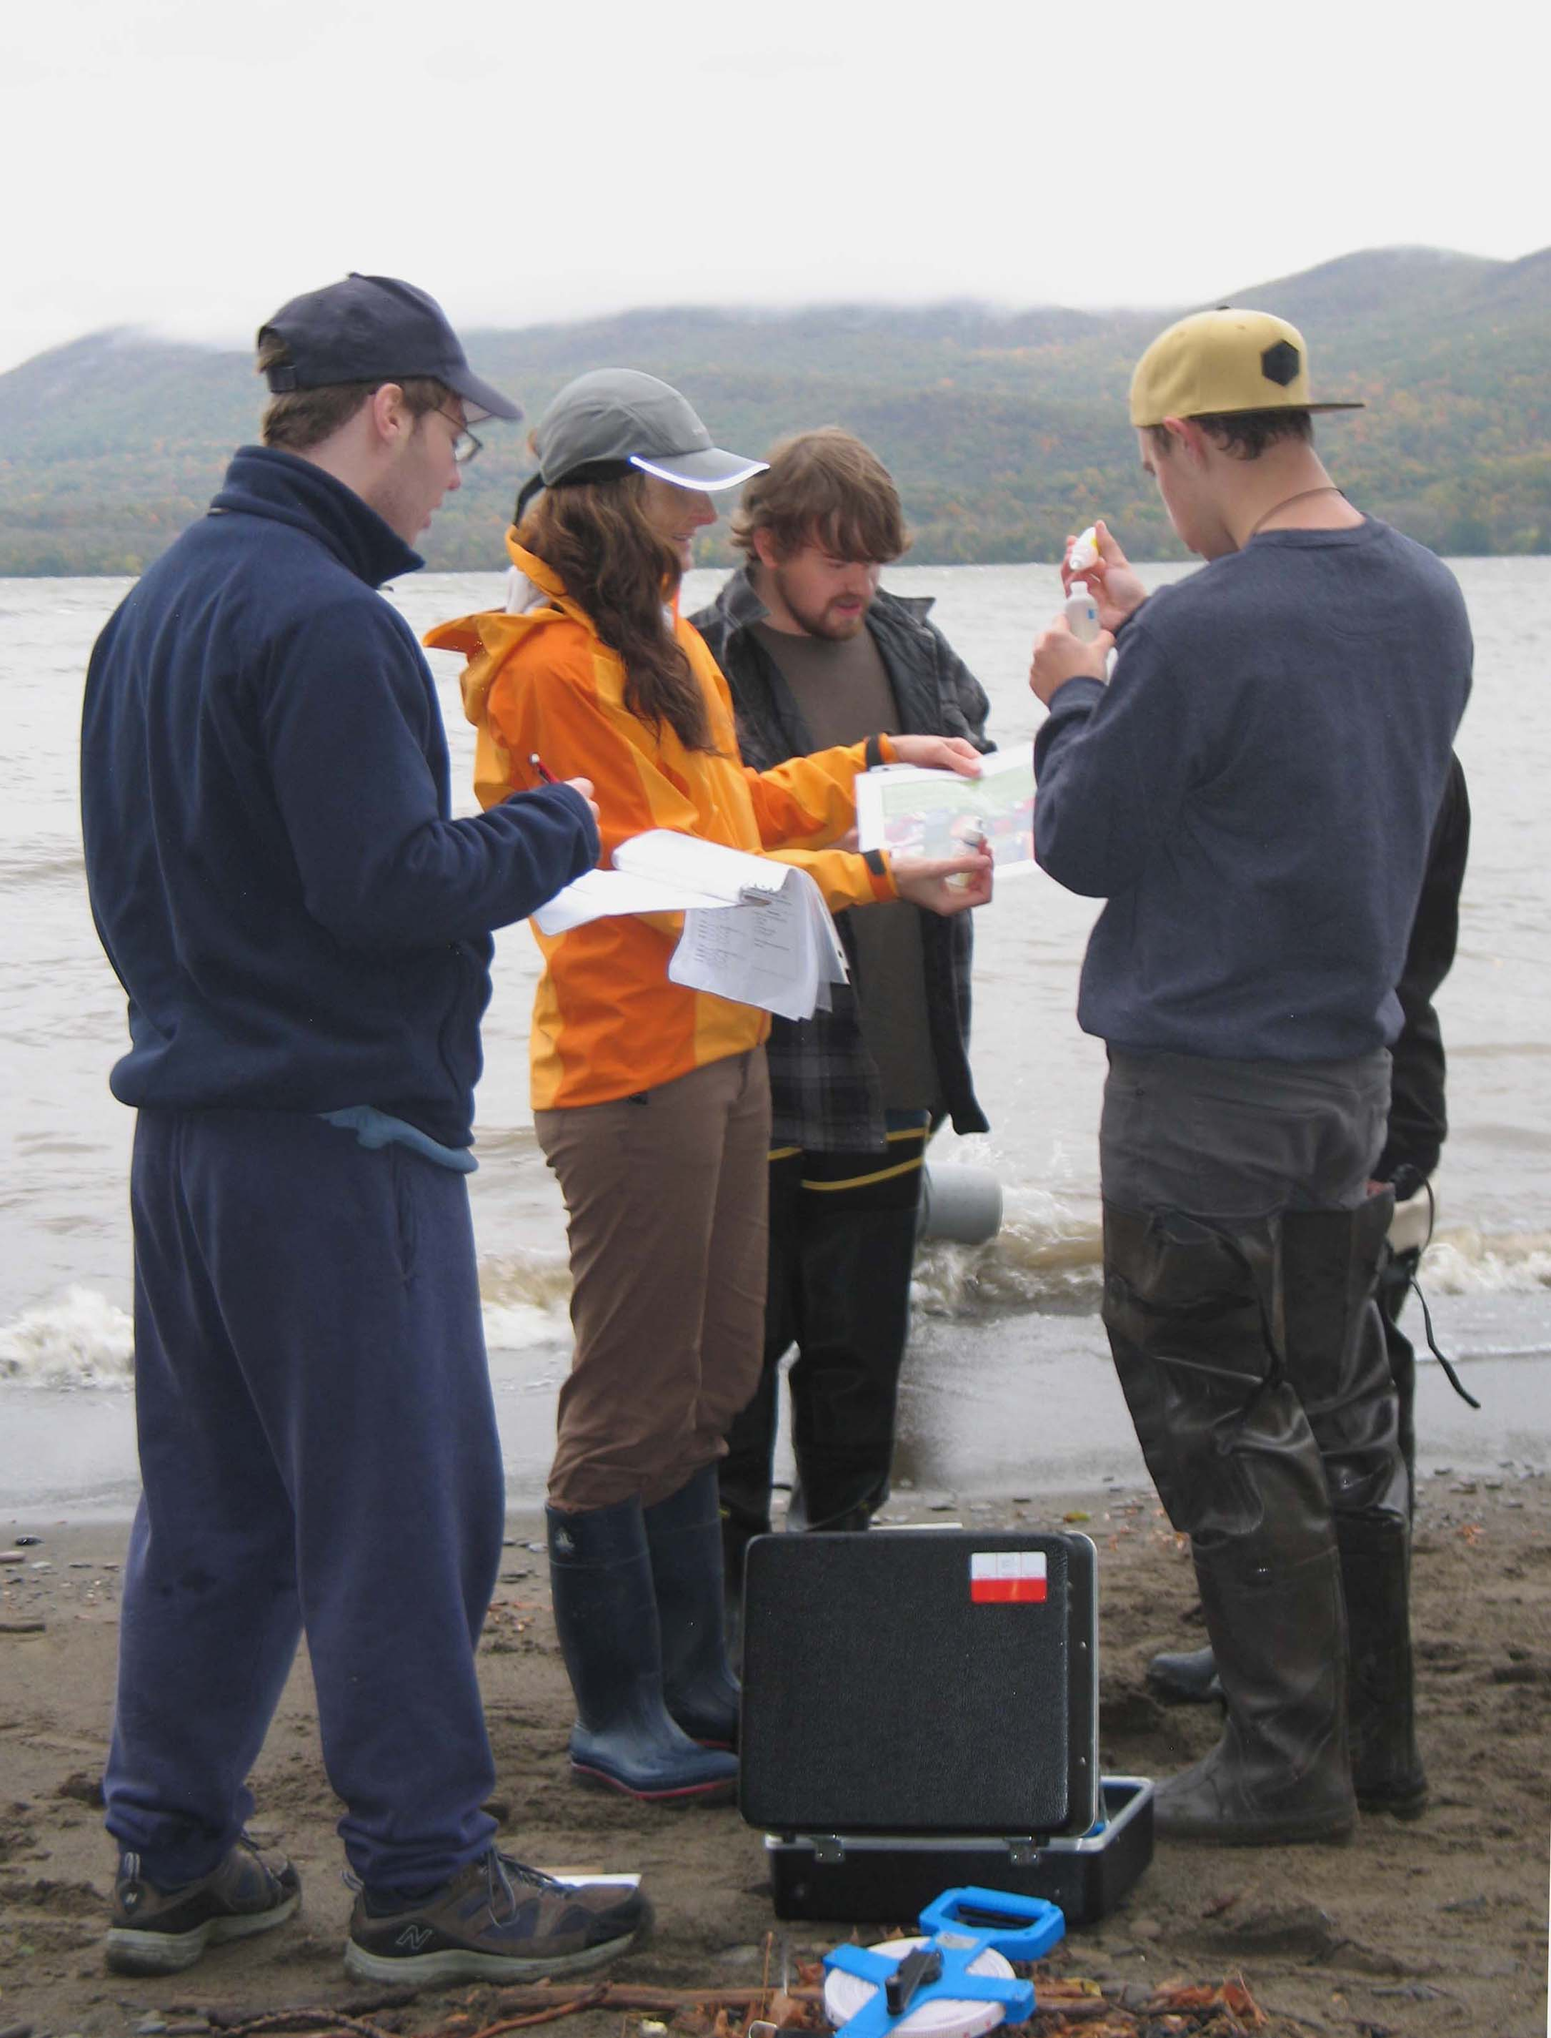
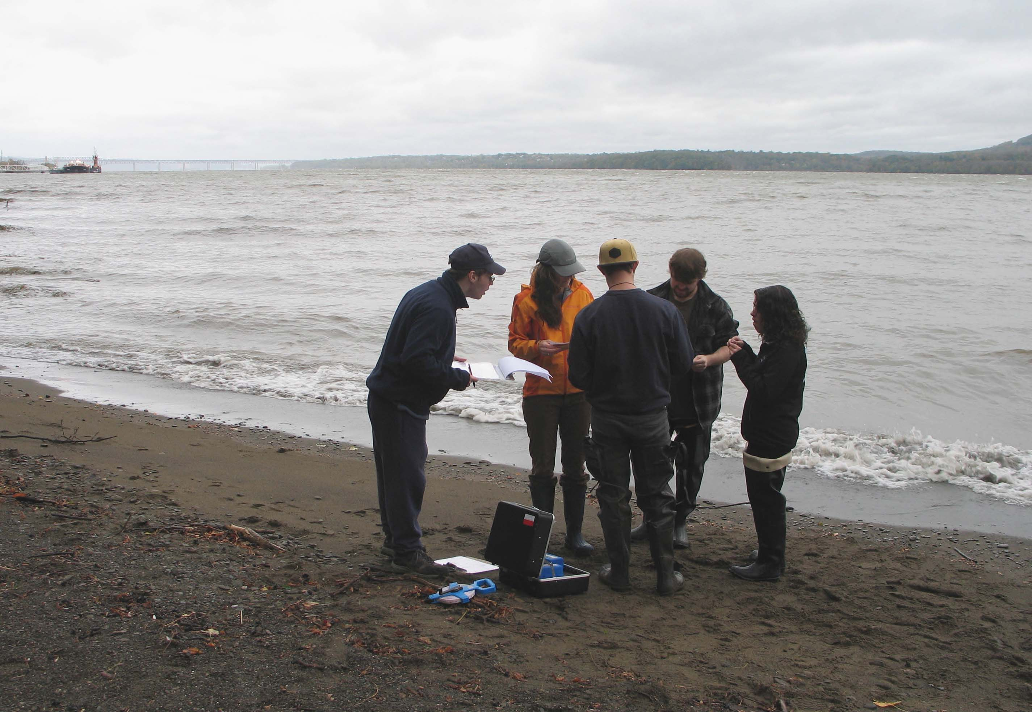

Location: Northern Sandy beach at Plum Point, New Windsor, Orange County, Public Shore, Picnic Area
Area: Sandy beach bordered by forested area and parking lot. Used for picnic, fishing, kayaking
Surrounding Land Use: Beach 50%, Forested 50%
Sampling Site: sandy beach (cove), rip rap in area of sampling site, debris in the area such as broken concrete, docking
Plants in area: No plants in the water
Water depth: sampling in 50 cm depth
River Bottom – sandy, rocky

ITEM | Time |  | Reading 1 | Reading 2 | Comments
Physical
Air Temperature | 8:40 AM |  | 9.5°C
Wind Speed | Beaufort #5 |  | North
Cloud Cover | overcast
Weather today | Steady rain
Weather recently | Steady rain last 12 hrs. - cool temperatures
Water Surface | choppy
Water Temperature | 8:35 AM | 10.7°C
 | 9:14 AM | 10.9 °C
Water Surface | Choppy
Turbidity  Short sight tube | 9:00 AM | 40 JTU
Chlorophyll | 8:50 AM | 1.5
Chemical
DO | TIME | Temp |  | DO |  | % Sat
DO – drop count test kits | 8:30 AM | 10.7 °C |  | 11 |  | 100%
pH – colormetric | 9:05 AM | 7  7
Salinity – Quantab | 9:14 AM | 98 ppm Cl- |  |  |  | 177 ppm TS
Fish Catch  20 ft. ‘ with ¼ inch mesh | Species | Count |  | Size of largest |  | Totals
3 pulls – 9:30 AM | Spottail Shiner | 12 |  |  |  | DIVERSITY 10
 | White Perch | 6 |  |  |  | TOTALS - 66
 | Channel Catfish | 14
 | Striped Bass | 18 |  |  |  | CPUE = 3.67
 | Pumpkinseed Sunfish | 9 |  |  |  | 18 m total used to compute CPUE
 | Red-breatsed sunfish | 1
 | Golden Shiner | 1
 | American Eel | 3
 | Herring | 1
 | Catfish (not channel) | 1
Tides | Time | Height in cm |  | Rate of change |  | Rising/falling
 | 8:28 AM |  |  |  |  | Rising
 | 8:58 AM | 5 cm |  | 0.166 cm/min |  | Rising
Currents | 8:45 AM | 4 cm/sec |  | 0.08 kts. |  | North/Flood

