A Day in the Life of the Hudson River 10/16/14 Data
(Salt Front RM 65.9)
RIVER MILE 60
Dennings Point
Jim Uhlig, Storm King School, 12th grade – 8 students
41.30’10” degrees Latitude 73.50’11” degrees Longitude
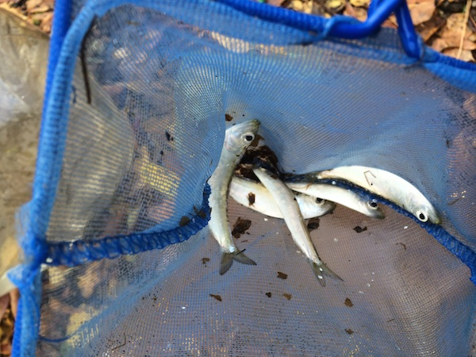

Location: Dennings Point, 200 yards south of Long Dock Rd. Parking Lot, Beacon, Dutchess County
Area: Forested, Beach with large piping entering river. Believe area mostly used for sightseeing and fishing. Found a homemade crab trap on the beach!
Surrounding Land Use: Nature preserve with few buildings, 50% forested; 50% beach;
Sampling Site: Beach, covered with vegetation, rocky & sandy
Water Depth @ sampling site: 3 ft.
Water: Choppy

ITEM | Time |  | Reading 1 | Reading 2 | Comments
Physical
Air Temperature | 1:45 PM |  | 60°F  20°C
Wind Speed | 1:23 PM |  | 4 Beaufort
Cloud Cover | Mostly |  | 51-75%
Weather today | Rain off and on, wind
Weather recently | Some rain previous 2 days - humid
Water Temperature-  Depth 0.1 ft. | 2:30 PM | 21°C
Water calm | yes
Turbidity -  Secchi disk | 1:40 PM | 24 cm  25 cm |  |  | 24.5average
Chlorophyll | 1:29 PM | 2.0
Chemical
DO  (drop count kit) | 1:30 PM  2:00 PM | 11 mg/L  12 mg/L |  | 21°C  21°C | 120%  130%
pH – color match test kit | 2:12 PM  2:23 PM | 5.5*  5.5* |  |  | *believes not working well
Salinity - quantabs | 2:00 PM | LR 5.5  HR 2.5 |  | 303 Cl- ppm  380 Cl- ppm | 547 ppm TS  686 ppm TS
Fish Catch  20 ft. X4 seine – 1 pull | Number –  20 | Species –  Alewife |  | CPUE -  Diversity – 1 | Seine  Total catch20
Tides | 1:29 PM | 32.9 cm
Currents | 1:23 PM | 300cm/30 sec |  | 10 cm/sec | 0.19 kts
 | 2:20 PM | 500 cm/30 sec |  | 16.6 cm/sec | 0.32 kts
Core Sample – no actual core but sediment in area | Common  Gravel | Abundant  Slag
Boats | 1:30 PM | Canoe |  | yellow | light

