**Day in the Life of the Hudson River 10/16/14 Data**

**(Salt Front RM 65.9)**

**RIVER MILE 76**

**Waryas Park, Poughkeepsie, Dutchess County**



**Pat Denima & Dianne Polidore, Pawling Elementary School 4th & 1st graders**

**34 students and 17 adults**

**N 41°7’ – W 73°9’**

|  |  |
| --- | --- |
|  |  |

**Location:** Waryas Park, Poughkeepsie, New York.

**Area:** public park, pier, grassy, parking lot. Park used for fishing, small boat launch, another pier for small boat launching

**Surrounding Land Use:** 30 % urban/residential; 30% forested; 40% park area with grass and waterfront docks

**Sampling Site:** shoreline is riprap, vegetation, banks altered, pier, rocky

**River Bottom** –rocky

|  |  |  |  |  |  |  |
| --- | --- | --- | --- | --- | --- | --- |
| ***ITEM*** | ***Time*** | | ***Reading 1*** | ***Reading 2*** | ***Comments*** | |
| ***Physical*** |  | |  |  |  | |
| Air Temperature | 10:30 AM  11:14 AM  12:39 PM | | 68 F  72 F  72 F | 20 C  22 C  22 C |  | |
| Wind Speed | 11:14 AM | | #3 |  | | |
| Cloud Cover | overcast >75% | |  |  |  | |
| Water | Calm | | | | | |
| Weather | 11:14 AM – rain – light drizzle with short heavier showers | | | | | |
| Weather last 3 days | Overcast with heavy rain Wednesday evening into Thursday AM | | | | | |
| ***Water Temp.-*** overcast & water still | 10:45 AM  11:34 AM  11:45 AM | 22 degrees C  22 degrees C  22 degrees C | | 72 F  72 F  72 F | | . |
| ***Turbidity – long site tube*** | AM | 23 cm  39 cm  31 cm | |  | | Average 31 cm |
| ***Chlorophyll*** |  |  | |  | | 1.5 |
| ***Chemical*** |  |  | |  | |  |
| DO - Drop Count Kit (***Salifert)*** | 10:40 AM  11:00 PM  11:45 PM | 15 ppm*  12 ppm  12 ppm | |  | |  |
| pH – color match | 10:45 AM  11:00 AM  11:34 AM  11:45 AM | 7.5  7.0  7.0  7.5 | |  | | *Possibly result of test |
| Salinity - |  |  | |  | |  |
| ***Fish Catch – 10feet net*** | ***Number Caught*** | ***Species*** | | ***Largest*** | |  |
| Attempted to seine twice from ramp with no luck |  |  | |  | |  |
| ***Tides*** | 10:45 AM  11:15 AM  11:34 AM  11:50 AM | 33 cm  34 cm  32 cm  32 cm | | *Tides were falling in this location – see HRECOS graph at end | |  |
| ***Currents*** | 10:45 AM | 22.3 cm/sec | |  | | EBB |
|  | 11:15 AM | 16.3 cm/sec | |  | | Ebb |
|  | 11:35 AM | 19.9 cm/sec | |  | | Ebb |
|  | 10:50 AM | 18.1 cm/sec | |  | | Ebb |
| ***Core*** | **Length of Core** | **Rare** | | **Common** | | **Abundant** |
| ***Shipping*** | **Type/Name** | **Color** | | **Direction** | | **Loaded/ Light** |
| 11:22 AM | Tugboat with 2 barges |  | | Northbound | | Loaded |
| 12:28 PM | Coast Guard | White, Black, red striped | | Southbound | | Loaded |
| 12:50 PM | Sailboat | White | | Northbound | |  |

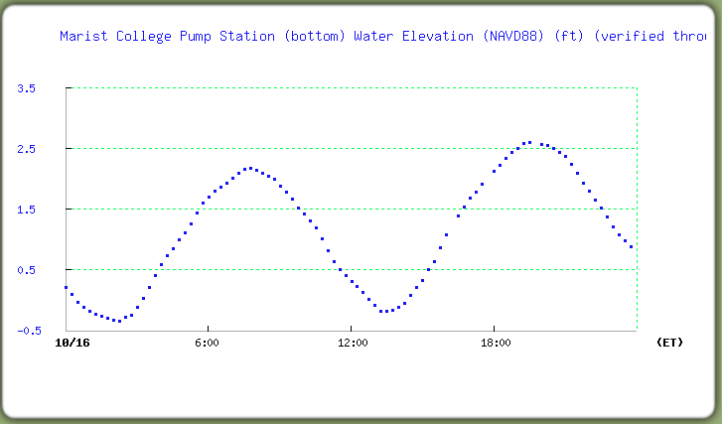

***HRECOS tide graph from Marist Station just to the north of this site. Tides were falling during sampling.***