Day in the Life of the Hudson River 10/16/14 Data
(Salt Front RM 65.9)
RIVER MILE 78
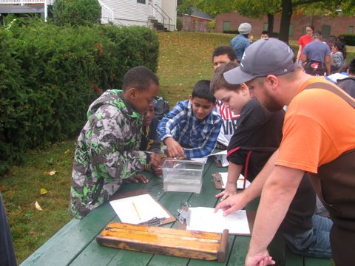

Quiet Cove, Poughkeepsie just north of Marist College
Carolyn Klocker and Neil Curry and 3 employees of Cornell Cooperative Extension of Duchess County, plus 7 youth employees from Poughkeepsie HS as part of NCLI
Robert Adams & and Peter Kinney from the DEC Fisheries Staff
Skip Hoover, G. W. Krieger Elementary School ( (104) 5th grade students,
41.44°N and 73.56°W
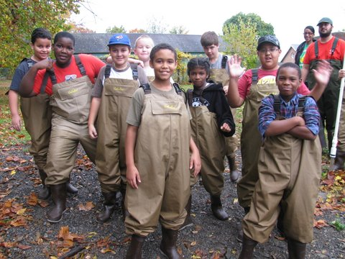
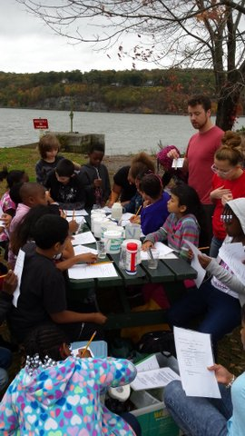
Location: Quiet Cove, Poughkeepsie, Dutchess County
Area: Grassy area with parking lot, beach like waterfront
Surrounding Land Use: Picnics, boating and fishing – 60% is beach with rip rap banks, 40% previous industrial site
Sampling Site: An old industrial area that has been turned into a park. Used by people for picnics, fishing. Shoreline rocky, banks altered with rip rap and wooden bulkhead, boat launch for kayaks and canoes
Plants in area: none visible
Debris in area: remnants of industrial site and some papers in the water
Water depth: 160 cm in the area with concrete embankments
River Bottom – muddy in beach area
ITEM | Time |  | Reading 1 |  | Wind Speed | Precipitation & Clouds
Physical
Air Temperature | 9:51 AM |  | 70°F  21°C |  | 1-3 mph N | heavy cloud cover
 | 10:16 AM |  | 68°F  20°C |  | 1-3 mph N | cloud cover/breaks of sun
 | 10:59 AM |  | 68°F  21°C |  | 7-10 mph N | Rain shower & heavy cloud cover
 | 12:46 PM |  | 70°F  21°C |  | 4-7 mph N | heavy cloud cover/storm moving upriver
Wind Speed
Cloud Cover | Heavy cloud cover
Weather today | Cool and cloudy
Weather recently | The weather for the past three days has been a mixture of rainy and sunny temps.in the high 60s.
Water Description
Water Temperature | 1:15 PM | 17°C
Turbidity – long site tube | 9:40 AM  10:00AM  10:30 AM  12:08 PM  12:51 PM | 47 cm  39.3 cm  31 cm  31 cm  12.6 |  | 53 cm  38 cm  32 cm  36.6 cm  13.8 cm |  | 50 cm Avg  38.7 cm Avg  32.5 cm Avg  33.8 cm Avg  13.2 cm Avg* this took place after significant wave action from Coast Guard boat passing
Chemical | TIME | DO Used kit we provided by no data yet |  | Temp |  | %Saturation
 | 9:40 AM |  |  | 20 °C
 | 10:03 AM |  |  | 20 °C
 | 12:07 PM |  |  | 20 °C
 | 12:42 PM |  |  | 17 °C
(LaMotte kit color match ) | Time | PH |  | NITRATES |  | PHOSPHATES
 | 9:40 AM | 7.5 |  | <5 ppm
 | 10:03 AM | 7 |  | <5 ppm |  | <5 ppm
 | 12:07 PM | 8 |  | <5 ppm |  | <5 ppm
 | 12:42 PM | 7.5 |  | <5 ppm |  | <5 ppm
Salinity
Fish Catch- 25 ft. – 4 pulls | Number Caught | Species |  | Length of largest |  | Seine - beach seine
9:30-12:30 AM | 15 | American Shad |  | 9 cm
 | 2 | Blueback Herring |  | 5 cm
 | 1 | Bay Anchovy |  | 6 cm
 | 1 | Striped Bass |  | 7 cm
Total count | 19 | Total diversity |  | 4

Tides – | Time | Top of water to top of pier | water depth | Rising/Falling
 | 9:45 AM | 50 cm |  | High/still
 | 10:11AM | 54 cm |  | falling
 | 10:53 AM | 73 cm |  | falling
 | 12:12 PM | 93 cm |  | falling
 | 12:46 PM | 100 cm |  | falling
Currents | TIME | Time over 10 meters | Cm/sec | Direction
 | 9:45 AM |  |  | Still
 | 10:11AM | 135 secs | 7.4 cm/sec | Ebb
 | 10:53 AM | 90 secs | 11.11 cm/sec | Ebb
 | 12:12 PM | 114 secs | 8.77 cm/sec | Ebb
 | 12:46 PM | 100cm | 10 cm/sec | Ebb
Traffic | 10:51 AM | Oil train |  | Southbound
 | 12:21 PM | Coastguard Vessel |  | Southbound
 | 1:05 PM | Sailboat |  | Northbound

