**Day in the Life of the Hudson River 10/16/14 Data**

**(Salt Front RM 65.9)**

**RIVER MILE 90**

**George Freer Memorial Park, Port Ewen, Ulster County**

**Meg Meisch, Rondout Valley High School**

**46 students 9th -12th graders, 7 adult helpers (2 SCA)**

**GPS Latitude 41°907 N Longitude 73°978 W**

west north

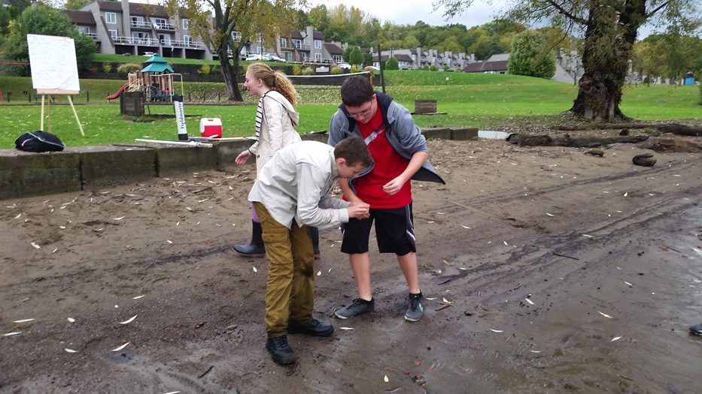east south

**SITE MAP ABOVE**

**Location:** George Freer Memorial Park, Town of Ulster, Ulster, NY

**Area:** Park space with grassy area, used for picnics, fishing and boating

**Surrounding Land Use**: 50% urban/residential; 20% forested; 10% industrial/commercial; 25% Beach

**Sampling Site:** Shore is beach, muddy and rocky along the water, banks have been altered with piping noted entering the river, bits of brick and charcoal on beach. 2 drainage pipes ~2 ft. in diameter

**Plants in area:** ~10% vegetation

**Water depth**:

**River Bottom** : muddy

**About the sit**e – Water Milfoil & Water Chestnut in water – each about 10% cover

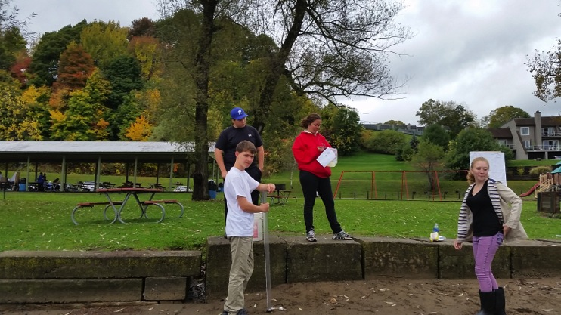

Turbidity (students facing East)

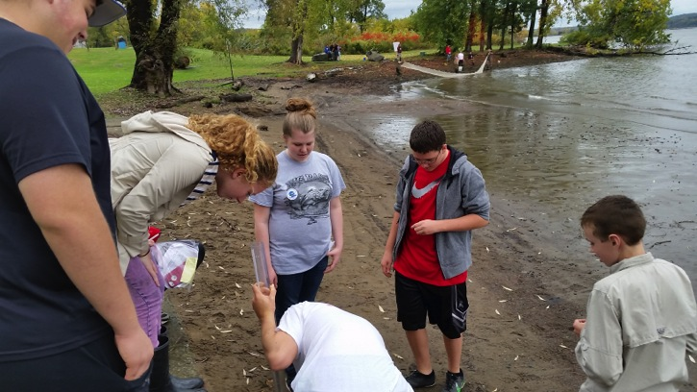

North South

|  |  |  |  |  |  |  |
| --- | --- | --- | --- | --- | --- | --- |
| ***ITEM*** | ***Time*** | | ***Reading 1*** | ***Reading 2*** | | ***Comments*** |
| ***Physical*** |  | |  |  | |  |
| Air Temperature | 10:10AM | | 17°C  18  17  17.3 | 62.6 °F  64.4  62.6  63.2 | |  |
| Wind Speed | 10:19 AM  10:46 AM  12:04 PM  12:34 PM | | Beaufort 1  Beaufort 2  Beaufort 3  Beaufort 3 | 1-3 mph  4-7 mph  8-12 mph  8-12 mph | | SE | |
| Cloud Cover | Overcast | |  | | | |
| Weather today | Rain @ 11:15 AM – ½ inch light rain – cloudy all day, gusty winds stated noon to 12:30 PM | | | | | |
| Weather recently | Sunny and warm last 3 days, rained heavily last night | | | | | |
| ***Water Temperature*** | 9:53 AM | 16.7°C | | |  |  |
|  | 10:45 AM | 16°C | | |  |  |
|  | 12:21 PM | 17 °C | | |  |  |
| ***Water surface*** | choppy |  | | |  |  |
| ***Turbidity long***  ***Site tube*** | 10:13 AM  10:35 AM  12:09 PM | 59 cm  60 cm  56 cm | | | 0  52 cm  35 cm | 59 cm Avg  56.3 cm  46.3 cm |
| ***Chemical*** |  |  | | |  |  |
| **DO**  ***Wards D.O.*** | **Time** | **Temp °C** | | | **DO** | **% saturated** |
|  | 10:06 AM | 20°C | | | 12 ppm | 130% |
|  | 10:52 AM | 20°C | | | 9 | 100% |
|  | 12:19 PM | 20°C | | | 9 | 100% |
|  | 12:49 PM | 20°C | | | 10 ppm | 105% |
| pH – indicator solution | 9:52 AM | 5  7  5 | | |  | Average 5.7 |
|  | 10:38 AM | 5  7  6 | | |  | Average 6.0 |
|  | 12:07 PM | 6  7.4  7 | | |  | Average 6.8 |
|  | 12:33 PM | 6  7.2  6 | | |  | Average 6.4 |
| Salinity - Quantab | 3:00 PM | 30 ppm Cl-  30 ppm Cl- | | | Converts to 54 ppm total salinity |  |
| ***Fish Catch***  *35’seine X 4 ft.* | ***Number Caught-*** | ***Species -*** | | | ***Largest Size*** | ***Diversity & Totals*** |
| ***9:57-1:00 PM***  ***8 pulls*** | 100 | American Shad | | | 3.5 inches | ***Diversity - 3*** |
|  | 4 | Shiner | | | 3.25 inches | ***Totals = 105*** |
|  | 1 | Yellow Perch | | | 4.5 inches |  |
| ***Tides*** | 10:10 AM | 46 cm | | | start |  |
|  | 10:40 AM | 30 cm | | | falling | 0.53cm/min |
|  | 12:06 PM | 10 cm | | | Falling | 0.67 cm/min |
| ***Currents*** | ***Time*** | ***Cm/30 secs*** | | | ***Cm/sec*** | ***Knots – Ebb Flood*** |
|  | 12:19 PM | 5.5 cm/30 sec | | | 0.18 cm/sec | 0.0035 knots – North/Ebb |
| ***ShippingTraffic*** | 11:30 AM | Barge – | | | RTC 502 | Northbound |