Day in the Life of the Hudson River 10/16/14 Data
(Salt Front RM 65.9)
RIVER MILE East River 1 West
Dan Tainow, Lower East Side Ecology Center
Michael Paoli, Ella Baker School
7th-8th grade, 25 students, 3 adults
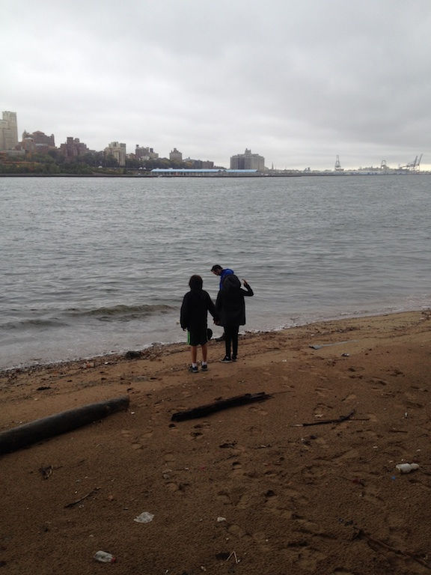 | 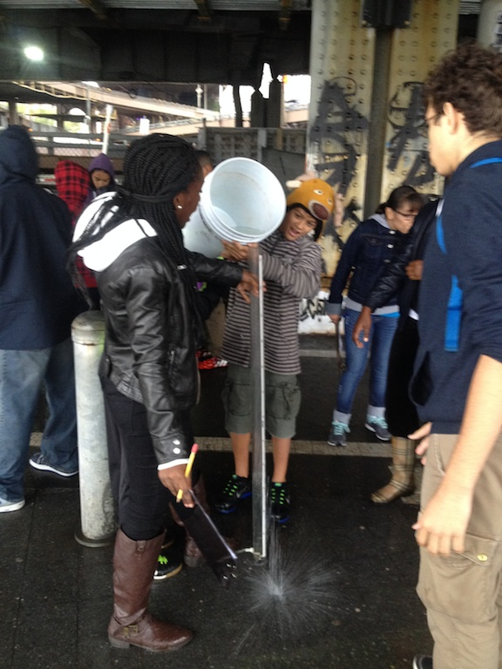
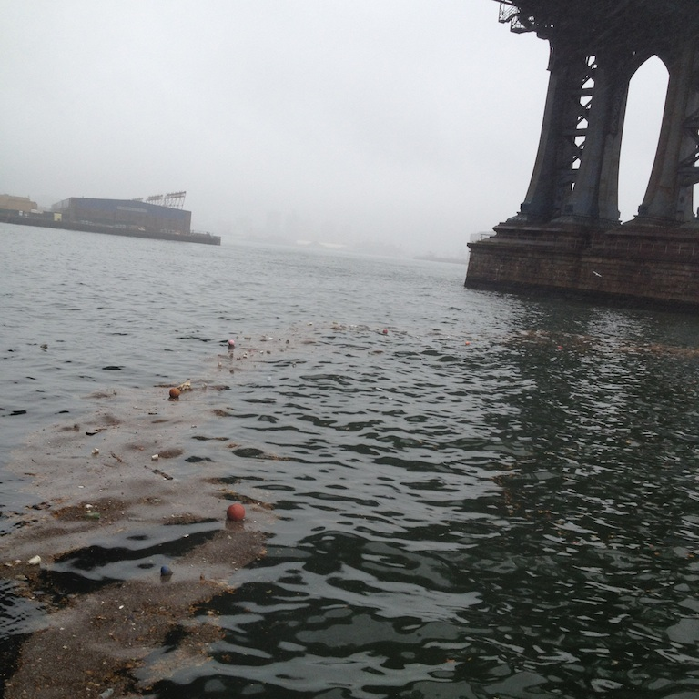
Location: Beach under the Brooklyn Bridge, 125 ft. North of Dover St., Manhattan side
Area: Pier and path for recreational walking, jogging, bike riding and fishing. The surrounding land is sandy with water – beach like. Water best used for fishing & boating. Lots of rocks and sand. Beach is opened to the public but no swimming. Also near a parking lot.
Approaching the site:
Surrounding Land Use: Urban/residential 20%; Forested 15%; Industrial/Commercial 10%; Beach 20%; other 35%
Sampling Site: Sandy, Beach, covered in vegetation, banks altered, bulkhead with timbers, RipRap. Piping entering river

ITEM | Time |  | Reading 1 | Reading 2 | Comments
Physical | 9:30-11:00 AM
Air Temperature |  |  | °F  °C
Wind Speed |  |  | 4-7MPH | S
Cloud Cover | overcast
Weather today | Rain! Warm and humid
Weather last 3 days | RAIN last night 1.75 inches! Humid last few days with tropical storm
Water surface
Water Temperature - |  | 65°F  18°C
Turbidity  Long site tube |  | 64 cm
Chlorophyll |  | 0.1 color chart
Chemical
DO - tablets |  | 10 ppm |  | 18°C | 105% saturation
Salinity - color match test kit |  | 28 ppt  28 ppt |  | Hydrometer  refractometer
pH |  | 7.6
Tides | LT 9:11 AM | For the full sampling |  | Flooding
Currents

