Snapshot Day 10/16/14 Data
Mohawk River Valley
SCHOHARIE RIVER SITE RIVER MILE
Middleburgh, NY
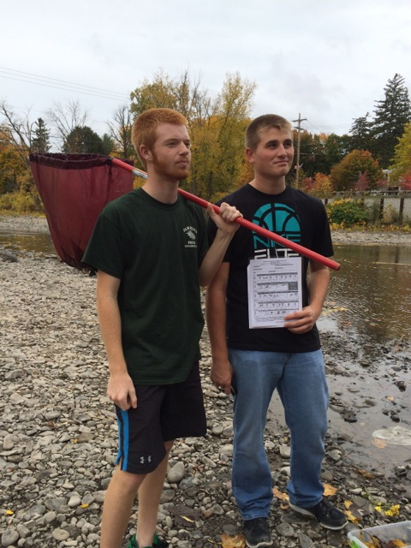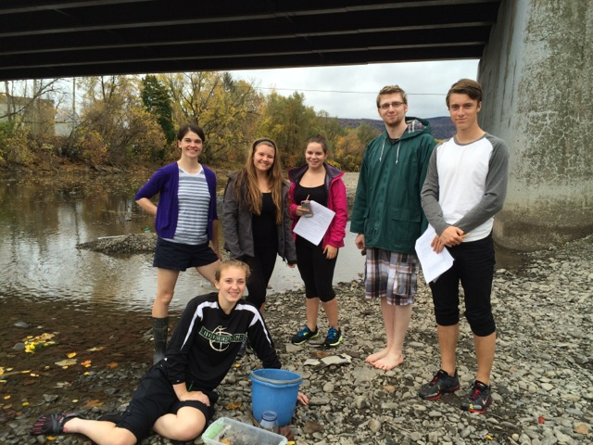
Mollie Burgett, Middleburgh High School & 7 students 12th grade
42.599774 Lat and -74.336856 Lon
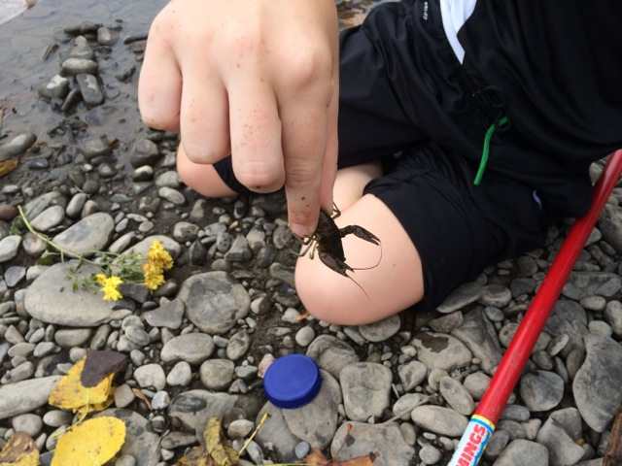
37 Invasive Rusty Crayfish collected and 0 native crayfish!

Location: On the Schoharie Creek by the Bridge Into Middleburgh, Schoharie County
Sample location runs right along river street (one of the main streets in the village) and is
full of cobbles, some grasses and short shrubs under 4 feet tall. The trees along the bank on one side make a break between the road and the creek and the other side divide the creek from farm fields.
Surrounding Land Use: 30% residential, 70% farmland
Shoreline: Riprap, Concrete blocking, stormdrain of some sort occasionally discharges in to the creek just down from the sample site. Lots of cobbles in stream channel.
Storm Drains: Several
River Bottom: Mostly rocky although sandy and muddy
Water Depth: 50 cm
Plants in area: 70 % grass, 7% trees, 10% shrub

ITEM | Time |  | Reading 1 | Reading 2 | Comments
Physical
Air Temperature | 12:55 PM |  | 73.4°F  23°C | 73.4°F  23°C
Wind Speed |  |  | Beaufort #4 | South
Cloud Cover | 12:55 PM |  | 100% overcast
Weather today | 1:00 – 4:00 PM |  | Intermittent rain
Weather recently | Large storm last night – but prior to that very dry
Water Surface
Water Temperature | 12:56 PM | 19°C |  | 66°F | Shade – water still  2 inch depth
 | 12:57 PM | 20°C |  | 68°F | 2 inch depth
 | 1:50 PM | 20°C |  | 68°F | 12 inch depth
Turbidity 60 cm  Site tube | 1:00 PM | Tube was too short – water very clear
Chlorophyll | 2:10PM | 1.5
Chemical
DO – titration kit  Slow section – not a riffle | 2:12 PM | 20°C |  | 9.0 mg/L | 98%
pH – test strips | 12:59 PM  1:04 PM  1:05 pM  1:08 PM | 6  7  6  8 |  |  | Average 7
Flow Rate (no current up here) | Slow moving section | 13.3 cm/sec |  | Average
 | Riffle | 39.4 cm/sec |  | Average
 | Mid section | 29.4 cm/sec |  | Average
Fish –2 ft. kicknet in a riffle – 1-2PM | 1 | White sucker |  | 2-5 inch | DIVERSITY  3
 | 1 | Yellow bullhead |  | 4 inch | TOTALS 3
 | 1 | Spottail Shiner |  | 2 inch
Large Macros | 37 | Rusty Crayfish |  | invasive | Div – 1  Total 37
Macroinvertebrates | Number | Species |  | 2:00 PM | Diversity 6
small handnets | 50 | Fishfly larvae |  |  | Totals 73
 | 5 | Mayfly larvae
 | 1 | Helgramite
 | 2 | Stonefly
 | 15 | Riffle Beetle
 | 10 | Mayfly larvae |  | 2:05 PM | Diversity 3
 | 2 | Helgramite |  |  | Totals 13
 | 1 | Water Penny
 | 2 | Helgramite |  | 2:15 PM | Diversity 3
 | 6 | Stonefly |  |  | Totals 9
 | 1 | Water penny
Core Sample | Length | Rare |  | Common | Abundant
 | 5 cm length | Macro- invertebrates |  | Leaves | Mud  Sand  Gravel  Pebbles
Observations | Slightly overgrown, crayfish shells, cardboard and other trash  Few butterflies, chickadees and pigeons

