Snapshot Day 10/24/14 Data
(Salt Front RM 65.3)
RM -2 , Valentino Pier
Theresa Geelhoed and Erin Maquire, NYS SCA members
Barbara Taragab, Elissa Eisenberg, Chris Doyle The Brooklyn New School PS 146 4th graders – 32 students, Adults 10
GPS Latitude N : 40°40’42. 10” - W-74°01’06.07
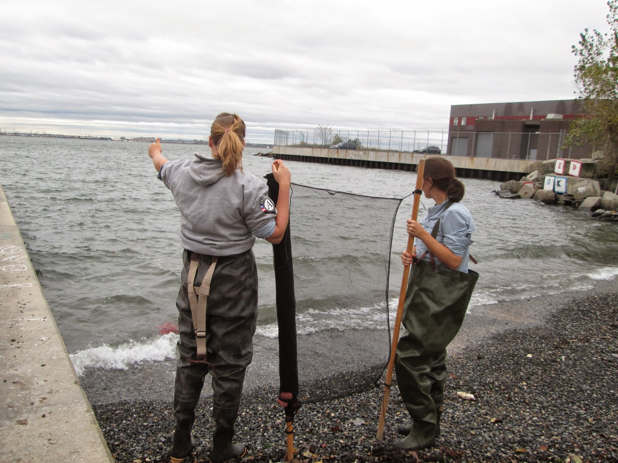 | 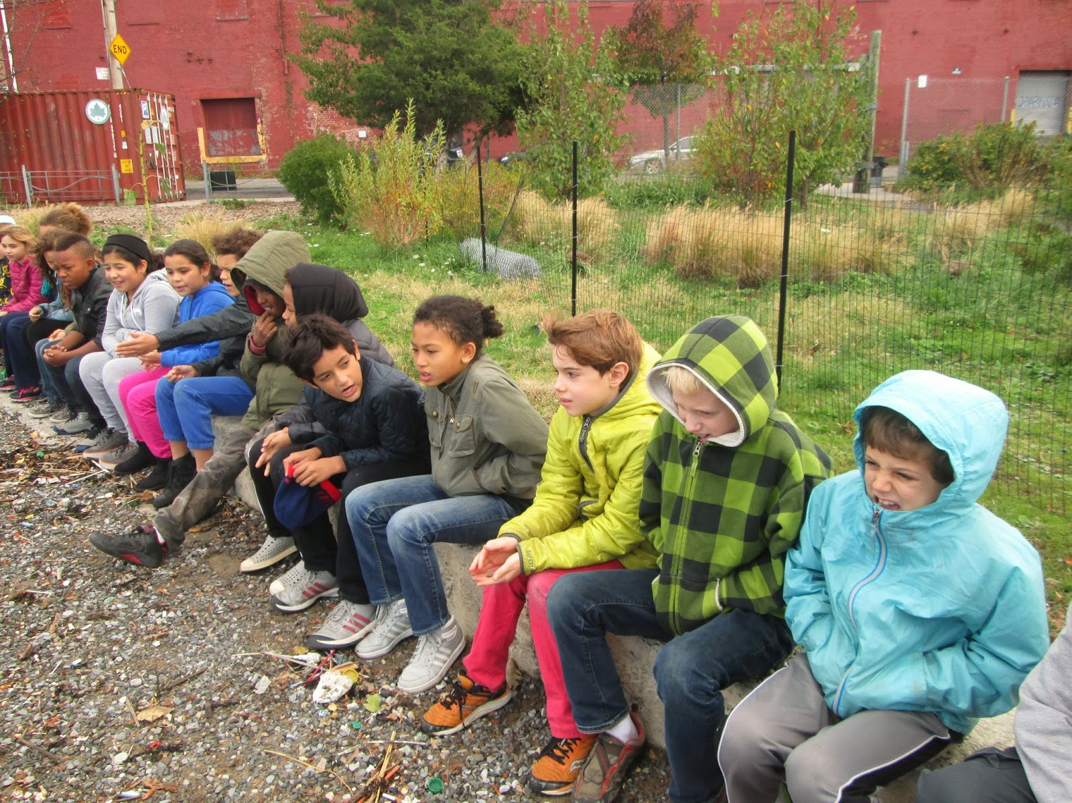
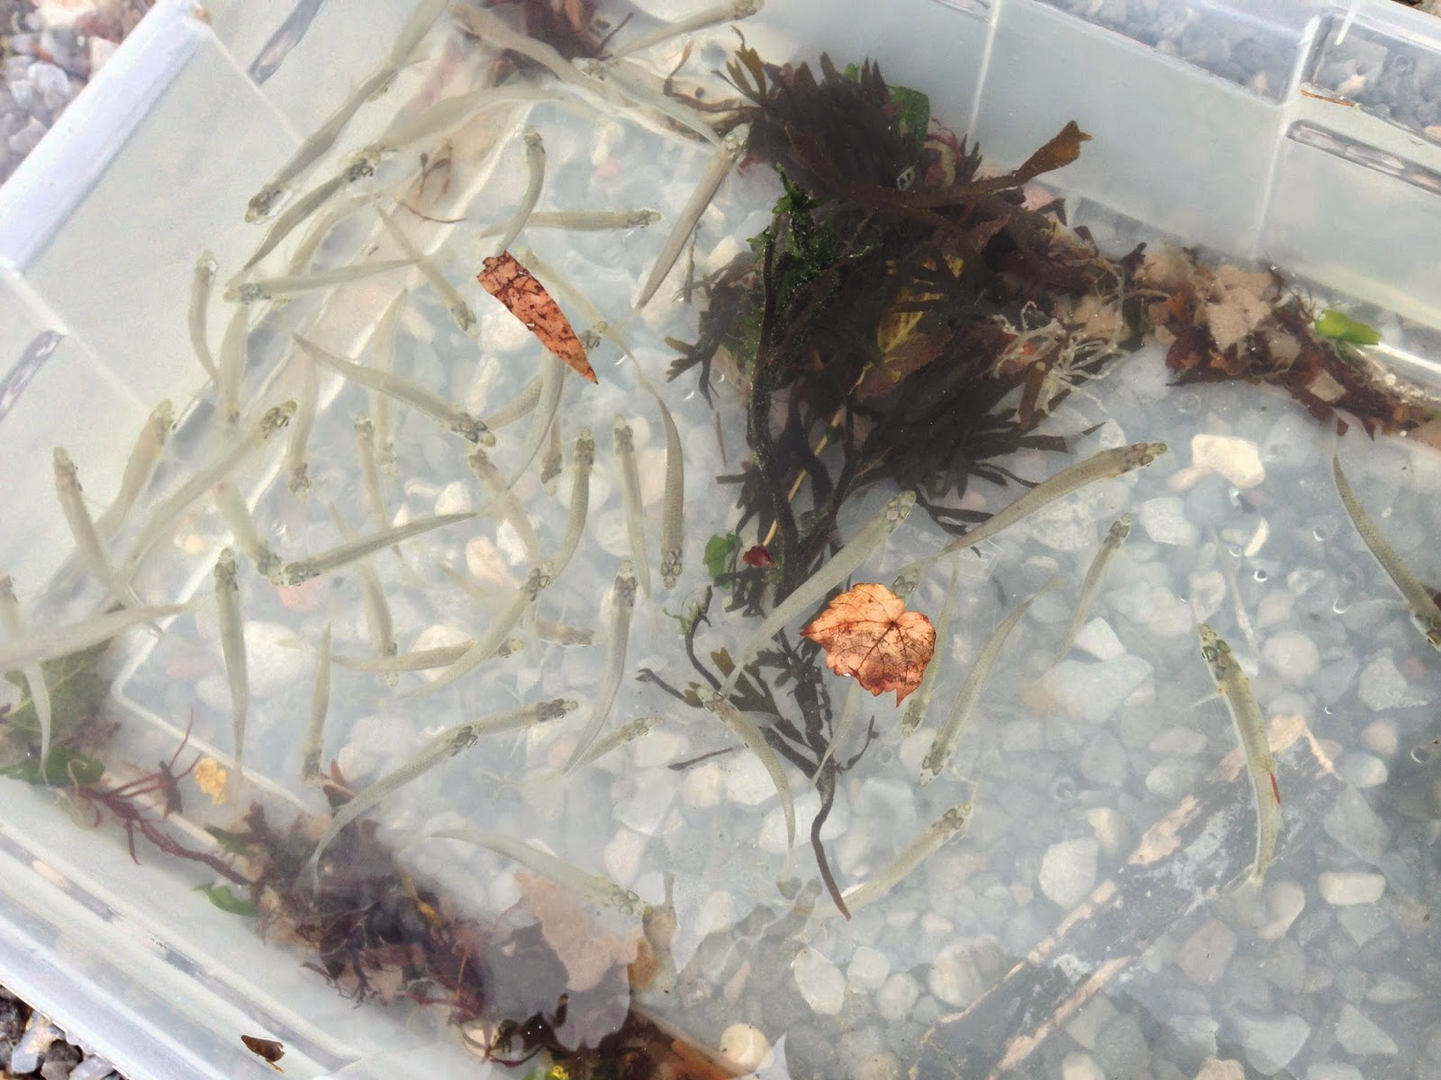 | 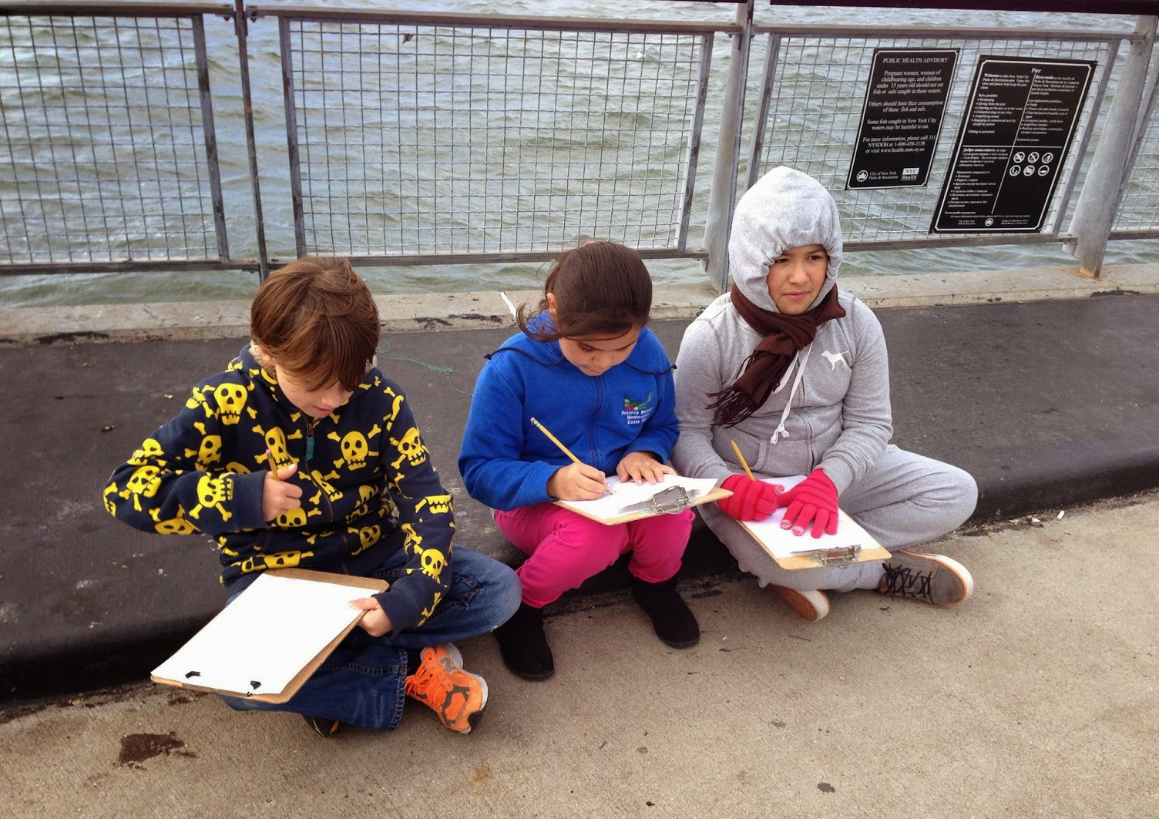
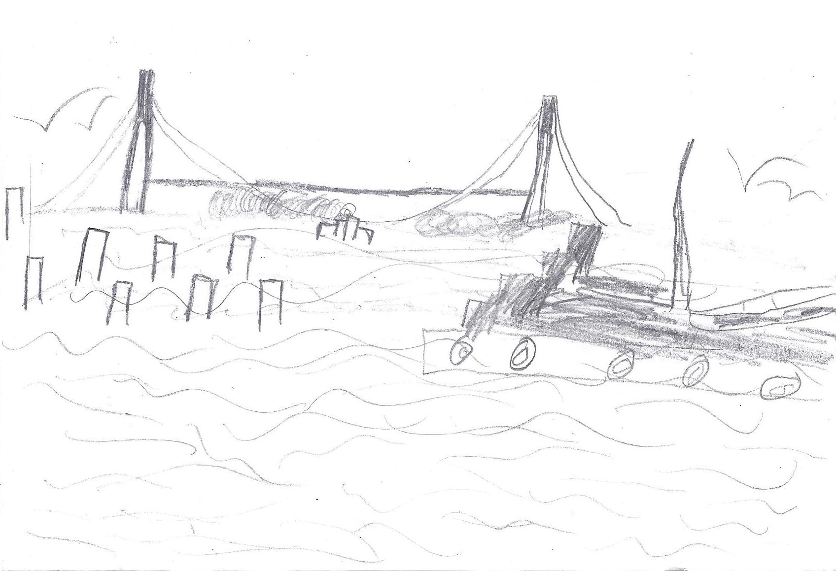
Location: Valentino Pier, Redhook, Brooklyn, NY
Area: A large pile of rocks with a small rocky “beach”; area with large pier;
Surrounding Land Use: Beach – 5%; Urban/residential 5%; Industrial/Commercial 90%; - surrounding area landscaped with sea grasses. It is used as a dog walk although signs prohibit that use. Fishing was happening at end of the pier.

Sampling Site: beach
Shoreline: Pier, riprap
River Bottom : rocky near the little beach area
More sketches at the end of this document.

ITEM | Time |  | Reading 1 | Reading 2 |  | Comments
Physical |  |  |  |  |  | 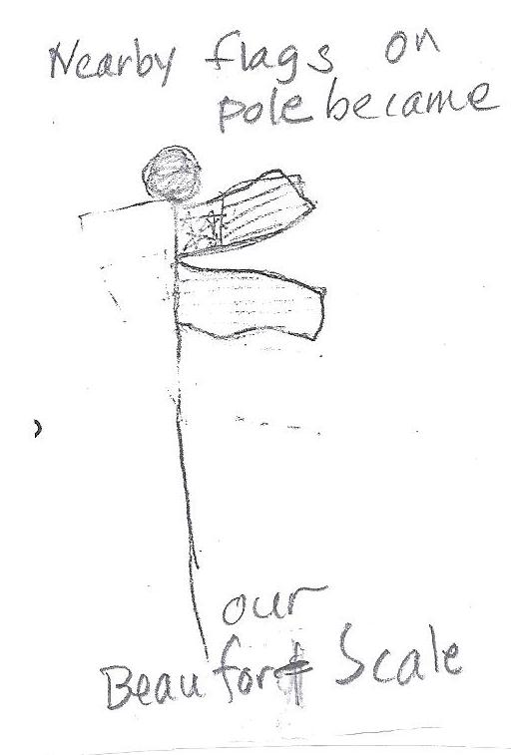
Air Temperature | 9:30 AM |  | 10°C
 | 10:30 AM |  | 15°C
Wind Speed | 9:30 AM |  | Beaufort Force #5 | Used flag for Beaufort
Cloud Cover | clear
Weather today | No rain
Weather recently | Cool weather. Rain on 10/21.
Water Temperature | 9:30 AM | 15°C  14  15 |  |  |  | Average 14.66°C
 | 10:00 AM | 15°C  15  15 |  |  |  | 15°C
 | 10:30 AM | 15°C  15  15 |  |  |  | 15°C
Water calm | yes
Turbidity – short sight tube | 9:30 – 10:30 AM | 40 JTU  40  40 |  |  |  | 40 cm
Chemical
DO  ampules | 9:30 to 10:30 AM | 8mg/L |  |  | 15°C | 78%
pH –indicator solution with LaMott testabs | 9:30 to 10:30 AM | 7 |  |  |  | 7
Salinity – refractometer | 9:30 to 10:30 AM | 28 ppt  28ppt  25 ppt |  |  |  | 27 ppt
Fish Catch  14 ft..seine net, mesh size ¼ inch | Number Caught | Species |  |  | Length of largest | Catch Totals
9:05 AM | 4 | Atlantic Silversides |  |  | 5 inch | Diversity 2  Total Catch 5
 | 1 | Striped Bass |  |  | 3.5 inch
9:20 AM | 54 | Atlantic Silversides |  |  | 3.5 inch | Diversity 1  Total Catch 54
Session Totals | Diversity- 2 | Total Catch - 59
Tides | HT from charts 8:50 AM
Currents | 9:00-10:30 AM | South* |  |  | *used white daisies off the south side of the pier
Journal Entry from student | I wonder why people make so many bridges. It just means more cars to across them. Just use boats. And why water abuse? Like pollution. Pollution is bullying to water! … I think bullying is the reason the water sent a fight over called the famous Sandy! We're so mean!”

Please see more of our journal entries and drawings below!
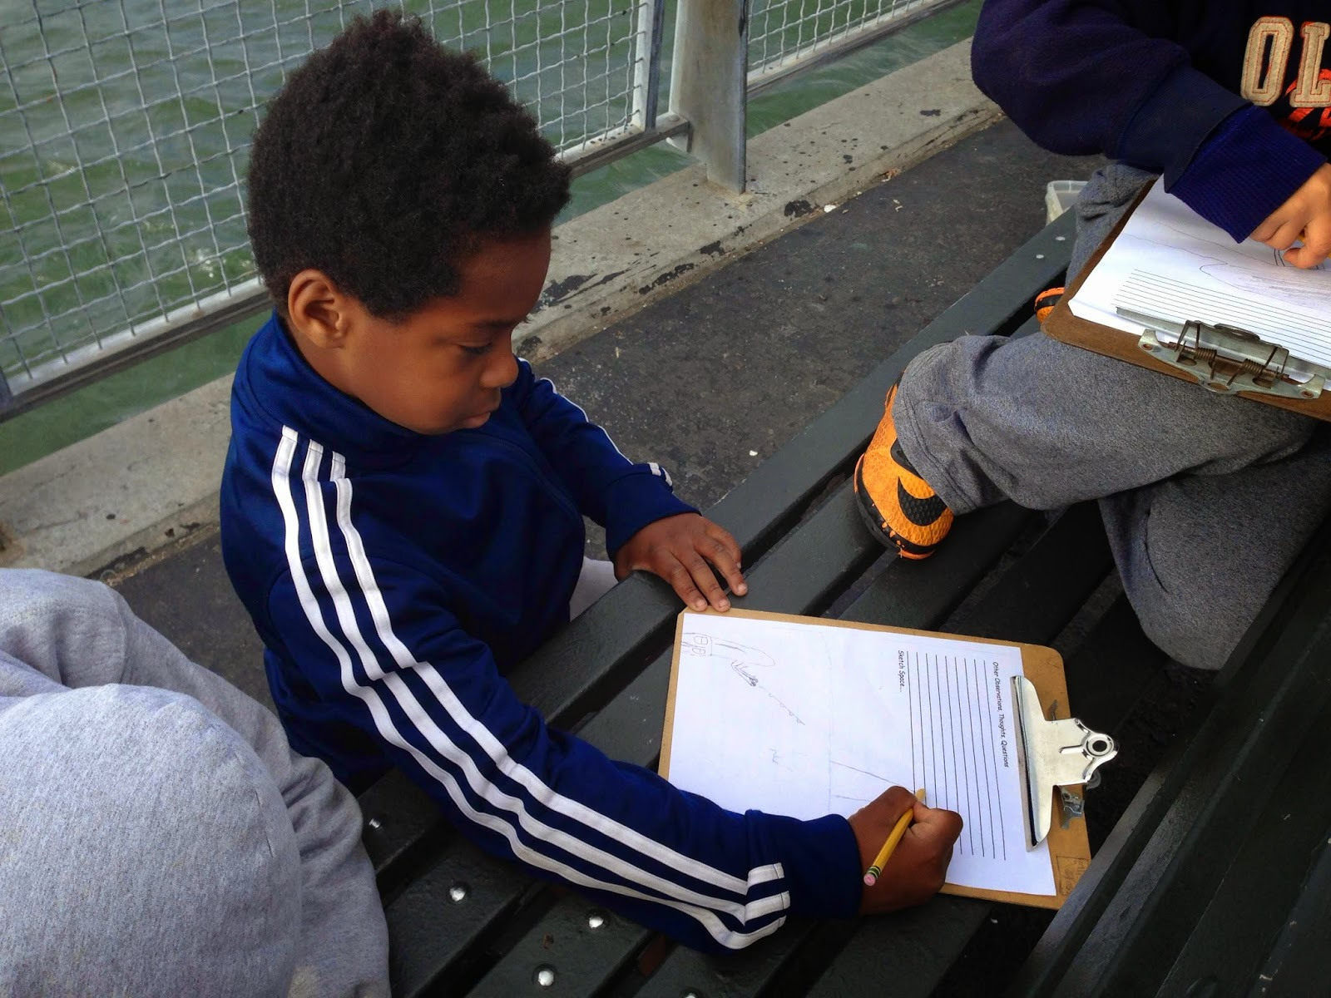

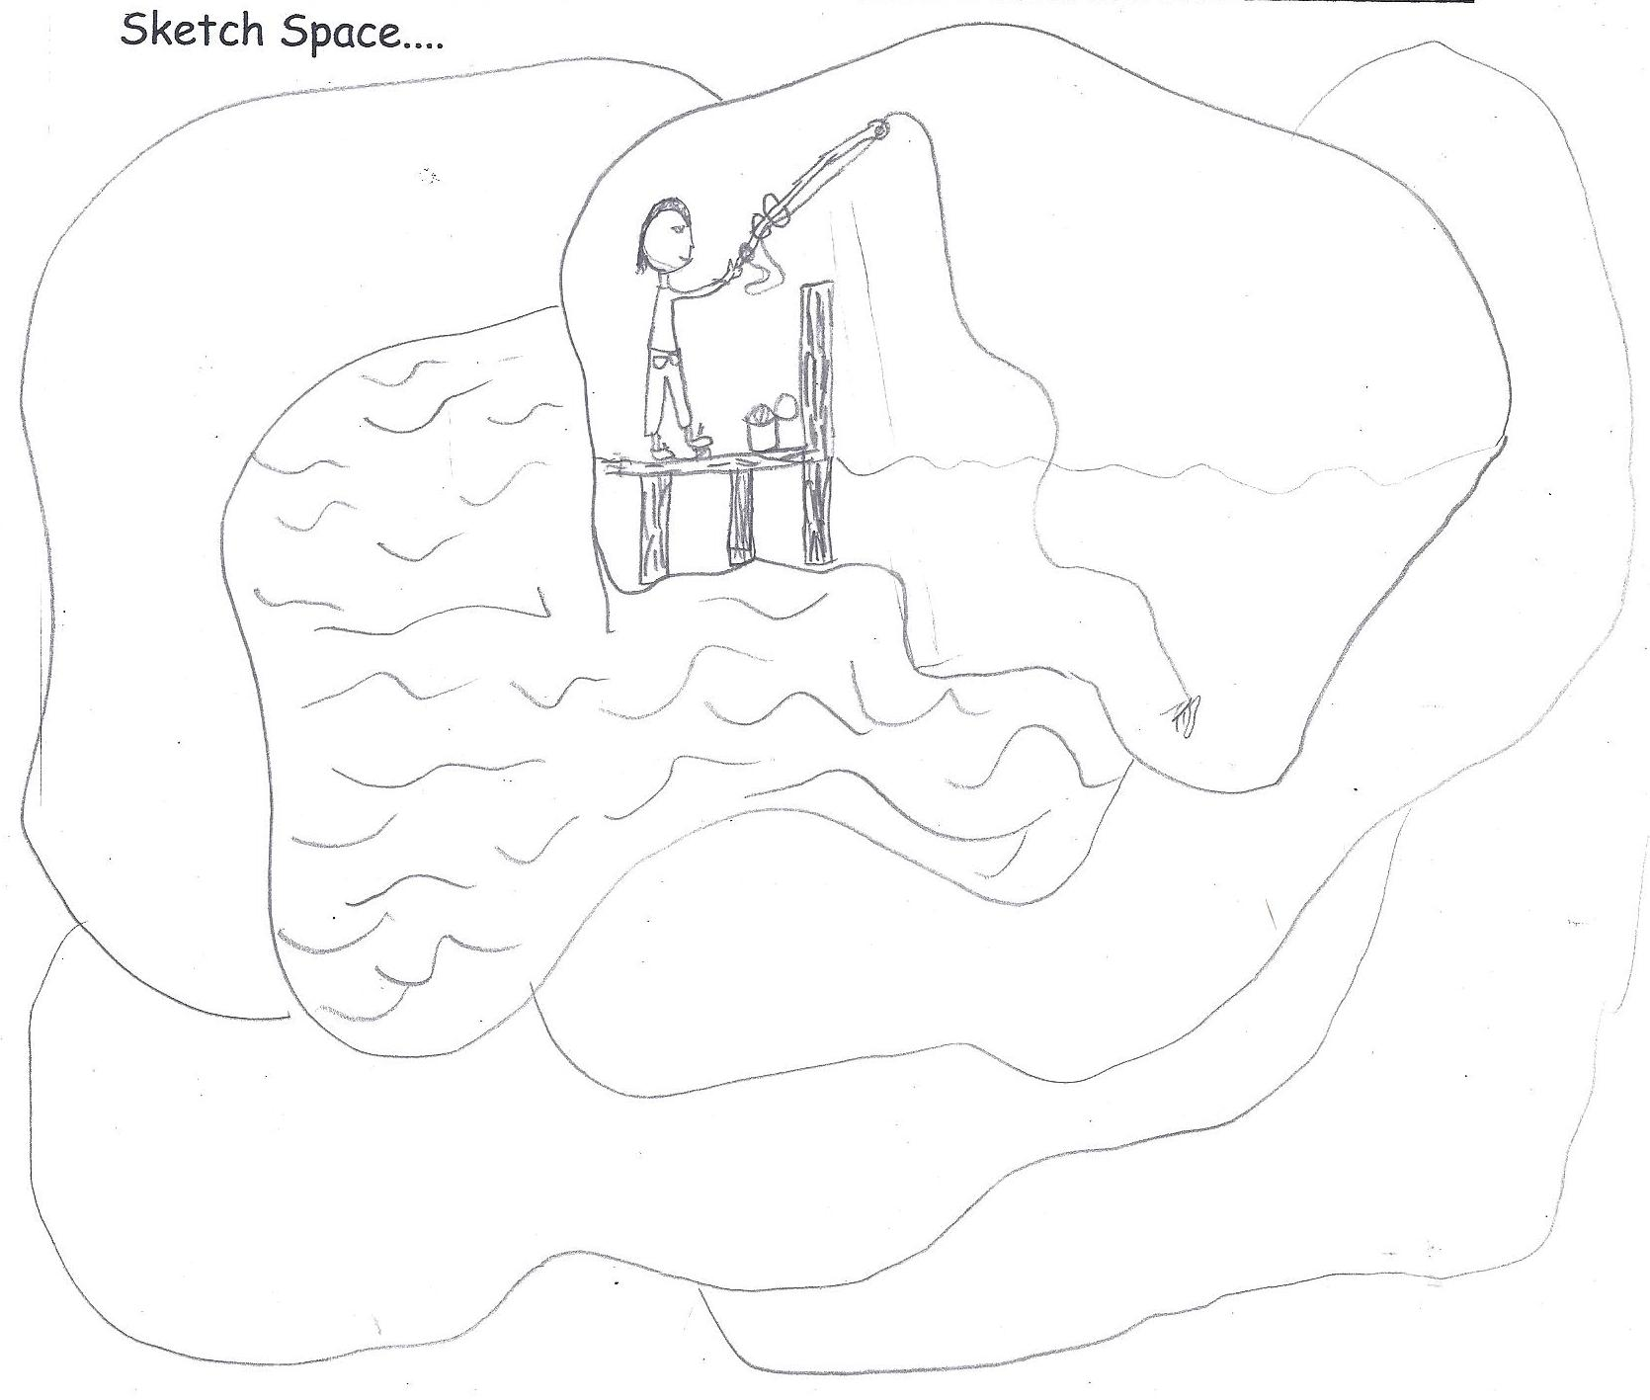

Lots of people fishing, lots of cruises, lots of liter, big waves & small waves, lost of small fish, some big-ish fish, Verrazano Bridge
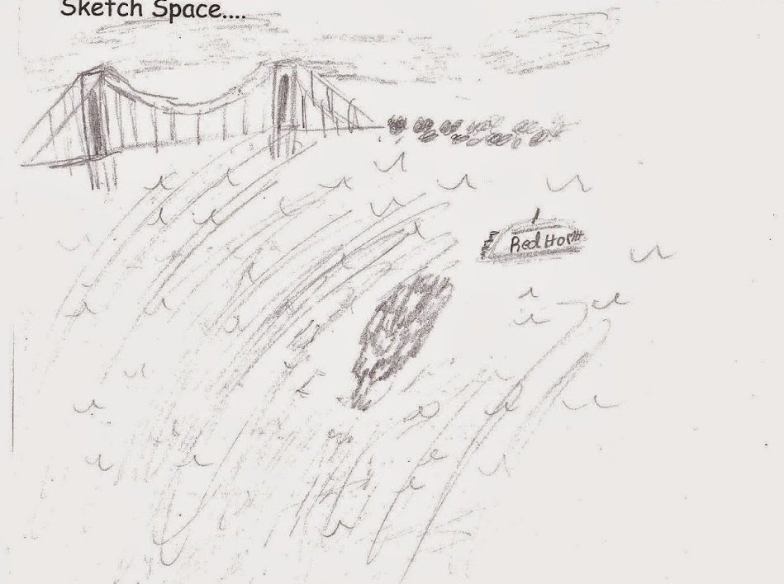

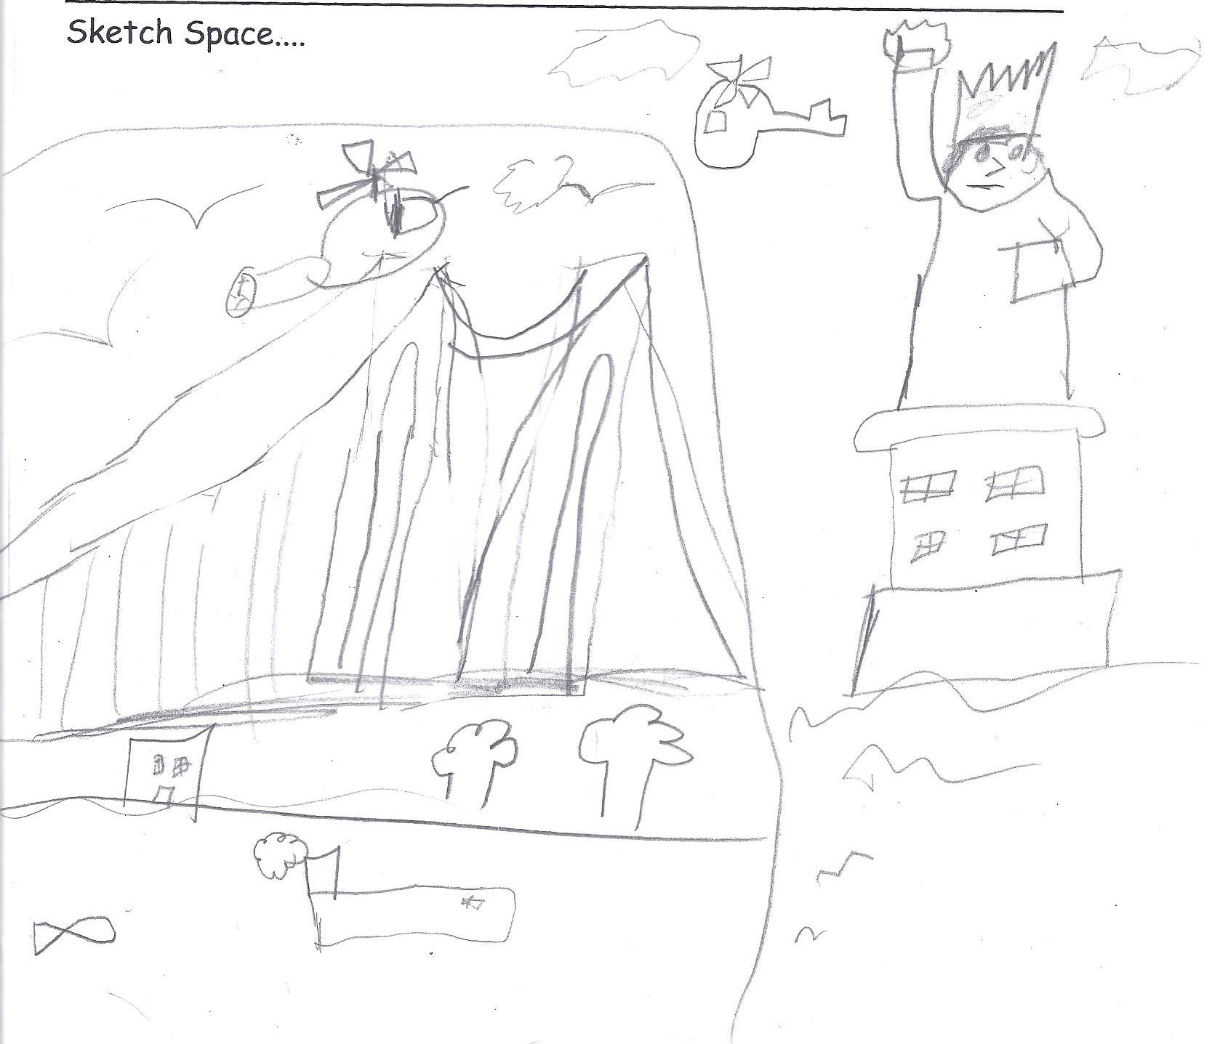

We see buildings and fishermen.
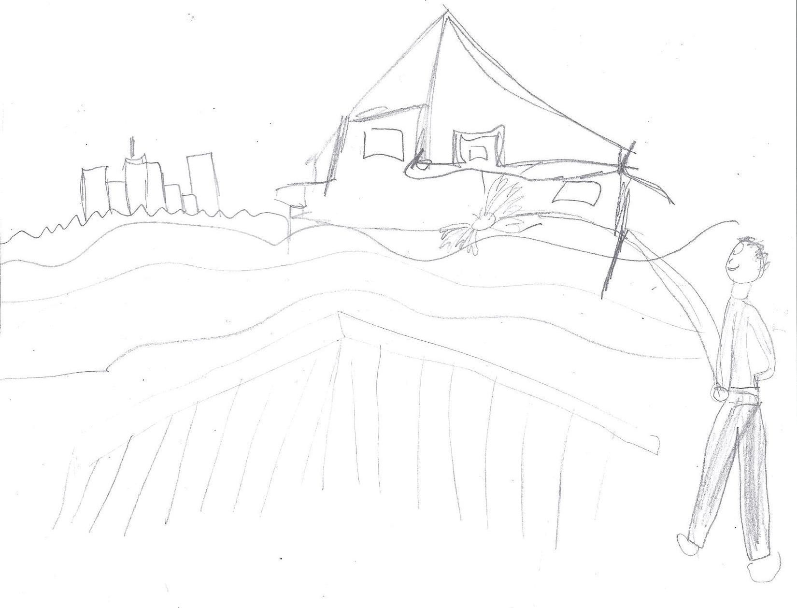

Lots of people fishing, bridge
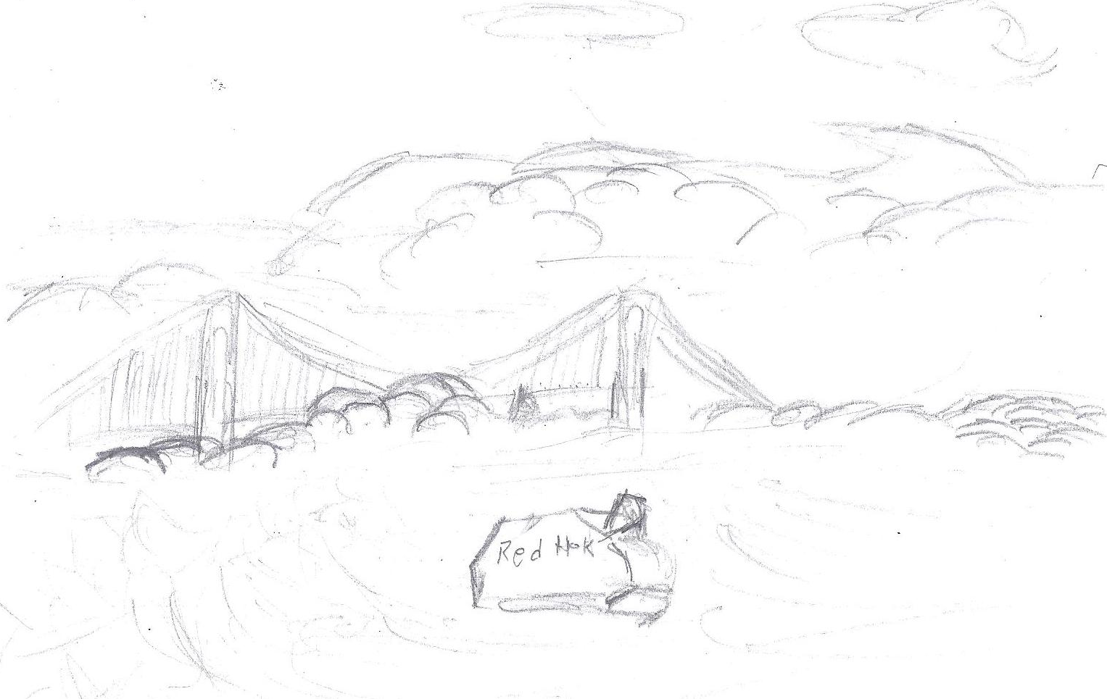

There’s a lot of boats and the water is very choppy. I think I counted like more than 30 cars! Just wow!
