Day in the Life by North Colonie
Thirty 5th grade students from the North Colonie CSD’s Learning Enrichment Program participated in this year’s “Day in the Life of the Hudson River” at Hudson Shores Park in Watervliet, NY (HRM 153).

While we were nervous based on the weather reports, we decided to brave the elements and not cancel our trip, and boy are we glad we did go! This was the best year yet. Despite overcast skies and High tide much of the time we were there, the students had a successful day.

The tide stick we had was 8’ long, however by 10:30 the water levels were well over that. Students problem solved and figured out if they added the length of their arm that got wet to the 8’ length of the stick, they could come fairly close to what the actual depth was.

They collected and recorded data on the currents, air and water temps, dissolved oxygen, pH and turbidity of the water. They were able to analyze a few small core samples that the teachers had gotten in the morning knowing that the tide would make it difficult for the students to do on their own.
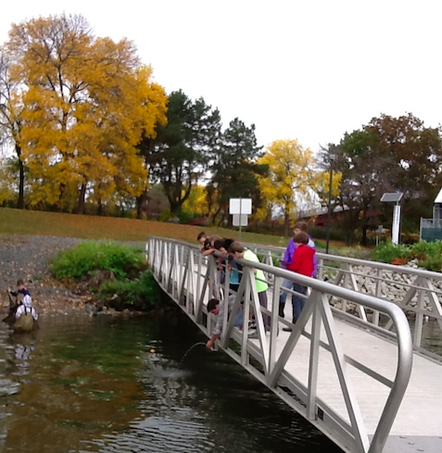

At the fish ID station students were able to get out in the water with the waders and try seining. The previous two years we have not caught anything in our seine nets, so while we wanted to let the students try it, we were fairly confident that they would not catch anything. Especially since we caught NOTHING in the minnow traps we had set the evening before (I guess the fish did not like the flavor of cat food we bought). To our, and the student’s delight, the first group pulled out nine fish, which they were able to identify as Spot-Tail Shiners. The second group caught 2 more later in the morning.
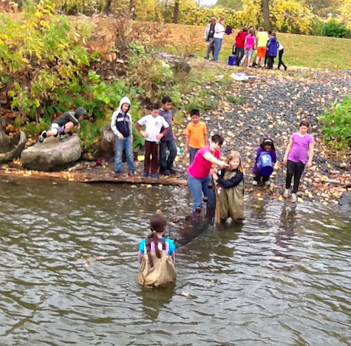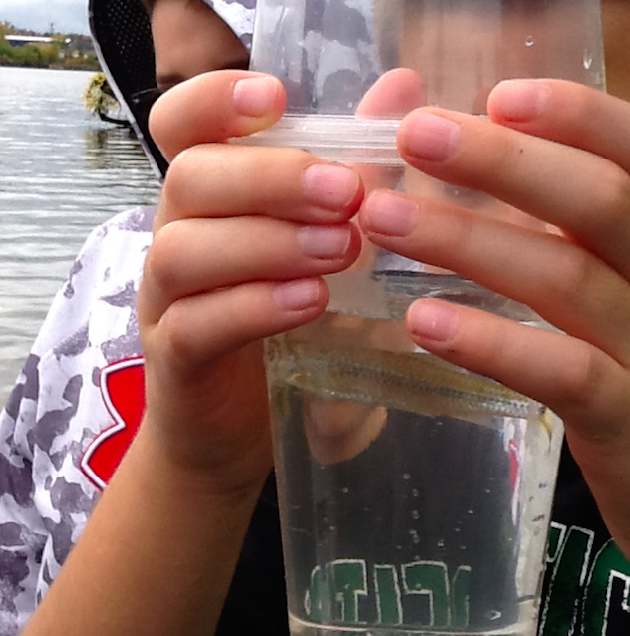
The highlight of our day however was when we had a surprise visit from 4 professional “fishers” from the DEC! They took their boat down river by Postinkill where they sent an electric current into the water to stun the fish which they then brought back to show the students. We got to see herring, catfish, small mouth bass, and even an eel to name a few. These guys were amazing and really took the time to talk to the kids about what they do, and answer all their questions. While they were showing off the fish, the kids were also able to see how they measure and record the data on the fish they catch.
