Day in the Life of the Hudson River 10/20/15 Data
Canarsie Pier, Jamaica Bay, Brooklyn NY
Ragini Singhal – Robert Van Wyck MS 217
NYSDEC SCA Members - 1
30 students, 6th grade. MS, 3 adults
N 40.37’49.0” - W-73.53’00.98”
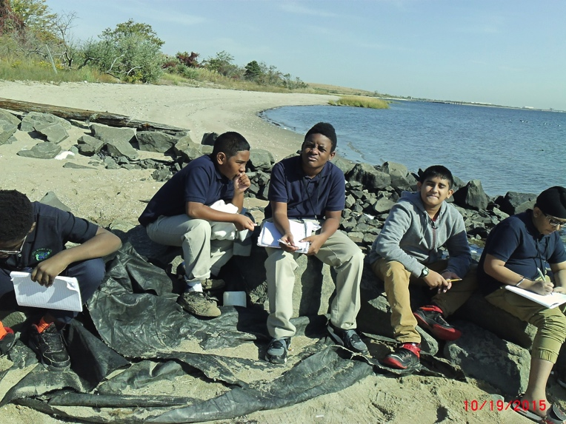

Location: Jamaica Bay, Canarsie Pier,
Area: Beach, large piping entering river
Surrounding Land Use: 50% forested; 40% beach; 10% constructed pier
Sampling Site: Beach, covered with vegetation, concrete pier, some fabric & other debris in rocks, man placed boulders along part of the shoreline near the pier
Recreational pier – rocks near the edge, banks altered
Bottom: sandy bottom
Plants in area: phragmites

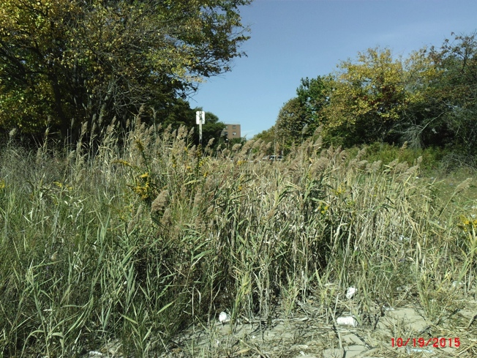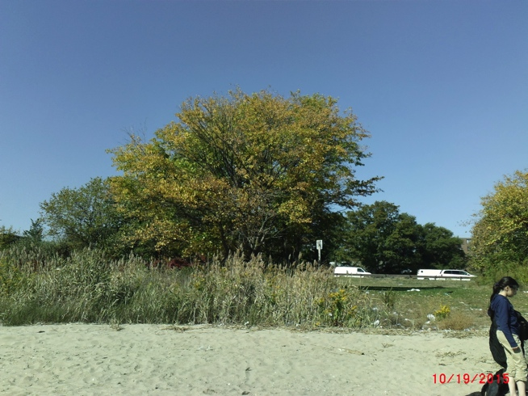

Fish Collection -
No Count or ID provided but from the attached image we can identify a large number of killifish and several Atlantic Silversides.
