A Day in the Life of the Hudson River 10/20/15 data
East River; Pier 16 South Street Seaport - PM group
Heather Page & the High School of Economics & Finance,
Laura Norwitz, South Street Seaport Museum
30 - 11rd & 12th APES students, 3 adults
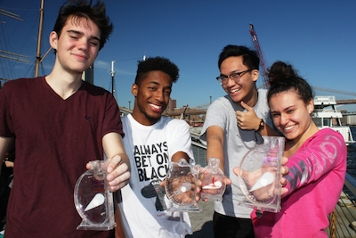 | 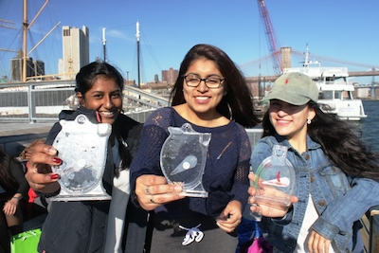
Location: South Street Seaport, Pier 16
Area: East River; Pier 16
Surrounding Land Use: Museum, Pier for boat access, Urban/residential and industrial/commercial
Shoreline: Pier, large docking with concrete and wood surface,
Bottom: Rocky shoreline
Water: Choppy
ITEM | TIME | Reading | Comments
Physical
Cloud Cover |  | clear
Weather Today |  | Warm in the PM
Weather Recently | Cool and dry
Water Surface | Choppy
Turbidity – long tube | 3:00 AM | 274 cm
Chemical
Salinity | 3 PM | 21 ppt  salinity | Plastic Hydrometer

