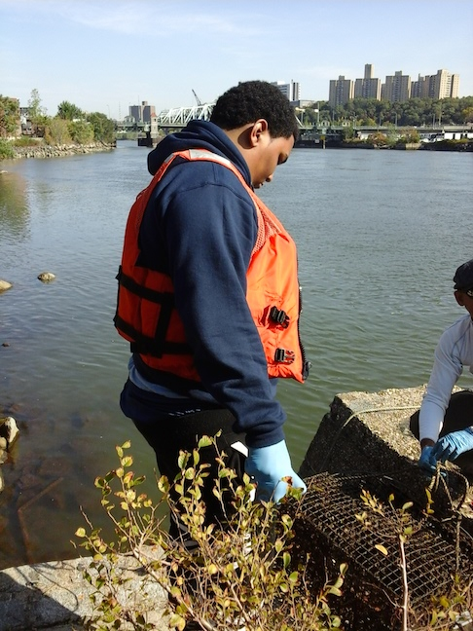
Day in the Life of the Hudson River 10/20/15Data
HARLEM RIVER MILE 13b
Sherman Cove Park saltmarsh flats, Harlem River
Obed Fulcar, Friends of Sherman Creek
MS319 Middle School, 8thgrade, 25 students, 2 adult
GPS Latitude 40.85 E - Longitude -73.92 N

Note: We participate in the Billion Oyster Project and so it played a role in our sampling. Here we are checking the oyster cage.

Academy Street (New CON ED substation)
N
Sherman Creek

W E HARLEM RIVER

PHRAGMITES FOREST
XXXXXXXXXXXXXXXX
200 St S PS 5 Snapshot Day Site
HARLEM RIVER DRIVE
UPLAND TREES
XXXXXX

SITE MAP
Location: Saltmarsh/mudflats at Sherman Cove Park next to a side road/school building, adjacent to Swindler Cove next to the north end of Harlem River Drive, Manhattan – a forever wild area.
Surrounding Land Use: 40% urban/residential, 50% forested, 5% beach, 5% Industrial/commercial.
Sampling Site: Beach area, covered with vegetation - Sampled in salt marsh covered with phragmites on one side and a mudflat with gravel on the shore, pipe with 1 m diameter north of sampling site
Shoreline: 20% muddy, 80% rocky
Plants in area: Rocks covered with algae and cord grass spartina. 5% of water area has plants in it. 40% of site is invasive Phragmites, 20% other
River Bottom: muck/muddy bottom – water 1 ft. depth
ITEM | Time | Reading 1 | Reading 2 | Comments
Physical
Air Temperature | 10:15 AM | 22.1°C | 70.2 °F
Wind Speed | 10:05 AM | 5 m/sec | NW
Cloud Cover | Clear <25%
Weather today | Clouds | No rain
Weather recently | Sunny & cold
Water Conditions | calm
Water Temperature | 11:00 AM | 15.0 °C  19.9 °C  14.7 °C |  | Average 16.5°C
Turbidity – Long sight tube | 11:30 AM | 49.5 cm  26.1  34 |  | Average 36.5 cm
Chemical
DO – LaMotte greenforce kit – (note:this is a low resolution sample kit) | 11:30 -11:35 AM | 7 ppm  9 ppm  11 ppm | Average 9 ppm | 92% saturated
pH – | 11:30 AM | 7.25  7.28  7.34 | Average 7.29
Salinity – hydrometer & meter | 12:30 PM | 16.1 ppt | *Also reported Meter data but this is too high – perhaps error in calibration of meter | * Reported -21  32  34  Average for meter = 29 ppt
Phosphate | Not read
Fish Catch – 10 ft. net pull 30 ft., 31 fish caught | Number Caught | Species |  | Size
12:45 PM | None caught
Tides | 10:20 AM | Rising | LT ~ 9AM
Currents | 7.6 m/42 secs |  | 760 cm/42 sec | 18 cm/sec
Core Sample Sediments | 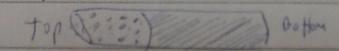
 | Core Length | Common | Abundant | Notes
 | 5 cm | Sand  Gravel  Pebbles  Shells | Mud  Living Vegetation | H2S smell
Commercial Traffic | 10:30 AM | Circle Line | Northbound | Loaded with people
 | 10:45 AM | Tugboat | Southbound | light
Other Items | Seagulls, yellow leaves from Autumn in the sample area.

