Day in the Life of the Hudson River 10/20/15
HARLEM RIVER MILE 10
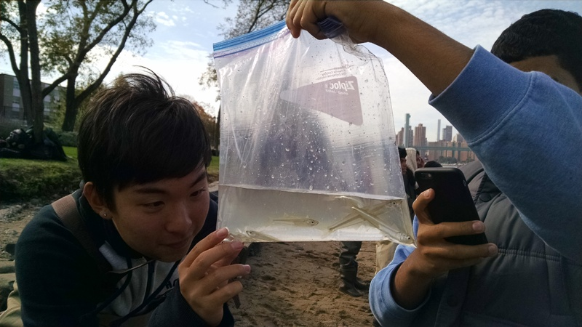
Ward’s Island on the Harlem River
Dinorah Hudson, High School for Math, Science and Engineering @ City College
60 -12th graders, 6 adults
40.79N and 73.92W
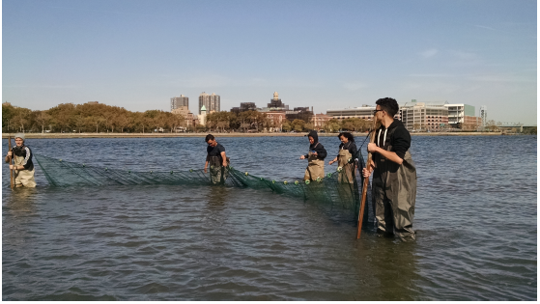
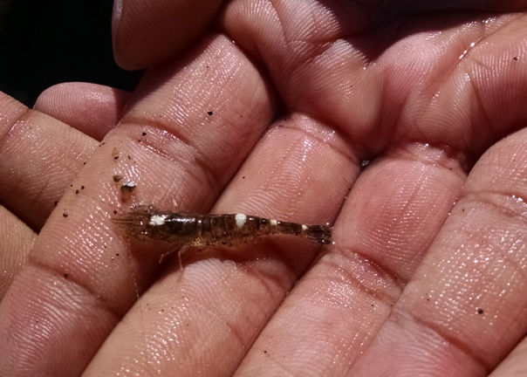 | 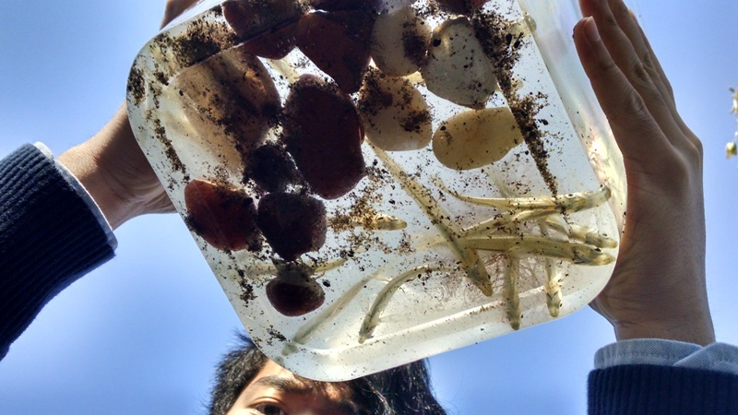

ITEM | Time | Reading 1 | Reading 2 | Comments
Weather | 11:00 AM | Clear day | Fall temperatures
Water Temperature | 11:05 AM | 17 Degrees C
Chemistry
Dissolved Oxygen | 11:05 AM | 7 ppm | 17 Degrees C | 70% saturated
pH (color match test strips) | 12:10 PM | 6
Salinity – hydrometer | 11:50 AM | 22 ppt
Phosphate test strips | 11:45 AM | 0%
Nitrate test Strips | 10:47 AM | 0%
Turbidity | 10:56 AM | 12.93 cm
Tides | 11:42 AM | Ebbing
Current | 11:55 AM | 16.7 ft.min | 509 cm/60 sec | 8.48 cm/sec
Fish Catch – | Number caught | Species | Length of largest
 | 41 | Atlantic Silverside
TOTAL CATCH 41 | DIV 1
Macroinvertebrate Catch | 1 | Crangon Shrimp
 | 4 | Jelly fish
 | 4 | Snails
TOTAL CATCH 9 | DIV 3
Sediment Core | Length | Properties | Common | Abundant
 | 8 inch | No H2S smell  No oil  No oxidized top | Mud  Gravel  Pebbles  Wood | Sand

