**Snapshot Day 10/20/15 Data**

**RM -2 , Valentino Pier**

**Barbara Taragab, Elissa Eisenberg, Taraneh, Josh, Cora, Nineka**

**Erika Kepski, Student Conservation Association**

**The Brooklyn New School PS 146 4th graders – 96 students, Adults 9-10**

**GPS Latitude N : 40°40’42. 10” - W-74°01’06.07**

|  |  |
| --- | --- |
|  |  |
|  |  |

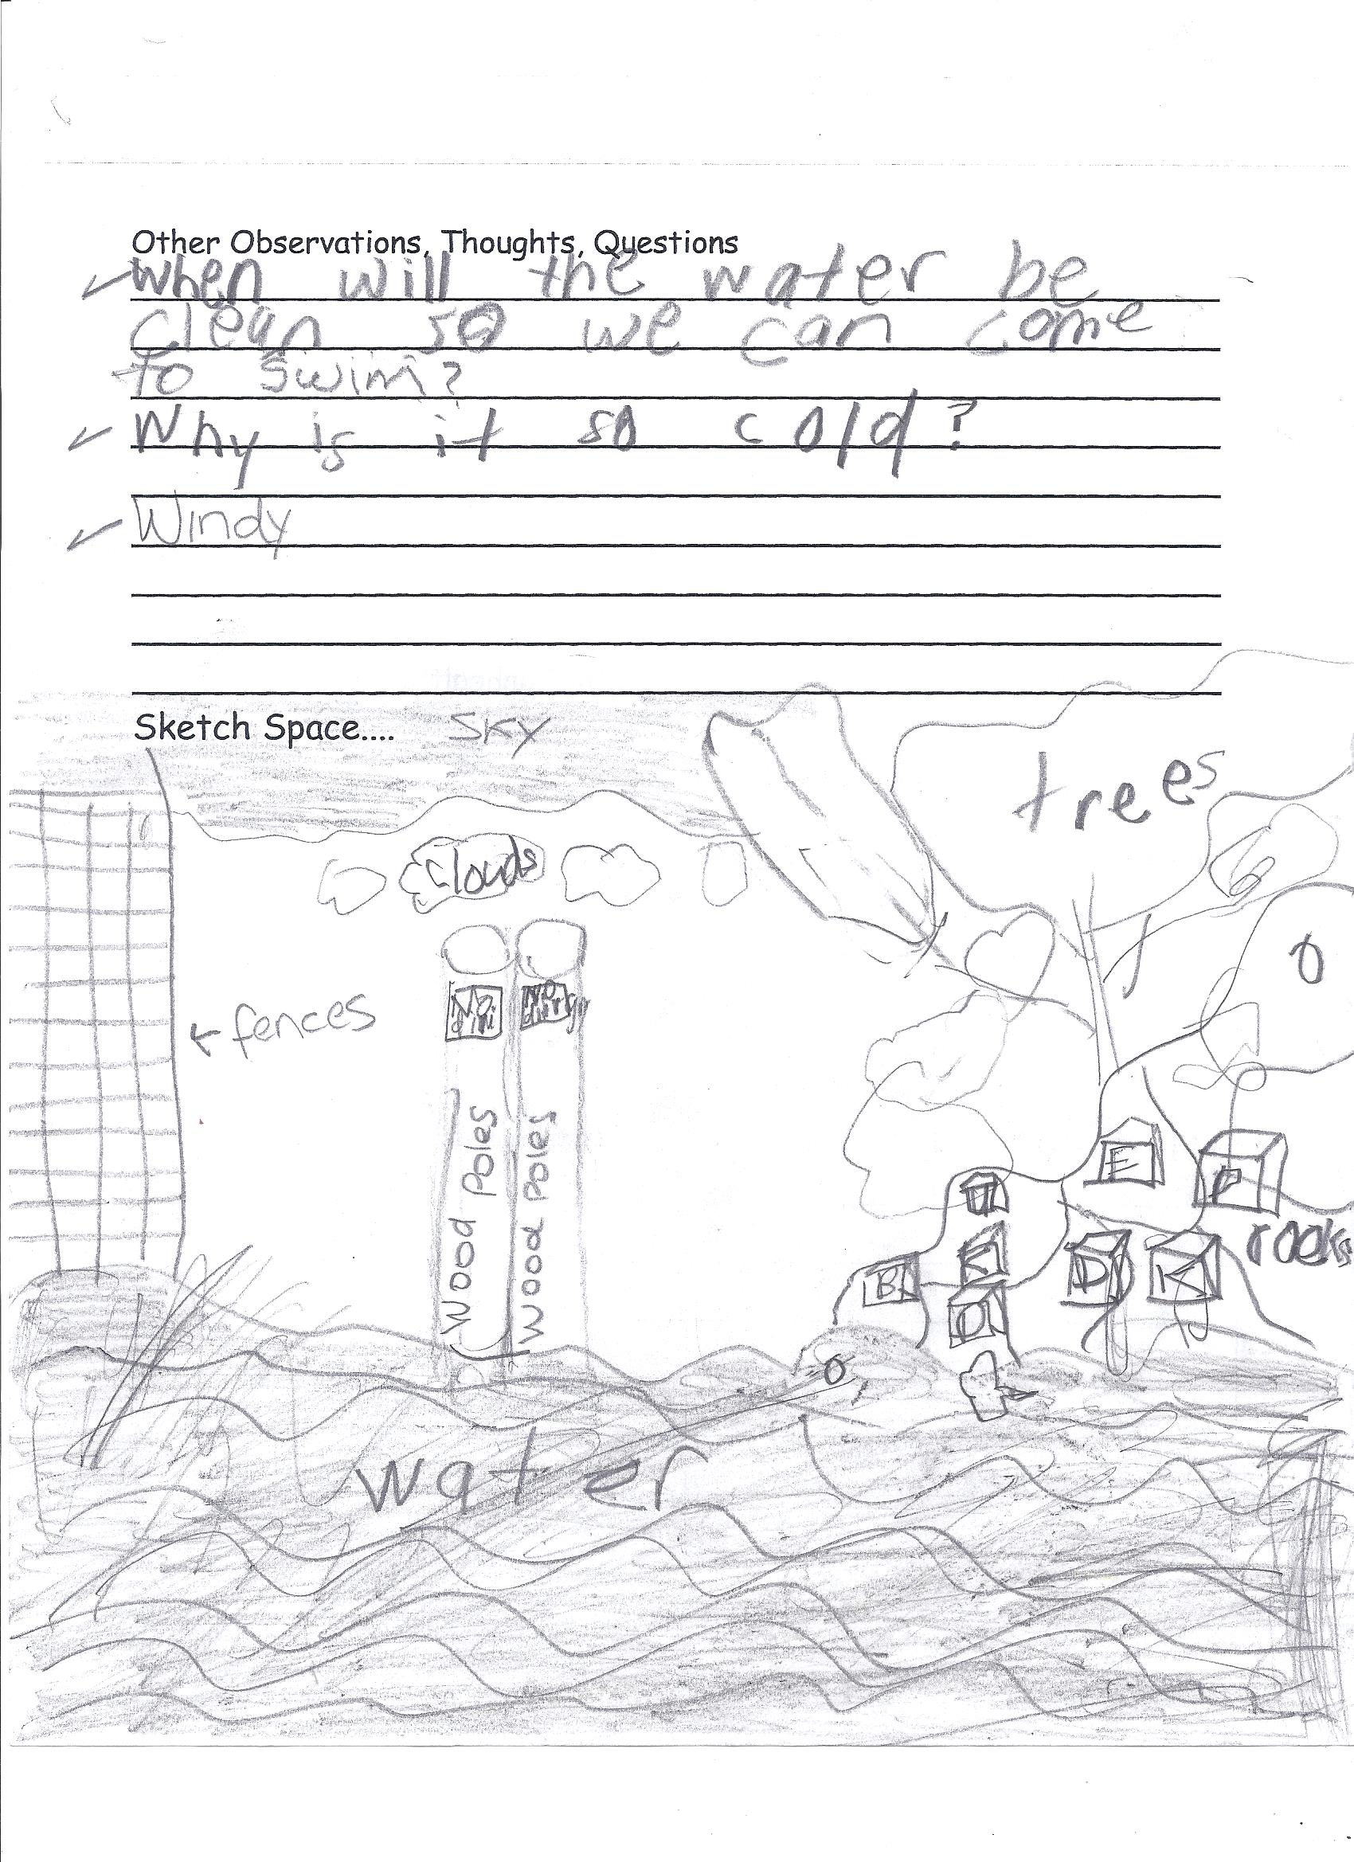**Location:** Valentino Pier, Redhook, Brooklyn, NY

**Area:** A large pile of rocks with a small rocky “beach”; area with large pier;

**Surrounding Land Use:** Beach – 5%; Urban/residential 5%; Industrial/Commercial 90%; - surrounding area landscaped with sea grasses. It is used as a dog walk although signs prohibit that use. Fishing was happening at end of the pier.

**Sampling Site:** beach

**Shoreline:** Pier, riprap

**River Bottom** : sandy and rocky near the little beach area

|  |  |  |  |  |  |  |
| --- | --- | --- | --- | --- | --- | --- |
| ***ITEM*** | ***Time*** | | ***Reading 1*** | ***Reading 2*** | | ***Comments*** |
| ***Physical*** |  | |  |  | |  |
| Air Temperature |  | |  |  | |  |
| Wind Speed |  | | Beaufort | #5 to 6 | |  |
| Cloud Cover | clear | |  |  | |  |
| Weather today | No rain | | | | | |
| Weather recently | Cool weather. | | | | | |
| ***Water Temperature*** | 9:30 AM | 15°C  14  15 | | |  | Average 14.66°C |
|  | 10:00 AM | 15°C  15  15 | | |  | 15°C |
|  | 10:30 AM | 15°C  15  15 | | |  | 15°C |
|  | 11:00 AM | 15°C  15  15 | | |  | 15°C |
|  | 12:00 PM | 15°C  15  15 | | |  | 15°C |
|  | 12:30 PM | 15°C  15  15 | | |  | 15°C |
| ***Water calm*** | yes |  | | |  |  |
| ***Turbidity – short sight tube*** | 9:30 – 1:30 PM | 40 JTU  40  40 | | |  | 40 JTUs |
| ***Chemical*** |  |  | | |  |  |
| DO  ampules | NR |  | | |  |  |
| *pH –indicator solution with LaMott testabs* | 9:30 to 1:00 PM | 7 | | |  | 7 |
| Salinity – refractometer | NR |  | | |  |  |
| ***Fish Catch***  14 ft..seine net, mesh size ¼ inch | ***Number Caught*** | ***Species*** | | | ***Length of largest*** | ***Catch Totals*** |
| 9:00 AM  **fish** | 20 | Atlantic Silversides | | | 9 cm | **Diversity 1**  **Total Catch 20** |
| **Macroinvert.** | 2 | Asian Shore Crab | | |  | **Diversity 1**  **Total Catch 2** |
| ***Tides*** | NR | | | | | |
| ***Currents*** | 9:30AM – 1:00 PM | South | | | We threw white daisies in water off of the south side of the Pier. | |
| ***Almanac Entry – some comments*** | **What are they doing to clean the river?**  **I know that the fish are being contaminated by the polluted water.**  **I think that the trash that people in NYC are throwing in the water is polluting it. Why is it so full of trash? There are garbage cans everywhere.”**  **When will the water be clean so we can come to swim?** | | | | | |