A Day in the Life of the Hudson River 10/20/15 Data
RIVER MILE 102
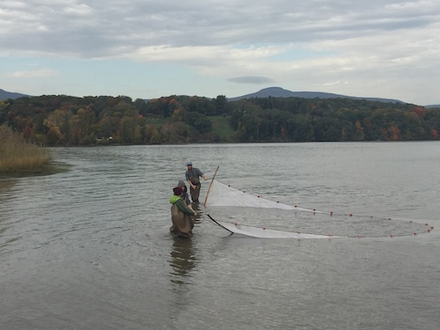
Saugerties Light House, Town of Saugerties, Ulster Co.
Marie Daniels, Jennifer Reid & Matthew, Woodstock Day School
Grades 5th & 7th, 20 students and 8 adults
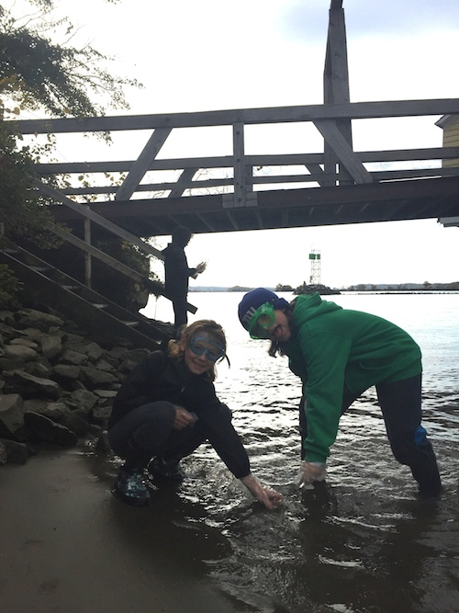
42.04°N, 73.92 °W

Location: Saugerties Light house @ northern bank of peninsula – pier with grassy area
Area: Pier of sorts, boating, fishing, swimming beach, picnics, hiking, walking
Surrounding Land Use: Forested 80%, Beach 20%
Sampling Site: beach, bulkhead altered banks years ago, covered with vegetation, collected wood/debris in area, shoreline riprap at lighthouse, shoreline is sandy, muddy, rocky
River Bottom: muddy, sandy, rocky
Plants in area: Percent reported varies from 50% to 90% water chestnut, and 50% to 10 % water celery

ITEM | Time |  | Reading 1 | Reading 2 | Comments
Physical
Air Temperature | 10:33 AM  11:37 AM  11:51 AM |  | 13°C  14°C  15°C | 55 F  57 F  60 F
Wind Speed | 11:00 AM  11:51 AM |  | Beaufort #3  Beaufort #2 |  | N  SW
Cloud Cover | 12:00 PM |  | Partly cloudy | 51-75% cloud
Weather today | No rain
Weather recently | Cool fall like
Water Temperature | 10:30 AM  11:50 AM  11:55 AM | 10 °C  15°C  15°C |  | 2 ft. water  3 ft. water  2 ft. water
Water Calm or Choppy | choppy
Turbidity  Long site tube | 10:35 AM | 25 cm  20  30 |  | Average 25 cm | Not clear but not turbid – on a scale of 1-10 it is about a 4!
 | 11:00 AM | 26 cm  32  35 |  | Average 31 cm
 | 11:28 AM | 26  34  25 |  | Average – 28.3 cm
 | 12:01 PM | 26 cm  27  29 |  | Average 27 cm
Chemical
DO  (ampules) | 10:30 AM  11:00 AM  12:00 PM | 6 mg/L  8 mg/L  8 mg/L
pH – color match kit | 11:30 AM  12:00 PM | 7.4  7.4
Salinity Quantabs
Fish – 50 ft. net | Time | Species |  | # caught | Length of largest
Seine #1 - Div 3  Totals 4 | 10:20 | Largemouth Bass |  | 1 | 15 cm
 |  | Banded Killi |  | 2 | 5 cm
 |  | Bluegill Sunfish |  | 1 | 2.5 cm
Seine #2 – Div 5  Totals 9 | 10:54 AM | Common Goldfish |  | 2 | 17 cm
 |  | Striped Bass |  | 4 | 17 cm
 |  | Pumpkinseed |  | 1 | 4 cm
 |  | Shad |  | 1 | 11 cm
 |  | Banded Killi |  | 1 | 10 cm
Seine #3 – Div 3  Totals 5 | 11:30 AM | Goldfish |  | 2 | 14 cm
 |  | Blueback Herring |  | 2 | 7cm
 |  | Tessellated Darter |  | 1 | 10 cm
Seine #4 – Div 7  Totals 28 | 11:46 AM | Pumpkinseed |  | 1 | 12 cm
 |  | Striped Bass |  | 5 | 18 cm
 |  | Shad |  | 8 | 8 cm
 |  | Bluegill sun. |  | 5
 |  | Tessellated Darter |  | 1
 |  | Banded Killifish |  | 7
 |  | Golden Shiner |  | 1 | 10 cm
 | GRAND TOTALS | DIVERSITY  - 9 |  | TOTAL CATCH -46
Tides | Time | Height |  | Falling/Rising
 | 10:36 AM  11:07 AM | 35cm  93 cm |  |  | HT was at 8:32 AM
Currents | Time | Cm/30 secs |  | Cm/sec | N/S - E/F/S
 | 11:45 AM  12:00 PM  12:09 PM | 30cm/30 sec  60 cm/30 sec  50cm/30 sec |  | 1cm/sec  2 cm/sec  6.6 cm/sec | North/flood  4.6 kts
Sediment Core -  Length | Observation | Rare |  | Common | Abundant
10:50 AM - | 8 inches – oxidized top |  |  |  | Mud on bottom
11:14 AM | 4 inches – 1 inch oxidized top | Gravel,  Living vegetation |  | Clay,  mud | sand
11:20 AM | 5 inches –oxidized top | Clay |  | Mud | Sand
11:54 AM | 3 inches –  H2S smell, 1inch oxidized top | Clay |  |  | Sand
Shipping  Commercial (C) | 10:00 AM  N/R  N/R  12:00 PM  12:00 PM | Red Barge  White  Barge Red/Bk  Black  Large Cargo |  | Northbound  Northbound  Southbound  Southbound  Southbound | Loaded  Light  Light  Light  Loaded
Recreational (R) | 10:00 AM  12:45 PM | White speedbt  Sailboat |  | Southbound  Southbound | Light  Light
Observations | Lots of devil’s heads from water chestnut, and bricks, lumps of coal, bits of shells, overgrown plants and seagulls, hummingbird, squirrels, hawks, dragonflies

