A Day in the Life of the Hudson River 10/4/13 Data
RIVER MILE 108
Lasher Memorial Park, Germantown, Columbia County
Tom Crowell, Columbia Land Conservancy
Jim McDarby, Hudson High School, 11/12th graders – 37 students, 8 adults
GPS Latitude 42°09.50’ N Longitude 73°53.21’W
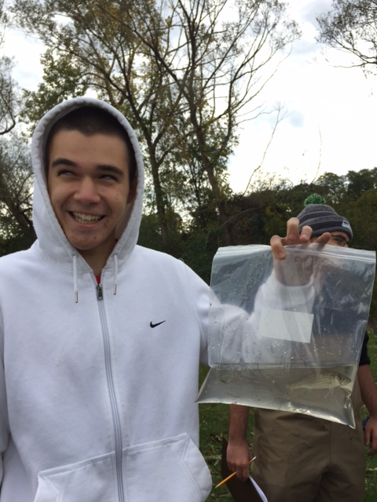 | 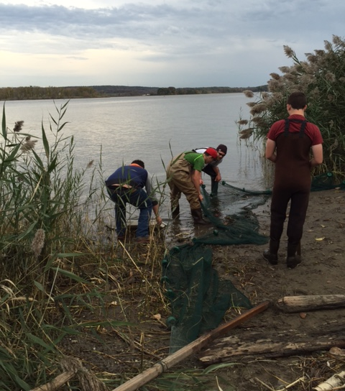
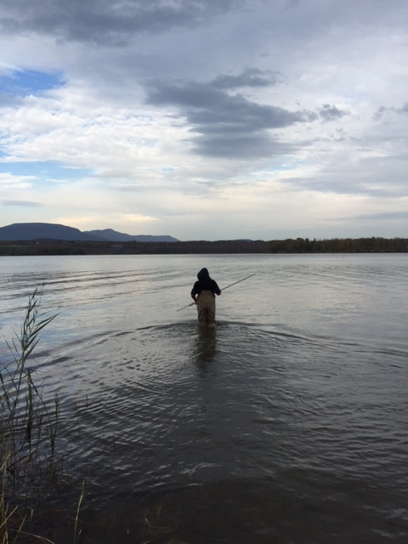
Location: Lasher Memorial Park, Boat Launch, North Germantown Landing
Area: Grassy area, used for picnics and boating, boat launch
Surrounding Land Use: Forested – 40%; Urban/residential 50%; Beach 5%, mowed park 5%
Sampling Site: Park with mowed lawn, rip rap in area
Water depth: 1 ft.
River Bottom : sandy
Water Plants: no plants in the water area
Plants in area: Phragmites

ITEM | Time | Reading 1 | Reading 2 | Comments
Physical
Air Temperature | 11:00 AM  1:00 PM | °F  °F | 13°C  15°C
Wind Speed | Beaufort #2 | S
Cloud Cover | 76-100% | Gradual clearing
Weather today | No rain, overcast with gradual clearing
Weather recently | 2 days ago very cold  yesterday snow
Water Temperature | 9:40 AM  12:02 PM | 11°C  12 | 51.8 °F  53.6 °F
Water calm | Calm
Turbidity – sight tube | Time not noted | 43 cm
Chemical
DO – drop count kit | 10:45 AM | 11°C | 16 ppm | Tested 6 times with this result
pH –indicator solution | 11:00 AM | 7.5  8 |  | Avg 7.75
Salinity – Quantabs | 10:40 AM | <1 on the bar | <28 ppm Chloride | <51 ppm total salinity
Fish Catch | Number Caught | Species | Length of largest | Macro Species
100 ft. seine net X 1/2 inch mesh | 111 | Blueback Herring | 9 cm | DIV 7
 | 6 | Darter | 8 cm | TOTAL 154
Fish- 6 seines total | 12 | Striped Bass | 13 cm
 | 3 | Banded Killi | 8 cm
 | 17 | Spottail Shiner | 13 cm
 | 4 | Pumpkinseed | 13 cm
 | 1 | Sunfish | 9 cm
Macro |  | Scud  Caddisfly  Zebra Mussels |  | DIV 3
Tides | 9:30 AM  11:30 AM  12:30 PM | 70 cm  50 cm  25 cm | Falling  Falling  Falling | 0.16 cm/min  0.42 cm/min
Currents | 11:30 AM | 11cm/sec | 0.21 kts | South/Ebb
Traffic | NR

