Day in the Life of the Hudson River 10/20/15 Data
RIVER MILE 11.5 – Fort Washington Park
Katie White, Marymount School of New York
51 students 7th grade, 7 adults
Latitude 40°50’46.42444” N - Longitude -73.°56’46.914”W
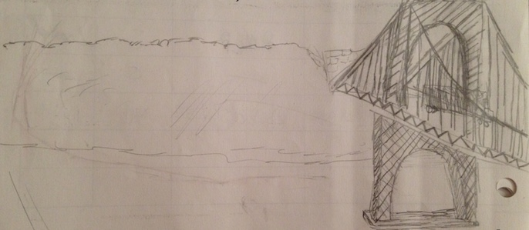

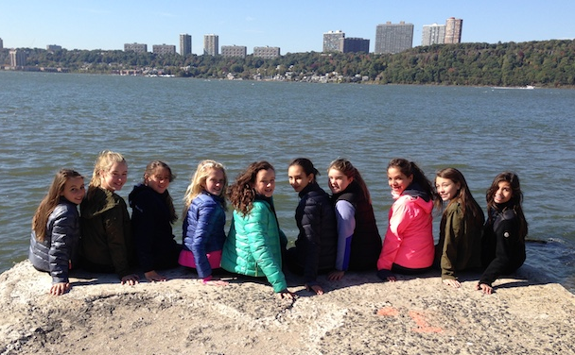 | 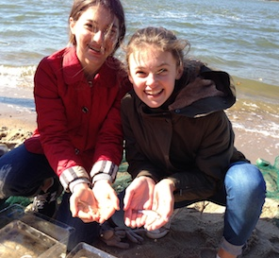
Location: Fort Washington Park just South of the George Washington Bridge
Area: Site is a sandy beach with rip rap adjacent to a paved jogging trail within a grassy park. Some trees on far side of jogging trail but none next to water. Very little aquatic vegetation.
Surrounding Land Use: : 14% forested, 85% grass park land, 1% beach,
Sampling Site: Park with a lot of trees, picnic tables, covered with vegetation, lots of riprap shore, collected wood debris. Large outflow pipe directly south of site
Plants in water: None
Water depth: mainly 0.5 meters or less but seined in 1.5 meter water
River Bottom –muddy but rocky closer to shore in some spots

ITEM | Time | Reading 1 | Reading 2 | Comments
Physical
Air Temperature | 9:58 AM  10:21 AM  10:50 AM  12:18 PM  12:48 PM | 13°C  14  15  20  17
Wind Speed –  Frequent gusts 15-20 throughout day | 10:02 AM  10:26 AM  10:55 AM  12:24 PM  12:52 PM | Beaufort 2  Beaufort 2  Beaufort 1  Beaufort3  Beaufort 3 | 5 pmh  5  3  6  8 | SSW  SSW  SSW  SSW  SSW
Cloud Cover | 10:06  10:26  10:55  12:24  12:52 | Partly cloudy Mostly  Mostly  Clear  Clear | 25-50 %  51-75  51-75  <25  <25
Weather today | No rain
Weather last 3 days | Cold (highs mid to low 50s) , Clear, No precip
Water | Before noon calm, after noon choppy
Water Temperature | 9:49 AM  10:23 AM  10:48 AM  12:18 PM  12:51 PM | 11°C  12°C  14°C  18°C  15°C
Turbidity - Long site tube | 10:00 AM  10:15 AM  11:00 AM  12:15 PM  12:45 PM | 49 cm  51 cm  52 cm  46 cm  55 cm |  | Averages per rotation
Chemical
DO  Hach Drop count | 10:10 AM  10:35 AM  11:03 AM  12:38 PM  1:13 PM | 11°C  12  14  18  15 | 10 ppm  10  10  10  10 | 90% saturation  110%  95%  15%  128%
pH  color match test kit | 9:58 AM  10:29 AM  10:56 PM  12:27 PM  12:59 PM | 7.0  7.2  7.3  7.2  7.2
Salinity |  | refractometer | hydrometer
 | 10:00 AM  10:15 AM  11:00 AM  12:15 PM  12:45 PM | 17 ppt  17  18  19  19 | 17 ppt  17  17  15  16
Fish Catch – 9 ft.  20 seines | Time | Fish Species | # caught | Length cm
Seine #1 | 9:50 AM | Atlantic Silversides | 1 | 8.0
#2 | 9:58 AM | Atlantic Silversides | 17 | 8.5
#3 | 10:06 AM | Atlantic Silversides | 1 | 8.5
#4 | 10:20 | Atlantic Silversides | 12 | 11.5
#5 | 10:30 | None | 0
#6 | 10:38 | Atlantic Silversides | 2 | 9.5
#7 | 10:40 | Atlantic Silversides | 7 | 10.5
#8 | 10:45 | Atlantic Silversides | 1 | 8.5
#9 | 10:55 | None | 0
#10 | 11:00 | Striped Bass | 2 | 10.5
#11 | 11:05 | None | 0
#12 | 12:15 PM | Atlantic Silversides | 1 | 10.0
#13 | 12:20 PM | Atlantic Silversides | 10 | 10.0
#14 | 12:22 | None | 0
#15 | 12:25 | Atlantic Silversides | 2 | 8.0
#16 | 12:47 | None | 0
#17 | 12:48 | None | 0
#18 | 12:49 | Atlantic Silversides | 8 | 8.5
#19 | 12:54 | None | 0
#20 | 1:00 PM | None | 0
TOTAL DIV - 2 | TOTAL CATCH 64
Macroinvert | Number | Macros | Number | Additional Info
Seine #1 | 9:50 AM | Mud Snail | 1
 |  | Ctenaphore | 2
#2 | 9:58 AM | Blue Crab | 1 | YOY Male
#2 |  | Shore Shrimp (Palaemonetes) | 1
#3 | 10:06 | Blue Crab | 1 | YOY Male
#3 |  | Ctenaphore | 1
#3 |  | Mud Snail | 1
#6 | 10:30 | Ctenaphore | 4
#7 | 10:38 | Ctenaphore | 4
#8 | 10:45 | Ctenaphore | 5
#9 | 10:55 | Ctenaphore | 5
#11 | 11:05 | Blue Crab | 1 | YOY Male
#11 |  | Mud Snail | 4
Macro – Div. 4 | Totals 31
Tides | 9:45AM | Rising | 77 cm | ---
 | 10:01 AM | Rising | 81 cm | 0.25 cm/min
 | 10:20 AM | Rising | 88 cm | 0.37
 | 10:39 AM | Rising | 99 cm | 0.58
 | 10:49 AM | Rising | 102 cm | 0.30
 | 11:07 AM | Rising | 106cm | 0.22
* meter stick got submerged so put in a new stick at a new location
 | 12:15 PM | Rising | 19 cm | ---
 | 12:31 PM | Rising | 30 cm | 0.69
Currents | CM/60 secs | Cm/Sec | North/South | Ebb/Flood/Still
9:58 AM  10:20 AM  11:00 AM  12:23 PM  12:55 PM | Were able to throw the orange into the main channel so this is main channel current! | 5.4 cm/sec  12.4 cm/sec  9.5 cm/sec  15.3 cm/sec  9.5 cm/sec |  | Flood  Flood  Flood  Flood  Flood
Shipping – Commercial | 10:03 AM | Barge | BMLP | S - Loaded
 | 12:55 PM | Tug/Barge | Doubleskin 301 | N - Light
Recreational | 9:59 AM |  | Unknown | N – N/A
 | 12:32 AM |  | UNKNOWN | S - NA

