Day in the Life of the Hudson River 10/20/15 Data
RIVER MILE 115
Cohotate Preserve, Athens, Greene Co.
Liz LoGuidice, Cornell Cooperative Extension of Greene County
Tony Loughran, Coxsackie Athens High School, Env. Sci. - 23 students, 12th
Sue Boyle, Cairo Durham HS – 27 students, 9th
(adults – 2 teachers, 4 chaperones, 2 instructors)
N 42.24410 – W 73.8362

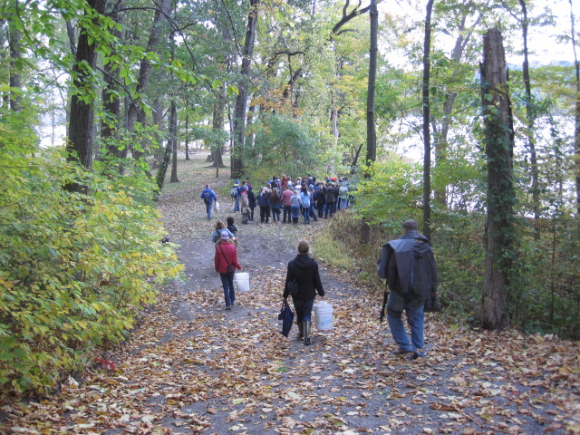 | 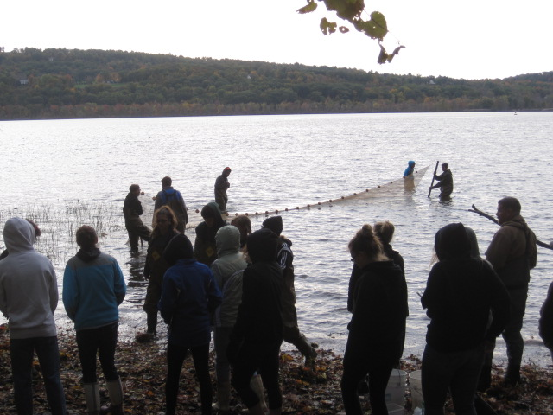

Location: Cohotate preserve – Ice house site –
Area: The ice house is a flat, grassy are on the river with several cotton wood trees. It is situated at the bottom of a forested hill. Large waterfront vegetated. The artificial shoreline of the bulkhead dominates the eastern shore. Shoreline is characterized by tidal mudflats. Area is used recreationally for picnicking, hiking and fishing. Ice house is approximately ½ miles walk from the parking area.
Surrounding Land Use: Forested 85%, Beach 10%; Urban/residential 5%
Sampling Site: Beach area, Shoreline includes tidal mud flats in the southeast, with a rocky shore further south. To the north of the tidal mud flat there is an old bulkhead, with another tidal flat to the north of the bulkhead, rip rap in sections.
The banks have been altered at the bulkhead (entire ice house area is likely dredge spoil), wood and debris are collected in the southern mudflat, there is lots of vegetation and no pipes entering the water. Brick pieces on shoreline
Water Depth: NR
River Bottom: Muddy, rocky, weedy
Plants in area: NR
ITEM | Time |  | Reading 1 | Reading 2 | Comments
Physical
Air Temperature | 9:50 AM  10:32 AM |  | 15°C  13 | 59°F  54
Wind Speed
Cloud Cover | Overcast
Weather today | Cool and cloudy
Weather recently | Cool
Water Temperature | 9:55 AM | 11.7°C  53°F
 | 10:35AM | 12°C  55°F
 | 11:15AM | 12°C  55°F
Water Surface | Choppy
Turbidity | 10:50AM  11:41AM | 86 cm  88 cm
Chemical
DO  Pasco Probe | 9:45 AM  10:30  11:15 | 8.9 ppm  9.7  9.67 |  | 12 °C  11.4  11.7 | 88%  89%  88%
pH – Pasco Probe | 11:15AM | 7.4  7.3  7.3 |  | Average 7.33
Conductivity – Pasco probe | 9:45 AM  10:45AM  11:15AM | 269.1 μs/cm  321  215 |  |  | Average 301.7 μs/cm
Nitrates | 10:00AM  11:00AM | 1.0 NO3 mg/l  0.4-0.6 NO3
Phosphates | 10:00AM  11:00AM | 0-0.1 mg/l  0-0.1
Fish Catch  40 ft. X 30 ft. | Total # | Species – |  | Size | Totals
FISH – 9:45  6 seines | 43  60  15 | Spottail Shiner  Banded Killifish  Blueback Herr. |  | 10 cm  NR  8cm | Seine #1
Diversity = 10 | 18 | Spottail Shiner |  | 8 cm | Seine #2
Total Catch = 266 | 1  2  1  1  6 | White Perch  Spottail Shiner  Banded Killifish  Darter  Bluegill Sunfish |  | NR  NR  NR  NR  13cm | Seine #3
 | 9  1  2  43  11  2  1  1 | Banded Killifish  Alewife  White perch  Spottail Shiner  Darter  Blueback Herrin.  Bluegill Sunfish  Black Crappie |  |  | Seine #4
 | 2  1 | Golden Shiner  Pumpkin Seed |  |  | Seine #5
 | 10  17  17  1  1 | Darter  Banded Killifish  Bluegill Sunfish  Spottail Shiner  Wihte Perch |  |  | Seine #6
Tide | 9:44 AM  10:43AM  11:35AM | Falling/Ebb  Ebb/Sluggish  Flood
Boating - Commercial | 10:07AM  10:10AM | Red Flag  Bouchard |  | Petroleum  B#264 | Light  Southbound

