Day in the Life of the Hudson River 10/20/15 Data
RIVER MILE 118
Shelley Forester, Cary Institute of Ecosystem Studies
Ms. Jeffrey, Ms. Kneller, Mrs. Fischer, Mr. Pearson, Mr. Kullman, Mr. V., Chatham & Taconic High School, Chatham NY
39 students 10t^{h} -12th grade, 9 adults
Latitude – N 42°15’ Latitude – W -73°48’
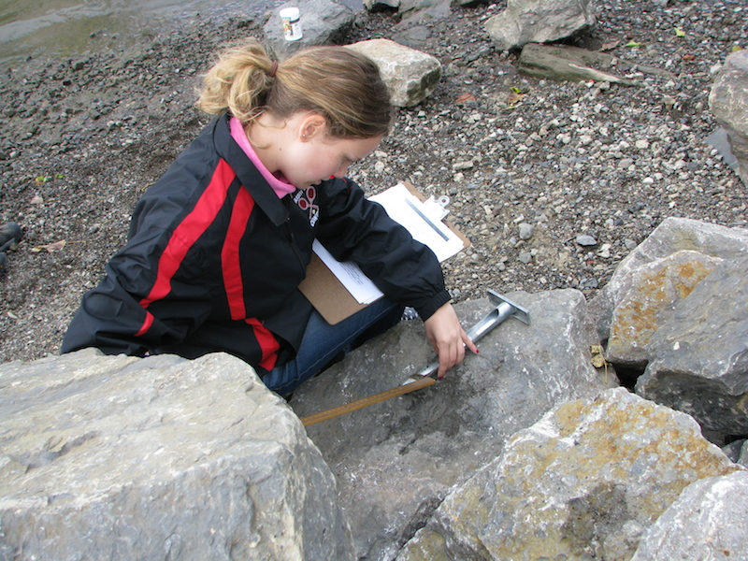

Location: Hudson River Waterfront Park, City of Hudson, Columbia County
Area: 1st dock in the waterfront property used for fishing, marina, picnics, large grassy area, just north of the old quarry site, has a parking lot
Surrounding Land Use: 75% urban/residential, 10 % forested, 15% Industrial/Commercial
Sampling Site: waterfront with banks altered to include wooden & concrete bulkheads and large riprap on shoreline,
Plants in area: Moss covering approximately 20% of shoreline
Water - Calm
River Bottom – muddy, rocky

 | Time | Reading 1 | Reading 2 | Comments
Physical
Air Temperature | 9:30 AM.  10:00 AM  10:35 AM  12:23 PM  12:54 PM | 9°C  8.8  8  13  13 | 49°F  48  47  56  56
Cloud Cover | 9:30-1:00 PM  >75%
Wind – wind picked up during day | Time  9:30 AM.  9:57AM  10:35 AM  12:23 PM  1:00 PM | Beaufort  1  1  1  1  1 | MPH  2  0.6  2.5  1.3  2.1 | Direction
Weather today | No Rain
Weather recently | Cool Temperatures, below 50°F and snow within last 3 days
Water | calm
Water Temperature –  In 3 meters depth of H2O | 9:13 AM  9:27AM  10:01 AM  10:41 AM  12:20 PM  12:49 PM | 13.2°C  14.0  13.1  13.3  13.5  14.5 | 55.76°F  57.20  55.58  55.94  56.3  58.1
Turbidity – | NR | 92.5 cm |  | Secchi
 | NR | 40 JTU |  | Short site tube
Chemical | Time | Temp C | DO ppm | % sat.
DO - | 10:10 AM  10:41 AM  12:03 PM  12:39 PM  12:50 PM | 13.1  13.3  13.4  14.5  14.7 | 10.1  9.6  11.4  11.4  13.0 | 95%  91  135  110  130
pH – Color Match | 9:15 AM  10:00 AM  10:26 AM  12:17 PM  12:43 PM | 7  7  7  7  7
Salinity Quantabs | Time  10:46 AM  12:00 PM | %  0.006  0.006 | Chloride ppm  38  32 | Total Salinity ppm  69 ppm  69 ppm
Fish Catch  Seine net 20 feet X 4 ft., 1.4 inch mesh | Time | Species | number | Size of largest
Diversity 2  Total Catch7 | 9:25 AM | Largemouth Bass  Shiner | 1  6 | 15 cm bass
Diversity 5  Total Catch 30 | 9:55 AM | Largemouth Bass  Shiner  Striped Bass  Yellow Perch  Bluegill Sunfish | 1  26  1  1  1 | 13 cm bass
Diversity 3  Total Catch 10 | 10:52 AM | Largemouth Bass  Shiner  Banded Killifish | 1  4  5 | 19 cm shiner
Diversity 5  Total Catch 33 | 12:11 PM | Largemouth Bass  Shiner  Blue Gill  Banded Killifish  Unknown | 1  17  1  11  3 | 11 cm unknown
Diversity 4  Total Catch 38 | 12:45 PM | Largemouth Bass Banded Killifish  Spottail Shiner  Darter | 2  18  17  1 | 10 cm shiner
 | For the Day | Total Diversity 8 | Total Catch 118
Tides | 9:15 AM  9:59 AM  10:36 AM  12:10 PM  12:50 PM | 47 cm  40 cm  25 cm  0 cm  0 cm | Set  Falling  Falling  Still  Still | Water Height
Currents | Time | Cm/sec | E/F/S | Direction
 | 9:30 AM. | 17 | Ebb | (NW)
 | 10:03 AM | 6.67 | Ebb | (NW)
 | 10:35 AM | 13.3 | Flood | (SE)
 | 12:23 PM | 6.7 | Flood | (SE)
 | 12:54 PM | 6 | Flood | (SE)
Core Sample | Length/ | Grain size | Plant Material
 | 10 cm  5.5 cm  5.1 cm  8 cm  3.8 cm | Sand/muds/clay  Sand/muds/clay  Sand/muds/clay  Muds & Clay  Muds & Clay | No  No  No  No  NO
10:45 AM | No length - Oxidized top | Clay, Mud |  | coal
12:10 PM | 2 inches | Mud | Gravel, Pebbles | Brick, Living Vegetation
12:16 PM | None listed | Clay |  | Mud, gravel, pebbles
12:40 PM | None listed | Clay | Mud | pebbles
Traffic - commercial | Time | Name | Color | Direction/Loaded or Light
 | 10:15 AM | Bouchard | Black & Red | Southbound, loaded
 | 11:01 AM | Red Dog | Red & White | Southbound Light
 | 11:05 AM | Unknown | WHite | Southbound Light
Other Items | Water chestnut seeds | Large rocks | Crab parts – legs and claws | Seagulls and ducks

