Day in the Life of the Hudson River 10/20/15 Data
RIVER MILE 120
Four Mile Point Preserve, Coxsackie, Greene County
Jean Cardany & Jen Rausch, Coxsackie Elementary School
39 students 9th -2nd graders, 18 adults helpers
GPS Latitude 42°19’ 1.3116 secs N Longitude 73°47’ 8.0484 secs W

Rocky shoreline
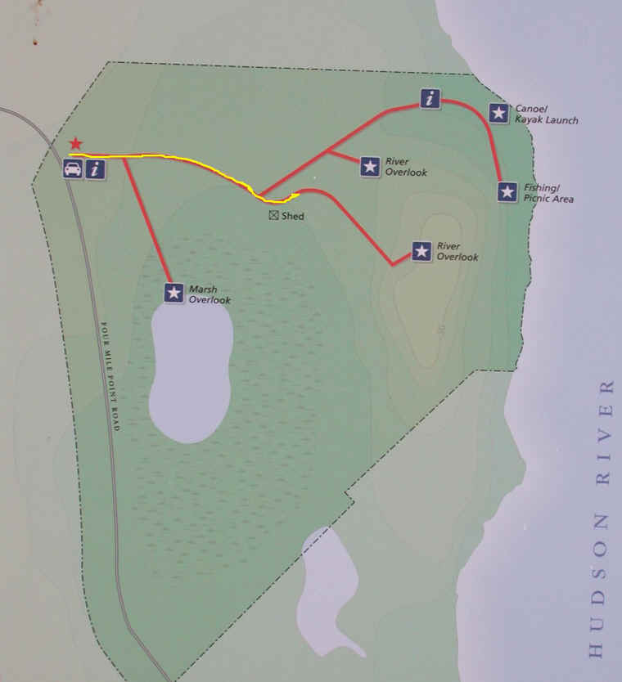
Location: Four Mile Point Preserve, Coxsackie, Greene County, NY
Area: Forested park space with grassy area, used for hiking, picnics
Surrounding Land Use: 100% small rural park preserve
Sampling Site: Shore is rocky, lots of vegetation (forested)
River Bottom : pebbles and rocks
Plants in water: none
Water Surface: calm
Note: Sampling area is a protected cove back from the main stem of the river
Observations: few water chestnut seeds, bricks, shale like rocks covered the area

ITEM | Time |  | Reading 1 | Reading 2 |  | Comments
Physical
Air Temperature | 10:25AM  10:43 AM  11:58 AM |  | 10°C  15°C  16 | 50 °F  59°F  62 F
Wind Speed | no wind |  | Beaufort 0- |  |  | S
Cloud Cover | 51-76%
Weather today | No rain
Weather recently | Very cold; below 30degrees night of 10/18 and morning of 10/19
Water Temperature | 10:13 AM  10:44 AM  11:20 AM | 10°C  10°C  16°C |  |  | 50°F  50°F  56°F
Turbidity long  Site tube | 10:04 AM  10:40 AM  11:20 AM | 31 cm  32 cm  33.6 cm |  |  |  | 32.2 cm Avg
Chemical
DO  Salifert kit | Time | Temp °C |  |  | DO | % saturated
 | 10:13AM  10:44 AM  11:20 AM | 10°C  16°C  16°C |  |  | 12 ppm  8  8 | 105%  80%  80%
pH – Litmus Paper | NR |  |  |  |  | Average 6
Salinity - Quantab | 10:13 AM  10:44 AM  11:20 AM  11:50 AM | 44 ppm Cl-  38 ppm Cl-  44 ppm Cl-  38 ppm Cl- |  |  | 79 total salinity  69 total salinity  79 total salinity  69 total salinity | average 74 ppm total salinity
Fish Catch  35’seine X 4 ft. | Number Caught- | Species - |  |  | Largest Size | Diversity & Totals
9:44AM-11:58 AM  10 pulls | Nothing caught
Tides | 9:56 AM | 34 cm |  |  | start
 | 10:24 AM | 23 cm |  |  | falling
 | 10:40 AM | 18 cm |  |  | Falling
 | 10:58 AM | 12 cm |  |  | Falling
 | 11:15 AM | 6 cm |  |  | Falling
 | 11:43 AM | Out of water |  |  | falling
Currents – data collected in a protected cove | Time | Cm/30 secs |  |  | Cm/sec | Knots – Ebb Flood
 | 10:04 AM | 429 cm/30 sec |  |  | 14.3 cm/sec
 | 11:34 AM | 315 cm/30 secs |  |  | 10.5 cm/sec
Sediment Core | Length | Description |  |  | Top | Bottom
11:17 AM | 8 cm core - | H2S smell  Oil  Oxidized top |  |  | Gravel & Loose | Gravel,  mud,  softer
 |  |  |  |  | Mud  Sand  Gravel  pebbles | Mud  Sand  gravel
Shipping  Commercial | 9:46 AM | Bouchard – red & black |  |  | southbound | Light - empty
 | 9:48 AM | Sedrata |  |  | Northbound | Loaded
 | 10:43 AM | Barge |  |  | southbound | Loaded with piece of TZ bridge on it
Recreational | 9:46 AM  10:15 AM | Yacht -Sailboat |  |  | Southbound  Southbound

