Day in the Life of the Hudson River 10/20/15 Data
RIVER MILE 144
Rensselaer Boat Launch, Forbes Rd., Rensselaer, NY
Leah Penniman, Tech Valley High School - 9th grade
Environmental Science & Geography – 32 students, 2 Adults
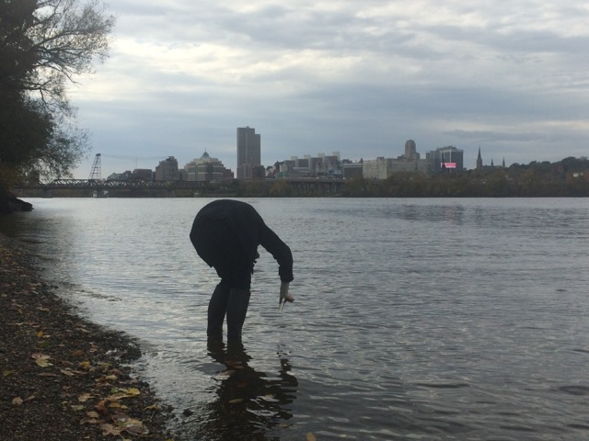 | 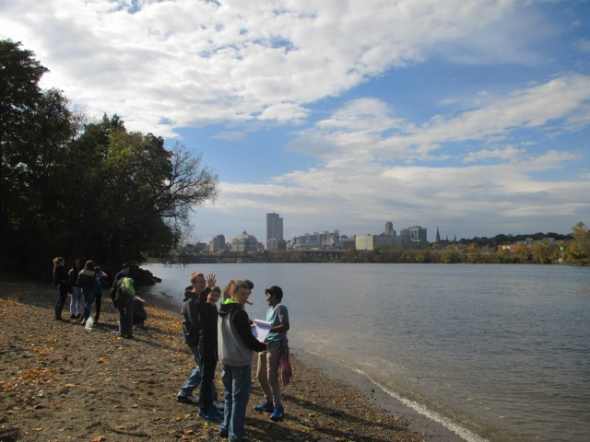

Location: Rensselaer Boat Launch
Area: Boat launch – beach area
Surrounding Land Use: Boat launch with small beach, wooded, landscaped, adjacent to urban residential area
Sampling Site: boat launch with surrounding beach area
Plants in area:
Water depth: unknown
River Bottom :
Times: All sampling 12:30-2:15 PM
ITEM | Time |  | Average Readings - |  | Comments
Physical
Air Temperature | 12:30 PM-2:15 PM |  | 13°C
Wind Speed
Cloud Cover | Cloudy
Weather today | Foggy and wet
Weather recently | Some rain and humid
Water | calm
Water Temperature – student built thermometers |  | 12.25°C
Turbidity (Small site tube LaMotte) |  | 30 JTU
Chemical
DO (chemets color comparator) |  | 8.6 ppm |  | 97.3% saturation
pH – meter (Flinn) |  | 6.91
Phosphate -  Chemets |  | 0.7 mg/L
Nitrate –  Chemets |  | 0.9 ppm
Alkalinity |  | 47.6 ppm
Salinity* Lamotte kit? |  | Results not realistic
Electrical Conductivity |  | 272.75 uS |  | microseimens
Coliform  Petrifilm plate 1 ml water  • stated range is based on colonies per 100 ml sample |  | 7587.5 average
Shipping Traffic | 1 | BOAT

