Day in the Life of the Hudson River 10/20/15 Data
RIVER MILE 152.2
Hudson Shores Park, Watervleit, NY
Amy Parks/Stacey Shepard, North Colonie CSD
20 students, 5th grade students and 4 adults
Latitude 73* 41’ 55” W Longitude 42* 43’ 41” N
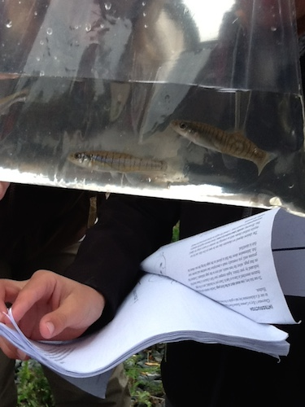  Banded Killifish Identification | 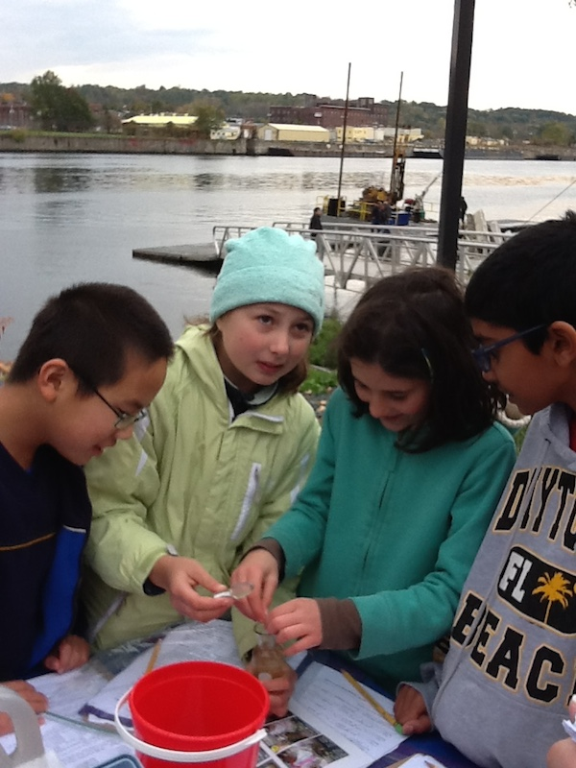  Dissolved Oxygen Sampling
Location: Hudson Shores Park, Watervleit, Albany County, NY
Area: Rowing dock at park right on the river’s edge
Surrounding Land Use: Fishing launch, Rocky with weedy vegetation and a few small shrubs (gravelly)
Sampling Site: 10% beach at low tide, 70% park/parking area, 20% planted/forested, - across the river land use100% Industrial/Commercial
Shoreline: rocky and muddy
Plants in area: none in the water
Water depth: sharp drop off 8-10 feet out, rocky bottom
Water: Calm
River Bottom: mixture of sand/mud, small rocks
Note: A sinking boat had to be rescued with some large cranes in the afternoon blocking access to the sampling area!

ITEM | Time |  | Reading 1 | Reading 2 | Comments
Physical - Air Temperature | Time |  | °F | °C | Average
 | 10:09 AM |  | 52 | 11
 | 10:40 AM |  | 53 | 12
 | 12:31 PM |  | 58 | 14
Wind Speed: | Time |  | Beaufort | Anemometer | Direction
Cloud Cover | Clear (<25%) |  | Partly Cloudy (26-50%) | Mostly Cloudy (51-75%) | Overcast (>75%)
Morning |  |  |  |  | ✓
Afternoon |  |  | ✓
Precipitation | Time |  | Rain | Describe
 | Morning |  | ✓
Weather last 3 days | Last three day windy and cool.
Water Temperature | Time |  | ºC | ºF | Average
 | 10:34 am |  | 15 | 60
 | 12;04 PM |  | 14 | 57
 | 12:22 PM |  | 14 | 57
Turbidity – long site tube | Reading 1 |  | Reading 2 | Reading 3 | Average
10:02AM | 108.5 cm
11:58 am | 111.5 cm
12:20 pm | 112.5 cm
Chemical | Time |  | mg/L | Water Temp | % Saturation
DO (Hach Drop count) | 10:34 am |  | 17* | 15 | 160%
* must be an error – too high | 12;04 PM |  | 16* | 14 | 152%
 | 12:22 PM |  | 19* | 14 | 170%
pH – color match test kit | 10:15 AM |  | 7.0 | 7.5
 | 12:01 PM |  | 7.5 | 7.4
 | 12:20 PM |  | 7.4 | 6.9
Salinity - quantab | 10:49 AM  12:04 PM  12:30 PM |  | 28 ppm  28 ppm  28 ppm | Chl | 51 TS  51  51
Fish Catch - | ID |  | Total | Length
1 Seine | Spot-Tail Shiner  Banded killifish |  | 2  2 | 2 inch  2.5 inch
2 Seine | Spot-Tail Shiner |  | 1
TOTALS | Abundance 5 |  | Diversity 2
In addition to seining the fisheries team brought some fish to ID – These included:
3 Striped Bass
2 Catfish
Yellow Perch
Walleye
Smallmouth Bass
Orange Sucker
Tides -  *calculate by: change in elevation/change in time | Time |  | Water height |  | *Rate of change
 | 8:15 AM |  | 155 cm
 | 9:50 AM |  | 180 cm | falling
 | 10:40 am |  | 170 cm
 | 11:53 am |  | 287.02 cm | Rising**
 | In the afternoon at 12:20 PM in a different location students measured the water’s edge and noted it had gone down 420 cm from the high tide line.
Currents - | cm/30 sec | Cm/sec | Knots | Flood/Edd
9:50 AM | 88 | 2.9 | .06 kts | Flood
12:35 PM | 78 | 2.7 | .05 | Ebb

