Day in the Life of the Hudson River 10/20/15 Data
(Above the Troy Dam and the Head of Tide)
RIVER MILE 154
Peebles Island State Park, Waterford, NY
Becky Zimmerman, Angela Jones and Raquel Santiago-Parker
Pine Hills Elementary School
50 students – 4th grade, 10 adults total
42°47.051’N and 73°40.706 W
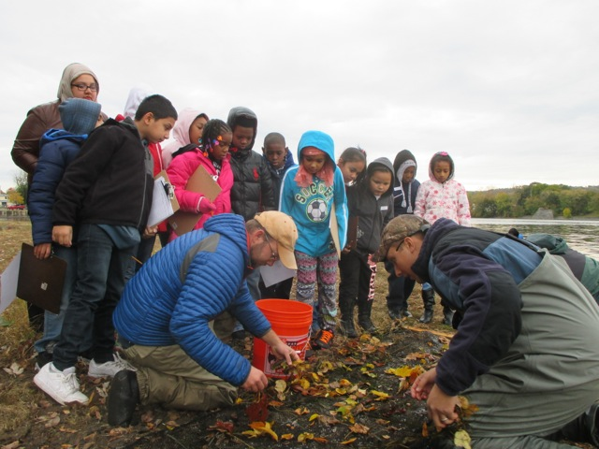
Peebles Sampling Area
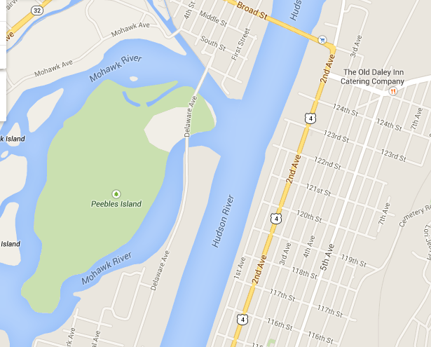
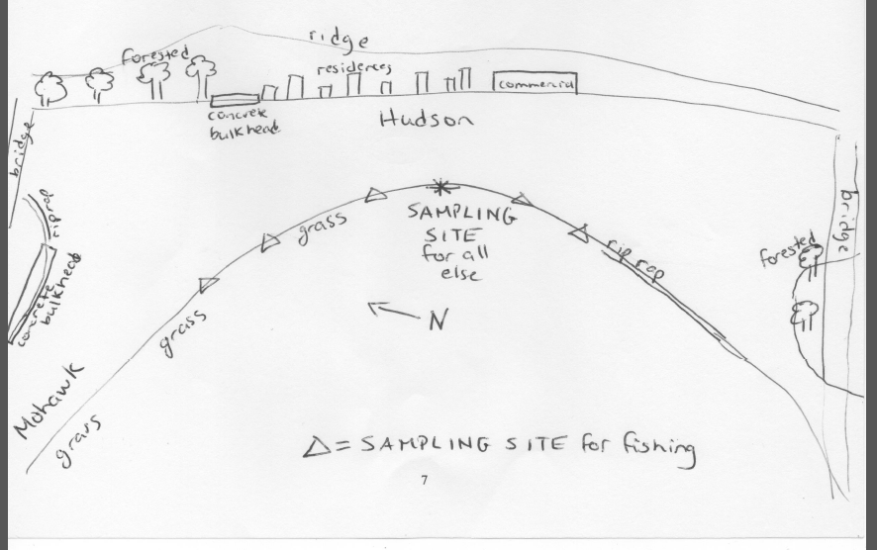

Location: Pavilion at Pebbles Island Park at the confluence of the Hudson River and the Mohawk River, Waterford, NY
Area: park just north of the Troy dam at the pavilion, grassy embankment, rip rap
Surrounding Land Use: 75% grassy, 25% riprap
Sampling Site: Park area
Shoreline: riprap
Plants in area: none
Water depth: 12 - 36 inches
River Bottom description: muddy
 | Time |  | Reading 1 | Reading 2 | Comments
Physical
Air Temperature | 9:40AM  10:40 AM  12:00 PM  12:45 PM |  | 50°F  50°F  55°F  63°F | 10°C  10°C  12.8°C  17°C
Wind Speed | 10:00 AM |  | Beaufort #4 | Anenometer kts. | Direction: SE
Cloud Cover | Mostly cloudy to start then clear
Weather today | Drizzle at 9:40 and 10:40 AM but then stopped
Weather recently | Cool and fall like
Water surface | Calm
Water Temperature | 9:35 AM  10:13 AM  12:07 PM  12:45 PM | 11°C  11  11  11 |  | 52°F  52  52  52
Turbidity –  long site tube  averages & standard deviation | 9:30 AM  10:15 AM  11:45 AM  12:30 PM | 39.8 cm  93.8 cm  48.5 cm  17.2 cm |  | ±12  ±14  ±5  ±2 | Each group had a new sample, not all from same place
Chemical | Time | Water Temp |  | ppm | saturation
DO - drop count | Unable to test
pH – indicator solution | 12:40 PM | 7.0  7.2  7.2 |  |  | Average 7.1
Fish Catch – 10 ft. net | Number | Species |  | Size largest
10ft - 1 cm mesh- 10m pull | 39 | Banded killifish |  | seined
~ 4 seines | 20 | Spottail shiner |  | seined
9:40 AM – 1:00 PM | 5 | Darter |  | seined
 | 4 | Sunfish |  | seined
 | Totals 68 | Diversity 4
Trapped by Fisheries group in a trap set the night before | 1 | Gizzard Shad |  | larger
 | 1 | Striped Bass |  | larger
Macroinvertebrates |  | Freshwater scud
 |  | Green Caddisfly
Water Level | Time | Height |  | Change | Change Rate
This is above the head of tide. Water level changes have to do with releases that occur from hydro plant that empties into the river below Cohoes Falls. | 9:40 AM | 22.9 cm
 | 10:40 AM | 27.9 cm |  | 5 cm/60 mins | 0.083 cm/min
 | 12:00 PM | 29.2 cm |  | 1.3 cm/60 min | 0.013 cm/min
 | 12:45 PM | 25.4 cm |  | -3.8 cm/60 min | -0.084 cm/min
Water Flow Velocity | Time | Rate of flow |  | Direction
This is not a tidal current just flow. At the confluence of two waterways the water direction can change. | 9:40 AM | 8.1 cm/sec |  | North
 | 10:40 AM | No movement |  | Still
 | 12:00 PM | 2.1 cm/sec |  | South
 | 12:45 PM | 2.4 cm/sec |  | South
Boat Traffic | 9:40 AM |  |  | North | recreational
 | 10:40 AM |  |  | South | recreational
Other | 1 bald eagle | Seagulls

