A Day in the Life of the Hudson River 10/20/15 Data
RIVER MILE East River 1 East – Dumbo Under Manhattan Bridge
Janet Villas, Brooklyn Friends School, 17 eight graders, and 3 adults
Isa Del Bello and staff from the Brooklyn Bridge Conservancy
Latitude 40.704546 – Longitude 73.988771
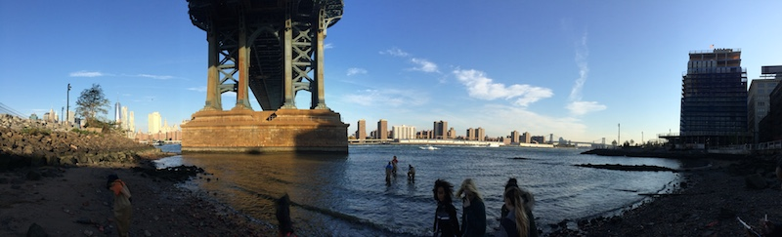
Location: East River, south of the Manhattan Bridge @ the new Brooklyn Bridge Park, Dumbo Section
Area: Urban residential, Park
Surrounding Land Use: pier, grassy
Sampling Site: Sandy beach and riprap, rocky
Plants in area: no plants noted in water
Water depth:
River Bottom: Sandy

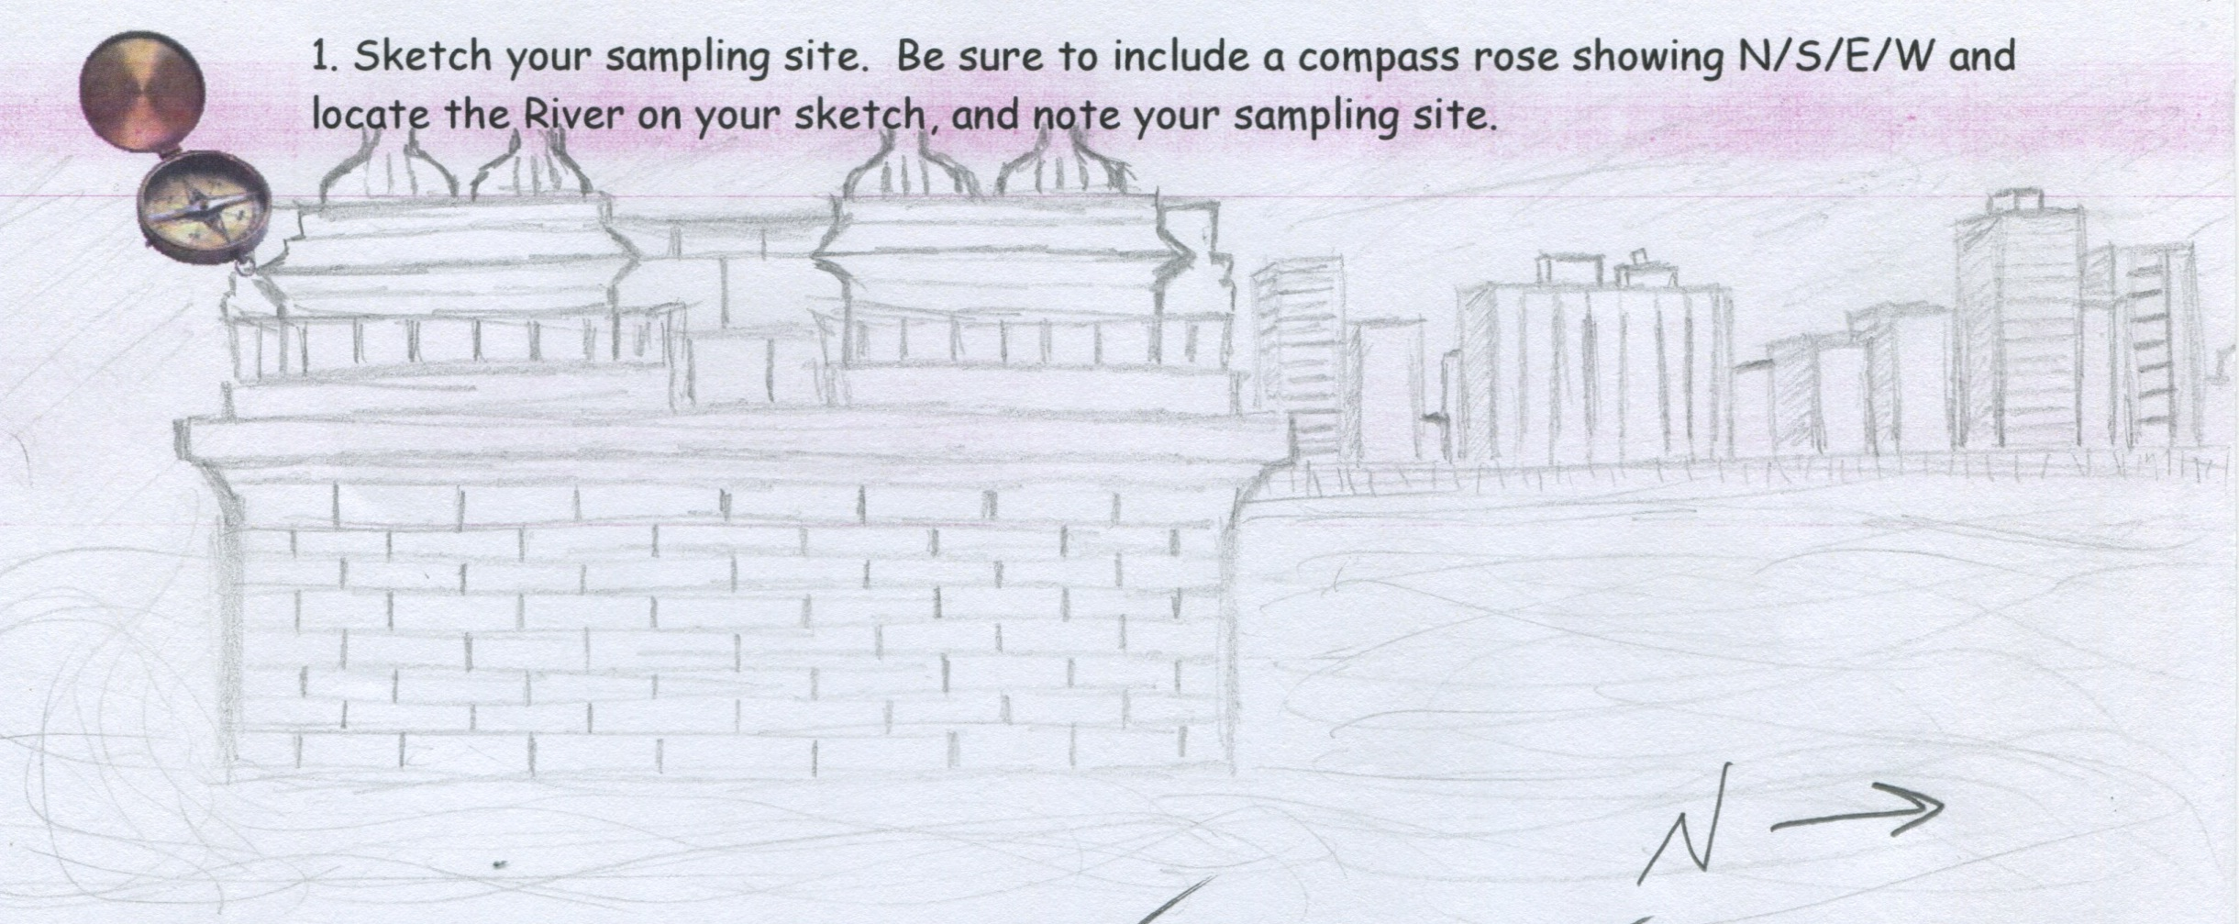

ITEM | TIME | 10/16/14 Data | TIME | 10/20/14 Data
Physical
Air Temperature | 8:45 AM | 13.2 °C  56 °F
Wind Speed
Cloud Cover | Partly Cloudy 26-50%
Weather today | No rain |  | AM | Cool but sunny
Weather last 3 days | Unseasonably cool
Water Surface | Choppy
Water Temp. | 8:45 AM | 15.1°C | It is a bit cloudy & you can’t see through very well. Looks more clear in the river
Turbidity – tube | AM | 28cm
Coliform Bact. |  | Positive |  | Positive
Chemical
DO -vernier | 8:45 AM | 14.2 ppm
pH - meter | 8:45 AM | 7.01 |  | 8
Salinity – vernier meter | 8:45 AM | 17.3 ppt
Solids – | Imhoff Cone | 20 ml | 1
Tides | 4:15 PM | Lowtide |  | Incoming tide
Fish – seine – 10 ft. net | 6 comb jellies
Commercial Ships - Time | Name | Color | N/S | Loaded/Light
8:50 AM | East River Ferry | White & Blue | N | Loaded
8:55 AM | East River Ferry | White & Blue | S | Loaded
9:01 AM |  | White | S | Light
Recreational Ships | Name | Color | N/S | Loaded/Light
8:56 AM | Seastreak | White | S | Light
Sediment Core from Dumbo | Length | Rare | Abundant | Other Comments
 | 16 cm | Clay | Sand | No H2S smell
 |  | Mud |  | No oil
 |  | Gravel |  | No oxidized top
 |  | Pebbles
 |  | Brick
Other items | Waterfront has bricks, sand and groomed park.

