Day in the Life of the Hudson River 10/20/15 Data
RIVER MILE 25W
Piermont Pier
Margie Turrin & 9 Lamonters, Lamont-Doherty Earth Observatory
Latitude N 41 degrees 02’591 Longitude W 73 degrees 53’794
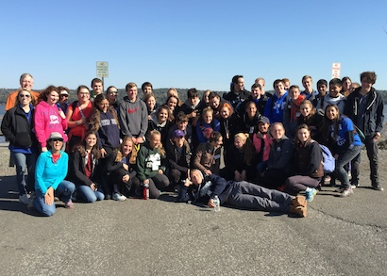 | 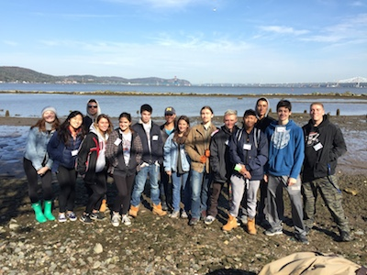
Tom Mullane, Eileen McCaffrey, and Catherine Bonanno– Pearl River HS APES – 44 Students | Jennifer Mazza  Clarkstown South HS  13 Environmental Science Students
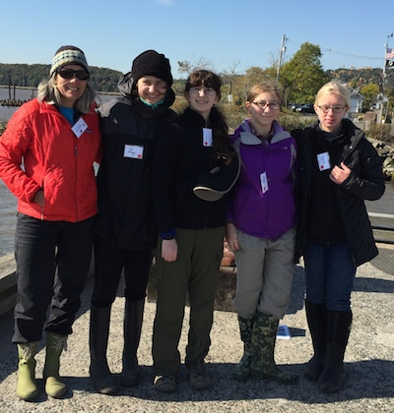
Julie West, Oak Meadow School
4 students
Location: Piermont Pier, Piermont NY
Area: Man made fishing/shipping pier at the east end, long pier with paved roadway and vegetated strip along both sides
Surrounding Land Use: Urban/residential 80% , Forested 20%
Sampling Site: Pier, roadway in center of whole pier, parking area at end, Plants and trees along side. Shoreline Rip Rap, collected wood in area and piping entering river on the south of sampling site
Plants in area: no submerged aquatic plants in the water
Water depth: Varied by location on the pier and by tide
River Bottom – sandy/rocky bottom with marsh grass growing in or near the water
Plants in area: sumac and other plants 15%; phragmites 85%
ITEM | Time |  | Temperature |  | Weather & Observations
Physical
Air Temperature | 9:10AM |  | 12.2°C  °F |  | Beaufort 2 Mph 10 SW |  |  |  | Cloud cover 26-50%
 | 9:45 AM |  | 13°C  °F |  | Beaufort 1  1-3 kts |  |  |  | Cloud cover 26-50%
 | 10:45 AM |  | 15°C  °F |  | Beaufort 3 Mph 8-12 SW |  |  |  | Cloud cover 0-25%
 | 12:15 PM |  | 17°C |  | Beaufort 3 Mph 8-12 SSW |  |  |  | Cloud cover 0-25%
 | 1: 10 PM |  | 18.5 °C  °F |  | Wind S
Weather today | No precip
Weather last 3 days | COLD – constantly, no precip.
Water Temperature | Time | Surface Sample thermometer |  |  |  |  | Meter sample
 | 9:10AM | 5.2°C
 | 9:45 AM | 13.3°C
 | 10:45 AM | 11.9°C |  |  |  |  | 13.1°C
 | 12:15 PM | 15.5°C |  |  |  |  | 14.2 °C
 | 1: 10 PM | 14.7 °C
Turbidity – | Time | Long Site Tube |  |  |  |  | Average
Long Site Tube | 9:10AM | 10 cm  14 cm  10.5 cm  11 cm |  |  |  |  | 11.1 cm
 | 10:00 AM | 10.0 cm  9.5 cm |  |  |  |  | 9.75 cm
 | 10:45 AM | 22.6 cm  27.8 cm  16.6 cm  28.0 cm |  |  |  |  | 23.75 cm
 | 12:12 PM | 16.5 cm  11 cm  12 cm |  |  |  |  | 13.17 cm
 | 1:15 PM | 7.1 cm  8 cm |  |  |  |  | 7.55 cm
Secchi | 9:10 | 30 cm  30  40  30  26  60  65  60 |  |  |  |  | 43.8 cm
 | 10:00 AM | 40 cm  40  35  35  40  40  45  47  50 |  |  |  |  | 41.33 cm
 | 10:40 AM | 45 cm  40  40  27  27  28  40  45  48 |  |  |  |  | 37.8 cm
 | 10:48 AM | 69 cm  50  40 |  |  |  |  | 53 cm
 | 12:15 PM | 10 cm  7  9  9  8  10  20  20  20 |  |  |  |  | 12.6 cm
 | 1:15 PM | 19 cm  12  8  17  16.5  15  32 |  |  |  |  | 17.1 cm
Water Depth - tides | Time | Pier to Bottom |  |  |  |  | Pier to water surface |  |  | Water Depth @ pier end
 | 9:04 AM | 127 cm |  |  |  |  | 51 cm |  |  | 76 cm/fall
 | 9:27 AM | 111 cm |  |  |  |  | 51 cm |  |  | 60 cm/fall
 | 9:53 AM | 88 cm |  |  |  |  | 46 cm |  |  | 42 cm/fall
Transition to rising tide | 10:10 AM | 111 cm |  |  |  |  | 52 cm |  |  | 59 cm/rise
*read in center of pier - found a deeper pocket | *10:40 AM | 155 cm |  |  |  |  | 53 cm |  |  | 102 cm/rise
 | 12:15 PM | 190 cm |  |  |  |  | 110 cm |  |  | 80 cm/rise
See HRECOS depth data below
Chemical | SAMPLES * see HRECOS readings appended at the end of the student reporting
DO | TIME |  | DO Reading |  |  | Water Temp |  | % Saturation
Drop count | 9:10AM |  | 14 ppm |  |  | 5.2°C |  | 110%
 | 9:45 AM |  | 9 ppm |  |  | 13.3°C |  | 85%
 | 10:45 AM |  | 12 ppm (bubble) |  |  | 11.9°C |  | 110%
 | 12:15 PM |  | 3 |  |  | 15.5 |  | 30%
 | 1: 10 PM |  | 10 ppm |  |  | 14.7°C |  | 96%
pH | TIME
colorimeter | 9:10AM |  | 7.8
 | 9:45 AM |  | 8.0
 | 10:45 AM |  | 7.5
 | 12:15 PM |  | 7.5
 | 1: 10 PM |  | 8.3
Other Chemistry | TIME |  | Phosphates  colorimeter |  |  | Nitrates  Drop count |  | Alkalinity  Drop count
 | 9:10AM |  | 0.2 mg/L |  |  | 0.44 mg/L |  | 59 ppm
 | 9:45 AM |  | 0.42 mg/L |  |  | 0 mg/L |  | 72 ppm
 | 10:45 AM |  | 0.5 mg/L |  |  | 0 mg/L |  | 136 ppm
 | 12:15 PM |  | 0 mg/L |  |  | 0 mg/L |  | 60 ppm
*Salinity - | Refracto. |  | Glass  Hydrometer |  |  | meter ppt
9:10AM | 10 ppt |  | 9.2 ppt  1.007s.g.@5.2 C
9:45 AM |  |  | 8.7 ppt
10:45 AM | 10 ppt |  |  |  |  | 8.5 ppt
12:15 PM | 9 ppt |  | 8.9 ppt  1.0075 s.g. |  |  | 8.8 ppt
1: 10 PM | 14 ppt |  |  |  |  | 8.9 ppt
Fish Catch  Northside of pier | Number Caught |  | Species |  |  | Measure of largest |  | TIME & CATCH
Rotation #1  Fish | 14 |  | Atlantic Silverside |  |  | 14 cm |  | 9:30 AM  F -DIV - 2
 | 2 |  | Striped Bass |  |  | 9 cm |  | 16 Totals
Macroinvert | 500 + |  | Comb jellies |  |  | 6 cm |  | Macro
 | 17 |  | Blue Crab |  |  | 6 cm |  | M - DIV 3
 | 1 |  | Sand Shrimp |  |  | 2.5 cm |  | 518 Totals
Rotation #2  Fish | 21 |  | Atlantic Silverside |  |  | 9.5 cm |  | 10:25 AM  F-DIV 3
 | 3 |  | Striped Bass |  |  | 11cm |  | 25 totals
 | 1 |  | American Eel |  |  | 15 cm
Macroinvert | 1 |  | Blue Crab |  |  | 3.5 cm |  | Macro
 | 8 |  | Sand Shrimp |  |  | 4 cm |  | M – DIV 3
 | 20 |  | Comb Jellies |  |  | 4 cm |  | 29 Totals
Rotation #3  Fish | 49 |  | Atlantic Silverside |  |  | 11 cm |  | 10:45 AM  Fish
 | 10 |  | Striped Bass |  |  | 16 cm |  | F - DIV 4
 | 1 |  | mummichog |  |  | NR |  | 61 Totals
 | 1 |  | White Perch |  |  | 14 cm
Macroinvert | 75 |  | Comb Jelly |  |  |  |  | Macro
 | 6 |  | Blue Crab |  |  | 3 cm |  | DIV – 3
 | 2 |  | Sand Shrimp |  |  | 2.5 cm |  | 83 Totals
Rotation #4  Fish | 104 |  | Atlantic Silverside |  |  | 8.3 cm |  | 12:20 PM  Fish
 | 2 |  | Striped Bass |  |  | 9 cm |  | DIV 2  106 Total
Macroinvert | 40 |  | Comb Jelly |  |  | 10 cm |  | Macro
 | 2 |  | Blue Crab |  |  | 3.5 cm |  | M - DIV - 3
 | 5 |  | Sand Shrimp |  |  | 3 cm |  | 47 Total
Rotation #5  Fish | 52 |  | Atlantic Silversides |  |  | 7 cm |  | 1:00 PM  FISH
 | 3 |  | Striped Bass |  |  | 10 cm |  | F - DIV - 3
 | 1 |  | White Perch |  |  | 8 cm |  | 56 - Total
Macroinvert | 100 |  | Comb Jellies |  |  |  |  | M - DIV 1  100 Total
GRAND TOTALS | FISH  DIV - 5 |  | FISH  TOTAL – 264 |  |  | MACRO  DIV- 3 |  | MACRO TOTAL - 777
Sediment Cores – (Nichole & Clare helping from core lab) | Length |  | H2S Smell | Rare |  | Common |  | Abundant
9:30 AM  shallow | 7 cm total:  Oxidized top  bottom ~5 cm plant material,  top ~ 2 cm sand |  | No | Clay |  | Sand  Gravel |  | N/R
9:30 AM  deep | 32cm with oxidized top top 7 cm -  4 layers noted:  ~1-2 cms bottom  ~13 cm next  ~7 cm next  ~7 cm top |  | Yes | Sand  Gravel  Pebbles  Coal |  | N/R |  | Clay
10:00 AM –  Shallow | 11cm  bottom ~ half plant material, ~top half sand |  | No | Clay |  | Sand  Gravel |  | N/R
10:00 AM deep | 32 cm  1) bottom few cm sand, 2) main section clay, 3) top few cm sand |  | No | Sand |  | N/R |  | Clay,
10:40 AM –  shallow | 11 cm disaggregated |  | No | N/R |  | N/R |  | Clay  Mud  Sand  Gravel
10:40 AM  deep | 30 cm  oxidized top (no measure on this) |  | No | Sand  Gravel |  | N/R |  | Clay  Mud
12:30 PM  Shallow | 9 cm  oxidized top (no measure on this) |  | Yes | Mud |  | Pebbles |  | Sand  Gravel
12:30 PM  deep | 11.5 cm oxidized top (4 cm) |  | Yes | Gravel  Pebbles  Wood (roots?)  Brick  Living veget.  (sprouts & roots) |  | Sand |  | Clay  Mud
1:07 PM  left shore | 12 cm no oxidized top |  | Yes | Mud  Shells |  | Sand  Gravel  Pebbles  Coal (image below) |  | N/R
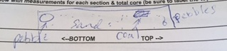Above core- pebbles, sand, coal
1:07 PM  deep core | 17.5 cm  no oxidized top |  | No | Pebbles |  | Mud  Sand |  | Gravel

Piermont HRECOS Screen Captures on following pages
HRECOS site is located just behind the rectangular eastern end of the pier attached to one of the pier stations. When operational it is a continuous data feed recorded every 15 minutes.

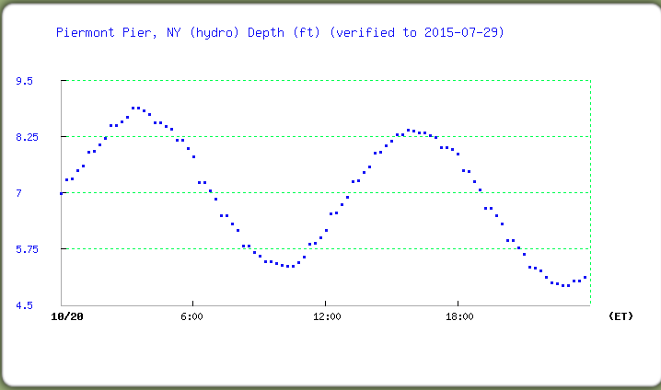
Depth – sampling team captured the transition from a falling to rising tide

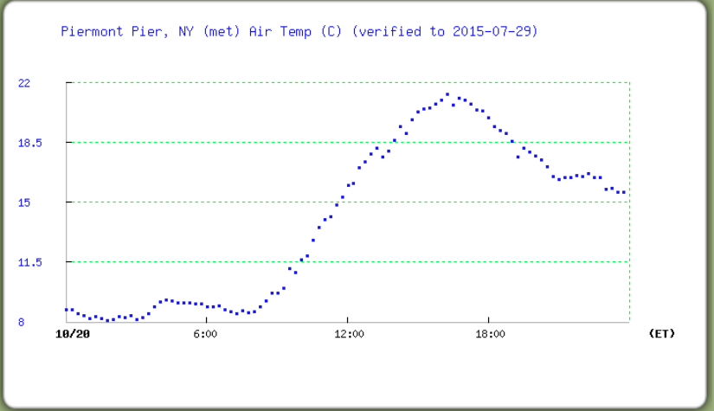
Air Temperature

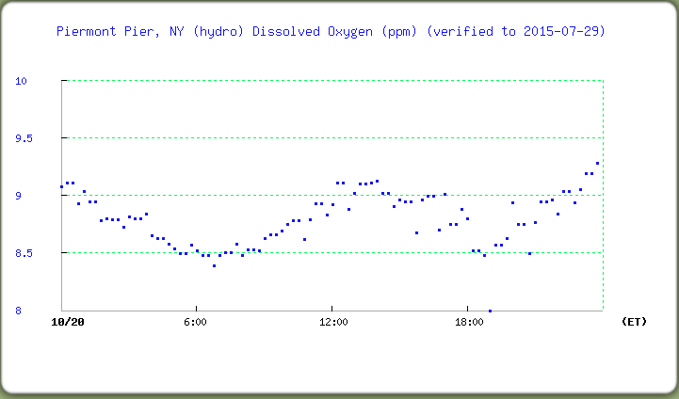
DO ppm
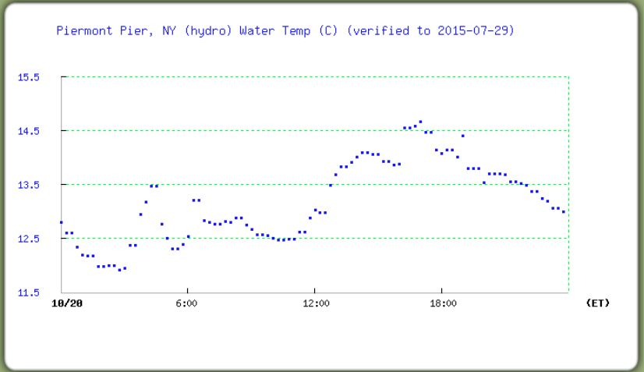
Water temperature

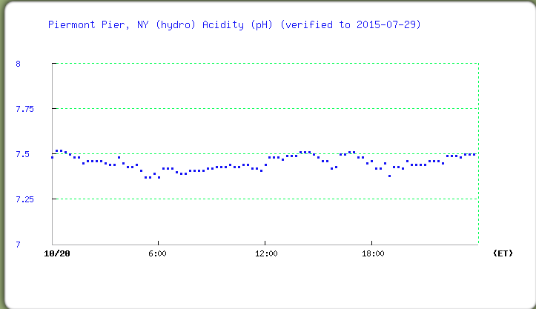
pH

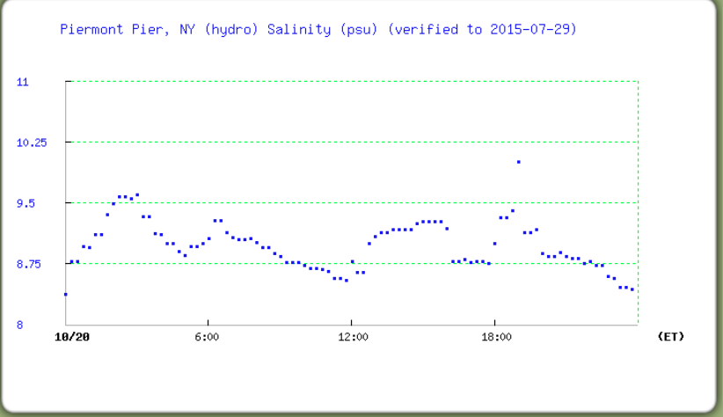
Salinity in psu (equates in the Hudson to ppt)

