Day in the Life of the Hudson River 10/20/15 Data
RIVER MILE 3.2W
Hudson River Pier #51
Arthur Eves, Hoboken Charter Upper School,
25 students twelfth graders, 2 adults
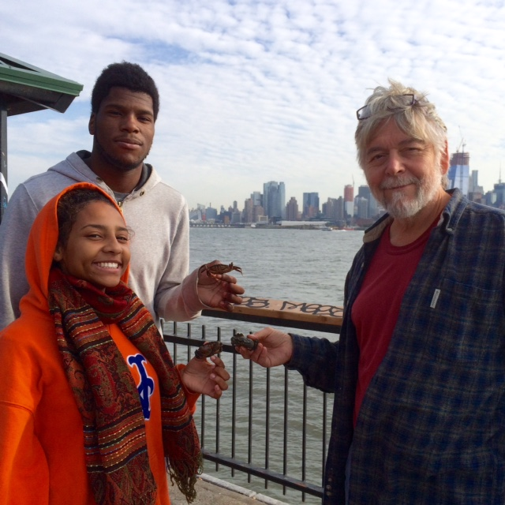
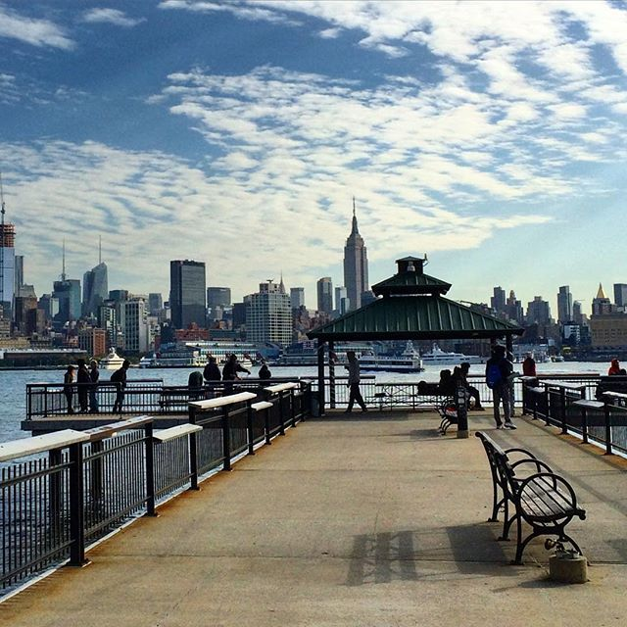
Location: Hoboken Pier, Hoboken waterfront, New Jersey
Area: Pier - mainly metal and wooden pier with metal railing all around
Surrounding Land Use: roads and park
Sampling Site: Recreational pier
Plants in area: None
Sampling – 8:30-12:30 PM
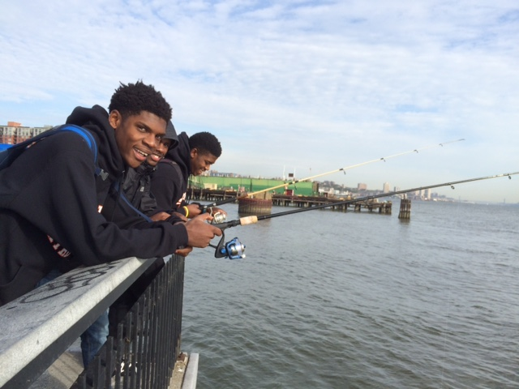 | 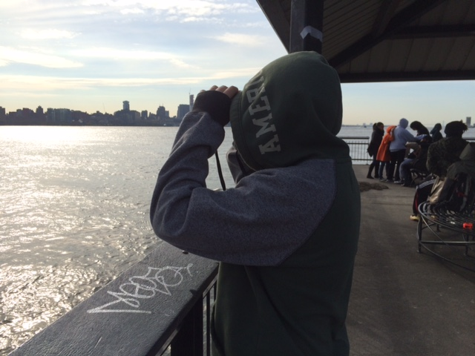

Fish | Didn’t catch anything | Fishermen gave them box of green crabs for bait
Currents | 8:30 AM – out at end of pier | 46 cm/sec | ~ 1 hr. after LT

