Day in the Life of the Hudson River 10/20/16 Data
RIVER MILE 3.2
Hudson River Pier #51, Manhattan
Susan Price & 3 other lab teachers - NYC Lab High School
64 APES students (4) 11& (60) 12th grade
GPS coordinates: 40.738138, -74.010706

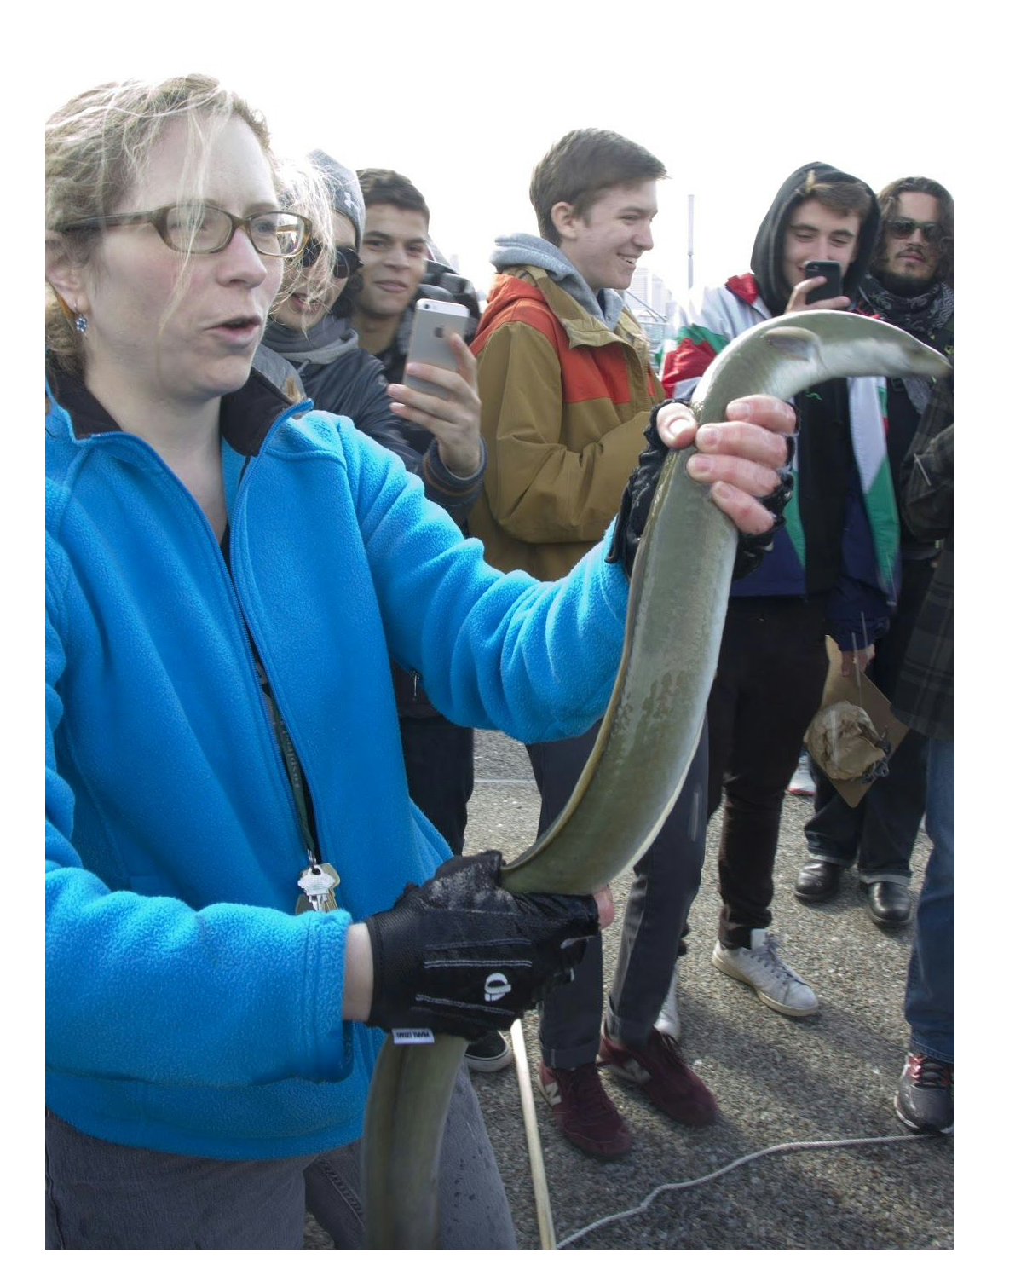
Location: Pier 51 – the Playground Pier, concrete pier
Area: Pier used for boating, picnics, fishing, playground, jogging, sitting and walking
Surrounding Land Use: 60% Urban/residential; 30% Industrial/Commercial; 5% Entertainment, 5% Planted.
Sampling Site: Recreational pier, grassy and concrete
Shoreline: Banks altered, wood bulkhead, pipe entering water, riprap, concrete bulkhead
Water Area: Bottom muddy, rocky
Water: Calm, slight chop, some wind
Plants in area: no plants in water, some trees planted on pier

ITEM | Time | Air Temp. | Wind | Wind
Physical |  |  | Beaufort # | Anemometer
Air Temperature & Wind | 9:57 AM | 13.4°C | #4 - SW | 4.3 m/s SW
 | 10:25 AM | 14°C |  | 3 m/s SW
 | 10:46 AM | 17 C
Cloud Cover | Partly | 26-50%
Weather today | Some clouds to the north and to the south but no rain
Weather recently | No rain – dry stretch

Water Temperature | 9:57 AM | 14°C
 | 10:05 AM | 15°C
Turbidity –site tube | 10:30 AM  10:50 AM | 48 cm  62 cm |  | Average 55 cm
Chemistry | Time | Sigma Test Strip | Color test match
pH – Color test match and test strip | 10:05 AM  10:13 AM  10:27 AM  10:52 AM | N/R  7.5  7.7  7.8 | 8.2  N/R  N/R  N/R
Salinity – plastic hydrometer | 9:52 AM  10:05 AM | 27.5 ppt  28 ppt | Plastic hydrometer  Glass hydrometer temp 15°C
D.O. - CHEMets | 9:57 AM  10:05 AM | 15°C  15°C | 5 ppm  7 ppm | 47% saturated  61%
Nitrogen – API Saltwater Master Test Kit | Nitrate – 1.2 ppm | Ammonia - 0 | Nitrite - 0
Fish – pole | American Eel | Large Adult ` | See photo above
Tides | N/R
Currents: | 9:58 AM | 580 cm/60 sec | 9.7 cm/sec | N/flood
 | 10:11 AM | 600 cm/60 sec | 10 cm/sec | Ebb
*Currents – Samplers noted on data sheet that the tide chart said it would be an ebb tide and that the north blowing wind could have affected results, however the NOAA charts show the tide flooding at this time of the day.
Commercial Traffic | Type | Color | North/South | Loaded/Light
10:05 AM | NY Waterway | White | North | Loaded with people
10:07 AM | NY water taxi |  | North | Some People
10:15 AM | US Army | Navy blue | South | Light
10:30 AM | Chandra B | White | South | Light
11:57 AM | Circle Line |  | South | Loaded with people
Recreational Traffic
10:10 AM | Sailboat | White | North
10:15 AM | Classic Harbor Line | White | South | Small engine propelled
10:41 AM | Sailboat | White | North
Other Observations | Buildings, pigeons, humans and boats.  We observed a lot of plastic floating near the pier. Also so a dead red-eared slider turtle which was a great teachable moment about caring for exotic pets and to never release them into the wild, especially to a saltwater environment when they are a freshwater species.

