Day in the Life of the Hudson River 10/20/15 Data
RIVER MILE 31 – Hook Mountain State Park
Laurie Seeman & Joanne Dickey– Strawtown Art & Garden Studio
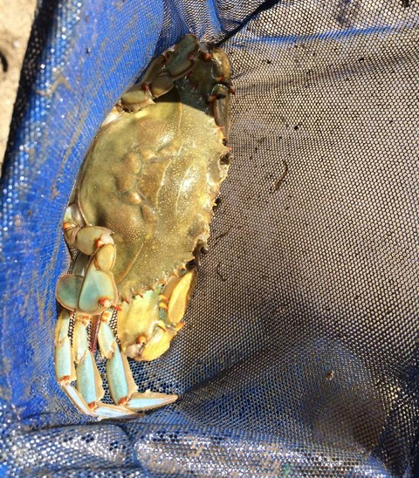

Lorraine Marden-Blue Rock School
Suzanne Reynolds and St. Thomas Aquinas College pre-service teachers
4^{th,} - 6th – 27 students, total 9 adults
41°N Latitude - 74° W Longitude
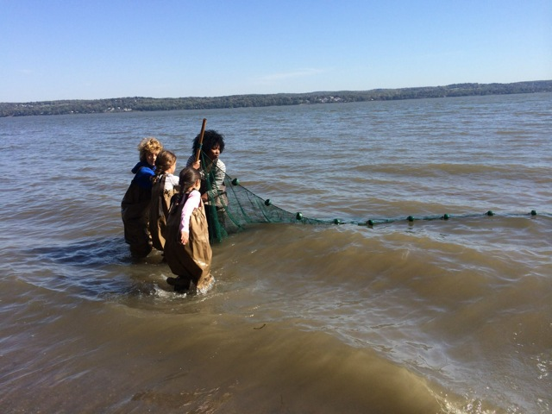 | 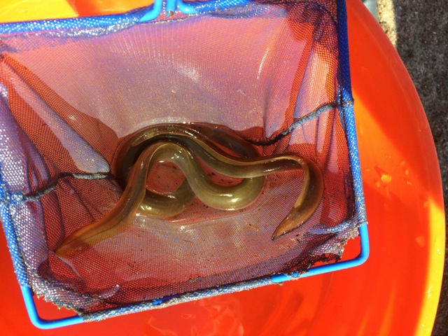

Location: Nyack Beach near Hook Mountain Sandy Beach right side of riverfront area
Area: Park/Boat launch, sandy beach area on the point with riprap
Surrounding Land Use: 10% urban/residential; 1% forested; 90% beach
Sampling Site: Sandy beach with retaining wall enclosing it and behind a lot of trees, picnic tables, sandy and rocky at edges, covered with vegetation beyond the beach, stone wall, riprap shore, concrete docking. Boat launch spits the site and steep bank behind picnic table area. Sandy beach is only available during lower to mid tide. Pipe enters river ~25 ft. south of sampling area
Plants in water: no plants in area
Along the waterfront: brick, charcoal, slag
Water depth: 3 ft.
River Bottom –rocky, sandy, muddy

ITEM | Time |  | Reading 1 | Reading 2 | Comments
Physical
Air Temperature | 10:53 AM |  | 16°C  60°F | 16°C  60°F
 | 11:39 AM |  | 16°C  60°F | 16°C  60°F
 | 12:10 PM |  | 16°C  60°F | 16°C  60°F
 | 1:33 PM |  | 18°C  62°F | 18°C  62°F
Wind Speed | Beaufort 5 |  | N | Wind picked up in the PM
Cloud Cover | clear
Weather today | No rain warmed during the day
Weather last 3 days | No rain, warmer that usual
Water | choppy
Water Temperature | 10:58 AM | 63°F X 3 |  | 17°C X3 | Average
 | 11:55 AM | 60°F X 3 |  | 13°C X 3 | Average
 | 1:06 PM | 68°F X 3 |  | 18°C X 3 | Average
Turbidity – short site tube | 11:03 AM  11:41 AM  12:28 PM | >100 JTU  >100 JTU  >100 JTU |  | Water was extremely turbid, exceeding visibility for the kit used which stopped at 100 JTU.
Chlorophyll | 12:07 PM | 1.0
Chemical
DO  Drop count | 12:30 PM | 7 mg/L |  | 16 ° C | 75%
pH  Indicator solution | 11:22 AM | 7.5  7 |  |  | 7.25
Salinity- Quantab  Test strip | 11:28AM | 0.356%NaCl  0.388 %NaCl |  | 2161 ppm Chl-  2356 ppm Chl- | 3904 TS  4256 TS  4080 ppm AVERAGE
Fish Catch | 15 ft. pull X 4 time | Number Caught |  | Species | Length of largest
Seine 20 ft. X 4ft.  Mesh 0.25 inch | 11:00 AM | 2 |  | Northern pipefish | 20 cm
Seine #1 |  | 1 |  | Flounder | 7.5 cm
Diversity 4  Totals 20 |  | 15 |  | Shiner | 5 cm
 |  | 2 |  | White perch | 7.5 cm
Seine #2 | 12:20 PM | 1 |  | Northern pipefish | 20 cm
Diversity 5  Totals 5 |  | 1 |  | Atlantic Silverside | NR
 |  | 15 |  | American eel | NR
 |  | 1 |  | White Perch | NR
 |  | 1 |  | Hog choker | NR
 | TOTAL FISH | Diversity 7 |  | Total Count 25
Macros – Seine #1 | 11:00 AM | 2 |  | Blue crab | 2.5 cm
Diversity 3  Totals 107 |  | 5 |  | Mud crab
 |  | 100 |  | Shrimp | 5 cm
Macros – Seine #2 | 12:20 PM | NR |  | Blue Crab
Diversity 3  Totals ? |  | NR |  | Shrimp
 |  | NR |  | Hermit Crab
Macros – Seine #3 - | Final PM pull | 4 |  | Comb Jellies
Diversity 1
Totals 4
Tides | Time | Height |  | Rate of Change | Rising/Falling
 | 10:50 AM | 10 cm |  |  | Baseline
 | 11:37 AM | 15 cm |  | 0.1063 | rising
 | 12:10 PM | 27 cm |  | 0.3636 | rising
Stick upended in current | *1:30 PM | #NR |  | #NR | rising
Currents* | CM/30 secs | Cm/Sec |  | Ebb/Flood/Still | North/South
11:05 AM | 474.98 cm | 15.83 cm/sec |  | Flood | N
11:48 AM | 128.27 cm | 4.27 cm/sec |  | Flood | N
1:35 PM | 161.29 | 5.3 cm/sec |  | Flood | N
1:47 PM | 350.52 | 11.68 |  | Flood | N
Shipping Traffic
Other Items

