Snapshot Day 10/20/15 Data
RIVER MILE 32
Lewis & Engel Park
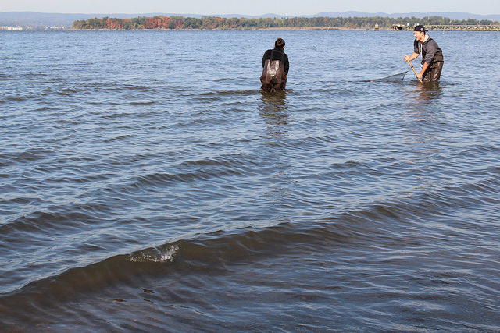 | 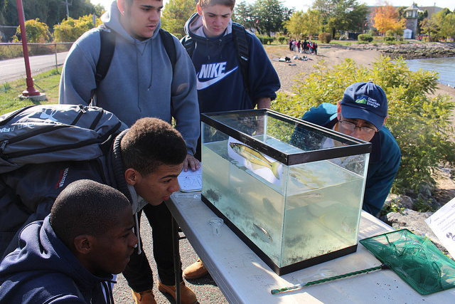

Bridget Baumann & Artie Carlucci, Ossining HS AP Environmental Science
10th-12th grade – 70 students, 10 adults
41°10’N - 73°52’W
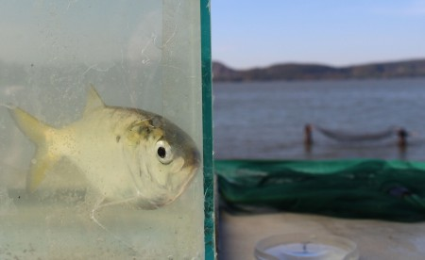
Location: Wading beach at Lewis J. Engel Park, Ossining, NY
Area: Beachfront area with a ferry pier, paved sidewalk, rock wall lining the river, riprap, grass by metro north station
Surrounding Land Use: 50% beach, 15% park, 25% industrial/commercial
Sampling Site: bulkhead lines the shoreline with pier, rock wall, beach, riprap, rocky, weedy, used for picnics and boats. Pipe enters the river North of the sample site.
Plants in the water: 10% water chestnut; 90% water celery
Shoreline: 50% Rocky, 50% Sandy
River Bottom: sandy, rocky, muddy

ITEM | Time |  | Reading 1 | Reading 2 | Comments
Physical
Air Temperature | 9:30 AM |  | 57°F  14°C | 1:15 PM | 64°F  18°C
Wind Speed | 1:18 PM |  | Beaufort #2 | South
Cloud Cover | 1:19 PM |  | <25%
Weather today | No Rain
Weather last 3 days | Unseasonably cool, no major rain or precipitation Snow flurries on 10/18 – 40°F
Water | Small wavelets
Water Temperature | 10:30 AM  11:15 AM | 14 ° C  12 ° C
Turbidity- site tube | AM | 35 cm  35  40 |  | AVERAGE- | 37cm
Turbidity Comment: Water was a little cloudy. We could see the bottom of a 5 gallon bucket
Chemical
DO – LaMotte Green Water test kit | 10:30 AM  11:15 PM  N/R | 2.0 mg/L  6.0 mg/L  4.0 mg/L |  | 14 ° C  12 ° C  16 ° C | 17% saturated  46% saturated  40% saturated
pH (test strips – color match) | 9:50 AM  10:23 AM  10:45 AM  11:25 AM | 6.0  7.0  8.0  7.0
Salinity- hydrometer | 10:00 AM  10:21 AM  11:34 AM  12:50 PM | 11, 12, 10, 11  10, 7 ppt  2, 2.8, 6 ppt  6, 6, 7, 8 |  | Averages | 11 ppt  8.5 ppt  4 ppt  7 ppt
Nitrogen | 5 ppm | 5 ppm
Phosphorous | 2 ppm | 1 ppm
Fish Catch  10 ft. seine | Number Caught | Species |  | Length of largest
10:00-2:00 PM | 136 | Atlantic Silversides |  | 10.6 cm | Diversity - 3
 | 1 | Striped Bass |  | 10.6 cm | Total Count -139
 | 2 | Herring |  | 15 cm
Currents | 1:15 PM | 200 cm/30 secs |  | 6.7 cm/sec
 | 1:22 PM | 201 cm/30 secs |  | 6.7 cm/sec
Shipping | 10:31 AM  12:41 PM | Blue Barge  Black Barge |  | North  South | Loaded  Loaded
Core Description | Length | Abundant |  | Common | Rare
Collected in 3 ft. water @  11:32 AM | Not listed *no H2S  *no O2 top | Sand |  | Mud  Gravel | Clay  Pebbles
Observations | Abiotic – bricks, shells, and rocks on the ground  Biotic - Birds, Insects & water chestnuts were on the ground

