Day in the Life of the Hudson River 10/16/15 Data
RIVER MILE 36
Riverfront Park, Stony Point Marina, Stony Point, Rockland
Jeanne Maguire, RCC Environmental Science Students through North Rockland HS – 28 students, 5 adults
Latitude N 41.224 - Longitude W 73.963

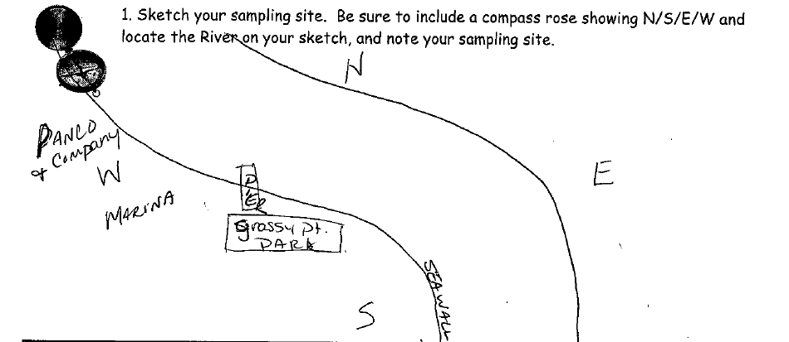
Sampling Map
Location: Stony Point Marina Riverfront Park, City of Stony Point in Rockland County
Area: Located along the side of the road at the south end of the marina – Forested in the wider area, Pier, Grassy, Parking Lot
Surrounding Land Use: 30% urban/residential, 40% Industrial/commercial, 20% beach and 10% forested
Sampling Site: Some beach and rip rap edges.
Shoreline: Sandy, muddy, but very rocky
Plants in area: No plants in the water but chestnut seed pods found on the shoreline
River Bottom – muddy, sandy, rocky

ITEM | Time |  |  | Reading 1 | Reading 2 |  |  | Comments
Physical
Air Temperature | 10:19 AM  10:36 AM  11:35 AM |  |  | 54 F  54 F  55 F | 12.2 C  12.2 C  12.78 C
Wind Speed | NR
Cloud Cover | 10-12:00 PM |  |  | Partly Cloudy | 26-50%
Weather today | No rain
Weather recently | No rain – cool
Water Surface | Calm & cloudy
Water  Temperature | 10:00 AM |  | 0.5 ft. deep in shade – water shaded by plants |  |  | 16ºC
Turbidity –  Transparency tube | 11:30 AM |  | 16.2 cm  16.5  15 |  |  | Average  15.9 cm |  |  | Water was very turbid – sand & dirt in it
Chemical
DO | 11:40 AM |  | 17 ºC  16 |  |  | 12 ppm  9 ppm |  |  | 100%  90%  Saturation
pH  Indicator solution | 9:55 AM  10:13 AM  10:15 AM |  | 7.2  7.4  7.3
Salinity – High Range  quantabs | 12:10 PM |  | 6.6 units |  |  | 2161 mg/L chloride |  |  | 3904 Total Salinity
Conductivity |  |  | 6451 uS |  |  | 6430 uS
Fish Catch- 9:40-12:15 AM | Number Caught |  | Species |  |  | Size of largest |  |  | Seine
24 ft net X 4ft– | 4 |  | Striped Bass |  |  | 13 cm
 | 88 |  | Atlantic Silversides |  |  | 8 cm
 | 1 |  | Yellow Perch |  |  | 10 cm
 | 8 |  | Smallmouth bass |  |  | 10 cm
 | 1 |  | Hogchoker |  |  | 10 cm
Total Catch | 102 |  | Total Fish Count |  |  | 5 #Species
 |  |  | Invert Seine
 | 2 |  | Blue Crab |  |  | 2 M
Total Catch | 2 |  | Total Invert Count |  |  | 1 #Species
Coring | Unable to collect – sediment corer broke
Tides |  | 10:14 | 4 cm
 |  | 10:30 | 15 cm
 |  | 10:58 | 25 cm
Current * |  | Time | Cm/sec |  | Ebb/Flood
Traffic - commercial |  | Name | Type |  | North/South |  | Loaded/Light
11:14 AM  11:30 AM  12:06 PM |  | Teal/white  blue/white  white/grey | Tug/barge  Tugboat  barge/ |  | Northbound  Northbound  Southbound |  | Loaded  Loaded  Loaded
Traffic Recreational |  | Type | Nam/color |  | North/South |  | Loaded/Light
11:10 AM  11:30 AM  11:30 AM |  | White  White  White | Fishing boat  Speed boat  Speedboat |  | South  North  South |  | Loaded  Light  Light
Observations |  | Water chestnut seeds, shell pieces, fish carcass, sand and different sized rocks and lots of driftwood.
Animals |  | Wasps, crabs, seagulls and ducks

