Day in the Life of the Hudson River 10/16/15 Data
RIVER MILE 41
Steamboat Dock Park, Verplanck, Westchester
Bob Connick, Sott Rizzo, Mahopac High School;
Environmental Research and Field Biology 9th - 12th graders –25 students,
4 teachers
Latitude N 41°14958 - Longitude W 73°936474

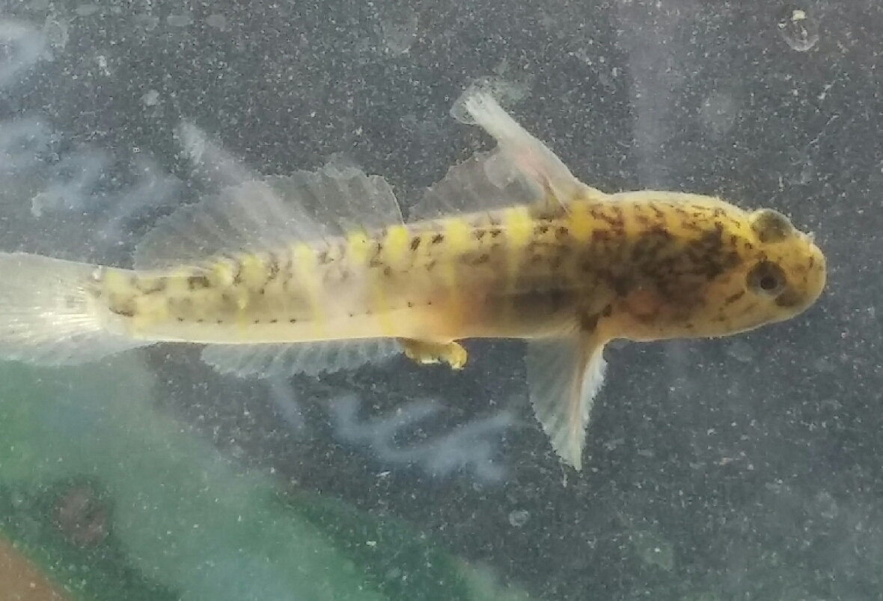 | 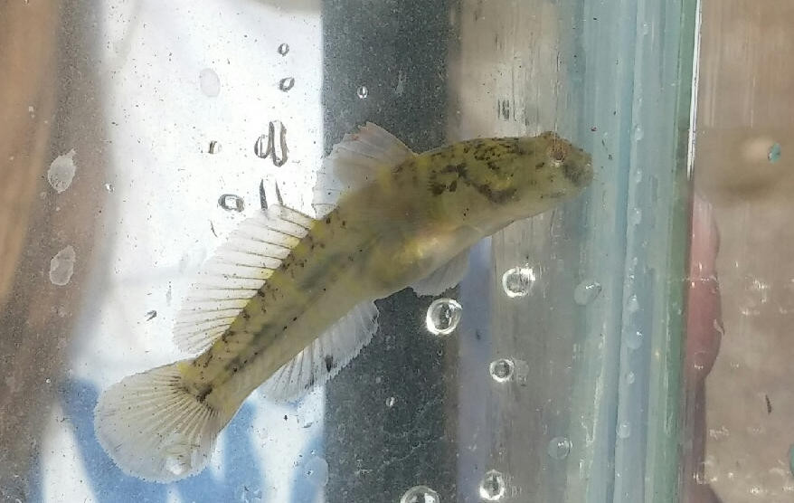
5 cm Adult Naked Goby | 5 cm Adult Naked Goby

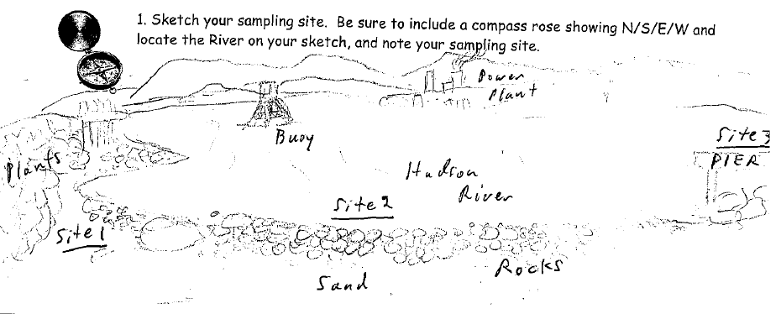
Sampling Map: Site 1 (Physical Data); Site 2 (Biological Data); Site 3 (Chemical Data)

Location: Steamboat Dock Park beach, City of Verplanck in Westchester County
Area: located in a small cove between a point and a bulkhead – Pier, Grassy, Parking Lot
Surrounding Land Use: Boating, Picnics, Swimming, Fishing, Jogging
Sampling Site: beach, covered in vegetation, riprap, banks altered, dock, bottom rocky, bulkhead, pipe south of the sampling site 10-15 m.
Shoreline: Sandy, muddy, rocky
Plants in area: Valissneria found on the shore, water chestnut seed pods
Other: No plants in water but plants in the area noted above
Water depth: 3 ft.
River Bottom – muddy, sandy, rocky

ITEM | Time |  |  | Reading 1 | Reading 2 |  |  | Comments
Physical
Air Temperature
Wind Speed | 11:30 AM |  |  | Beaufort 3 | South |  |  | 6 mph
Cloud Cover | 12:00 PM |  |  | Clear <25% | 5 contrails & few cirrocumulus
Weather today | 11:30 AM –cloudy, rainy
Weather recently | Humid and wet
Water Surface | Calm
Water  Temperature  9 YSI SCI meter | 11:42 AM  11:45 AM |  |  |  |  | 18.5ºC  18.6ºC
Turbidity –  Water very clean, no smell | 11:30 AM |  | ~31 cm  27.9  26.1  Transparency tube |  |  | Average  28.3 |  |  | 14 NTU LaMotte
Chemical
DO  (drop kits) |  |  | 18.5 ºC  18.5 |  |  | 8 ppm  9 ppm |  |  | 85%  100%  Saturation
pH  Indicator solution | 11:45 AM  12:00 PM  12:15 PM |  | 7.5  8.0  8.0
Salinity  YSI SCT meter | 10:30 AM  11:39 AM  11:41 AM |  | 4.2 ppt  4.0, 4.1  4.1, 4.1 |  |  | Site #1- 4ppt |  |  | Site #2-  4.1ppt
Conductivity |  |  | 6451 uS |  |  | 6430 uS
Fish Catch- 12:05 AM | Number Caught |  | Species |  |  | Size of largest |  |  | Seine
25 ft net X 4ft– 300 ft. pull | 3 |  | Striped Bass |  |  | 7.6 cm
 | 208 |  | Atlantic Silversides |  |  |  |  |  | 8 seines
 | 1 |  | Yellow Perch |  |  | 7.6 cm
 |  |  |  |  |  |  |  |  | Tide Pool
 | 1 |  | Naked Goby |  |  | 5 cm |  |  | Found under the rocks on shoreline
 | 6 |  | American Eel |  |  | 23 cm |  |  | Found under the rocks on shoreline
Total Catch | 219 |  | Total Fish Count |  |  | 5 |  |  | #Species
 |  |  |  |  |  |  |  |  | Invert Seine
 | 2 |  | Blue Crab |  |  | 1 M/1 F
 | 5 |  | Comb Jellies
 |  |  |  |  |  |  |  |  | Invert Pools
 | 15 |  | Juvenile blue crab
 | 15 |  | Scuds
Total Catch | 37 |  | Total Invert Count |  |  | 3 |  |  | #Species
Coring | Unable to collect – need new corer
Tides*  Meter stick kept coming out of bottom | TIME - Amt. Rise/ Fall
Tides*  Meter stick kept coming out of bottom |  | 11:05 | 7 cm
 |  | 11:20 | 7 cm
 |  | 12:14 | 28 cm
Current * |  | Time | Direction |  | Ebb/Flood |  | Speed
Full sampling time |  | FLOOD
Traffic - commercial |  | Name | Type |  | North/South |  | Loaded/Light
11:45 AM  11:25 AM  11:29 AM  12:30 PM |  | Red/orang  White  Blue/whit  Dory | Train  Tug/barge  Tugboat  Tug/barge/ |  | Southbound  Northbound  Southbound  Northbound |  | Loaded  Loaded  Loaded  Loaded
Traffic Recreational |  | Type | Nam/color |  | North/South |  | Loaded/Light
10:45 AM |  | White | Boat |  | North |  | Light
Birds |  | 8 ducks, 16 geese, crabs, sparrows, 10 ring-billed gulls & a couple of herring gulls,
Plants |  | Virginia creeper, locust, sumac, burdock
Anthropogenic |  | Bricks, feather, rocks, glass, plastic, wood, devil’s head seed pods for water chestnut

