Day in the Life of the Hudson River 10/20/15 Data
RIVER MILE 57
Donahue Memorial Park, Cornwall Landing, Village of Cornwall-On-Hudson, Town of Cornwall, Orange County, NY
Christopher O’Sullivan, NYSOPRHP Trailside Museums & Zoo
Deborah Gilson and teacher team @ Willow Ave. Elementary -
4th grade – 75 – students, 14 adults
GPS Latitude 41°26’36”N Longitude 74°0’1”W
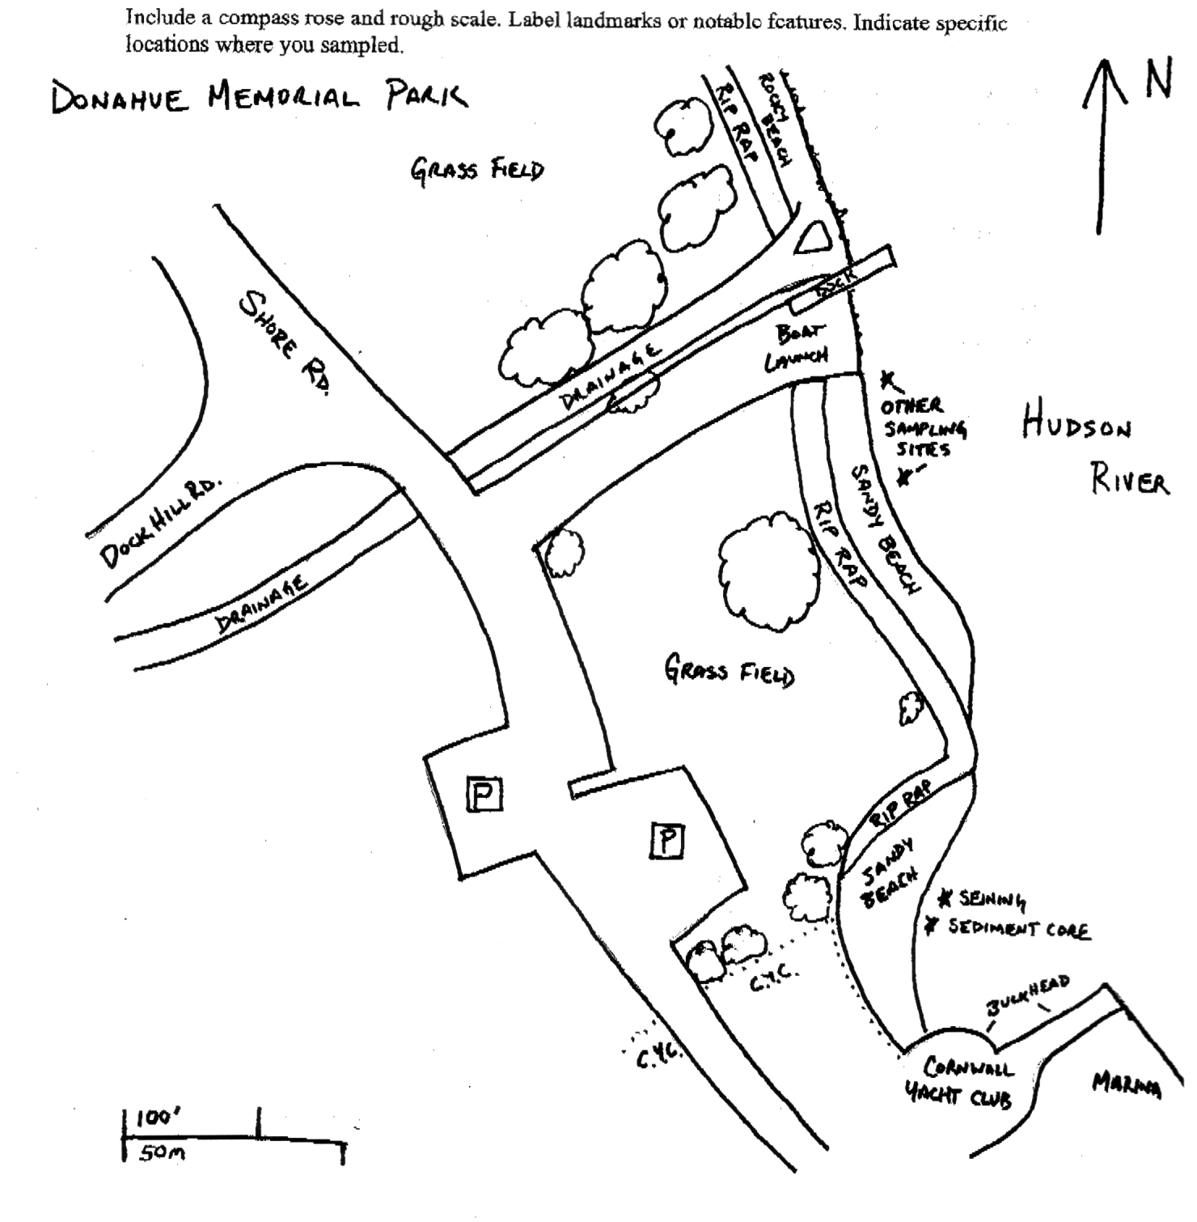
Location: Donahue Memorial Park
Area: Sandy beach used for seining & sediment core, 2nd beach are for other sampling.
Surrounding Land Use: 100% open and grassy park
Sampling Site: pier, sandy beach, altered banks, shoreline riprap, bulkhead, collected wood & debris in area,
Plants in area: NR
Water depth: NR
River Bottom – muddy, rocky
Observations – Rocky, algae in sampling area and sampled in sunlight

ITEM | Time |  | Reading 1 | Reading 2 | Comments
Physical
Air Temperature | 10:46 AM |  | 26°C
Wind Speed | 9:30 AM |  | #3 Beaufort | 7-10 km  8-12 kts | NW
Cloud Cover | Partly cloudy |  | (26-50%)
Weather today | Gentle breeze
Weather recently | Some snow and cold
Water Temperature | 9:56 AM  10:03 AM (students) | 12°C  12°C
Water Surface | NR
Turbidity  Long sight tube | 12:23 PM | 14 cm  17  12 |  |  |  | Average 14.3 cm
Chlorophyll | 12:15 PM | 1.0
Chemical
DO  Drop count kit | NR
pH (indicator sol.) | 10:04 AM | 7.0
Salinity - | 10:07 AM | Salinity 348 mg/L Cl- |  | 629 mg/L total salinity
Fish Catch | Number Caught | Species |  | Size |  | Comment
Total Catch
Tides | TIME | RISING/  FALLING |  | HEIGHT IN CM |  | RATE OF CHANGE
 | 11:55 AM | Falling |  | -10 cm
 | 1:00 PM
Currents | 12:00 PM |  |  |  |  | Flood
Boat
Other Observations

