A Day in the Life of the Hudson River 10/20/15 Data
RIVER MILE 61W
Newburgh Rowing Club, Newburgh, Orange County
Suparna Bhalla and Mount St. Mary’s Students and faculty 51 total
San Miguel Academy Middle School, 39 students 6th and 7th graders

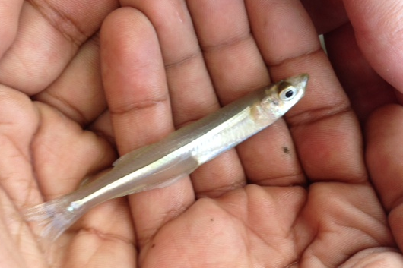

Location: Newburgh Rowing Club in Newburgh
Area: Pier and parking lot
Surrounding Land Use: 100% Industrial/commercial
Shoreline: 50% sandy and 50% rocky comprising 30% beach, 40% riprap and 30% wood bulkhead
Water sampling area: 100% sandy bottom
Plants in water area: none
Water: Choppy

ITEM | Time |  | Reading 1 | Reading 2 | Comments
Physical
Air Temperature | 1:00PM  2:00 PM  3:00 PM |  | 19°C  22  23 | Average 21.7°C
Wind Speed
Cloud Cover | Clear |  | <25%
Weather today | No rain
Weather recently | Cold frost at night
Water Temperature-  Direct sun @ shoreline | 1:00 PM  2:00 PM  3:00 PM | 17.3°C  17.1  17.5 |  | Average 17.2°C
Water calm | yes
Turbidity -  Short site tube | 1-3PM | 22 JTU
Conductivity | 1-3PM | 0.74 ug/L
Chemical
DO  meter | 1-3:00 PM | 10.11 ppm |  | 17°C | 108%
pH – meter | 1-3PM | 6.2
Salinity - meter | 1-3:00 PM | 296 ppm |  | average
Nitrate - meter | 1-3PM | 0 ppm
Phosphate - meter | 1-3PM | 0.6 ppm
Fish Catch-  1-3 PM | Number –  45 | Species –  Spottail shiner |  | Length Lgst  5 cm | Diversity/Total Catch
5 hauls – DEC (large net) | 10 | Tessellated Darter |  | 2 | Diversity 9
4 hauls MSMC  small net | 1 | Carp |  | 15 | Total Fish Catch 85
Results mixed | 3 | Shad |  | 9
 | 6 | Striped Bass |  | 6
 | 14 | River Herring |  | 9
 | 4 | White Perch |  | 17
 | 1 | Hog Choker |  | 2
 | 1 | Atlantic Silverside |  | NR
INVERTBRATES | 17 | Blue Crab |  | NR | Total Diversity 1  Total Count 1
Tides
Currents | 1:00 -3:00PM | 4.76 cm/s |  | average

