Day in the Life of the Hudson River 10/20/15 Data
RIVER MILE 76W
Bob Shepard Highland Landing Park, Highland, Dutchess County
Kevin Rizzo, Highland, 30 students, 8th grade Living Environment, 4 adults
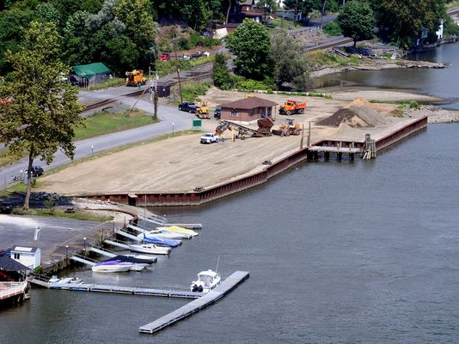
N

W E

S
Location: Bob Shepard Highland Landing Park, Highland, New York.
Area: New park, pier, grassy, parking lot. Park used for fishing, boating
Surrounding Land Use: 50 % urban/residential; 40% urban/residential; 10% park area with grass and waterfront docks
Sampling Site: shoreline is riprap, banks altered, concrete bulkhead, wood bulkhead, banks altered, broken concrete and docking debris, construction debris, some brick on shoreline.
Plants in area: ~10% plants in water (not identified)
Water depth: 2 ft. to 50 ft.
River Bottom –mostly rocky at shoreline with mud ad silt at greater depths
Sampled 9:00 AM to 1:00 PM
ITEM | Time |  | Farenheit | Celcius | Comments
Physical
Air Temperature | NR
Wind Speed | NR
Cloud Cover | NR |  | 25-50% | Water condition | Choppy
Weather today | No rain today
Weather last 3 days | Cool weather but a dry season
Water Temp. | NR | °F |  | °C
Turbidity – Secchi disc | NR | 65 cm  76 cm  72.5 |  | Average – 71 cm
Long sight tube |  | 34  31.4  35.6 cm |  | Average 33.6 cm
Chemical
DO - meter | NR
pH – litmus paper & pH pen | NR | Recorded at N for neutral to slightly basic
Salinity - | NR
Fish Catch – 10feet net | Number Caught | Species |  | Largest
NR | 2 | Striped Bass |  | 11 cm |  | Diversity 3  Total Catch 183
 | 179 | American Shad |  | 10 cm
 | 2 | Tessellated darter |  | 6 cm
Tides – Time | Falling/  Rising | Height in cm |  | Rate/change cm/min |  | Rate per min.
9:30 AM  10:00 AM  10:40 AM  11:00 AM  11:45 AM  12:10 PM  12:30 PM | Falling  Falling  Falling  Falling  Falling  Falling | 0  -43 cm  -109 cm  -145 cm  -175 cm  -299 cm  -312 cm |  | 43/30  66/40  36/20  30/45  124/25  13/20 |  | 1.43 cm/min  1.65 cm/min  1.8 cm/min  0.67 cm/min  4.96 cm/min  0.65 cm/min
Currents | Time | Cm/sec |  | N/S |  | Comment
 | 9:37 AM  9:41 AM  9:53 AM | 12.88  4.28  31.5 |  | N  N  N |  | Orange was thrown in different places
Ship Traffic – Commercial | 9:12 AM  9:12 AM  11:30 AM  11:45 AM  12:20 PM | UBL 85  Arabian Sea  NR  Bouchard  Cap Willy Landers |  | Black  White  Red  Black  Blue |  | South/Light  South/Light  South/Light  South/Light  North/Light
Ship Traffic - Recreational | 12:25 PM | River Wrangler |  | White |  | North

