Day in the Life of the Hudson River 10/20/15 Data
RIVER MILE 76
Waryas Park, Poughkeepsie, Dutchess County
Brian Reid & Lynn Fordin, Poughkeepsie Day School Second Grade
24 students and 9 adults
N 41°7’ – W 73°9’
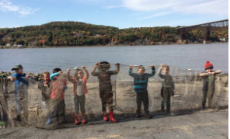
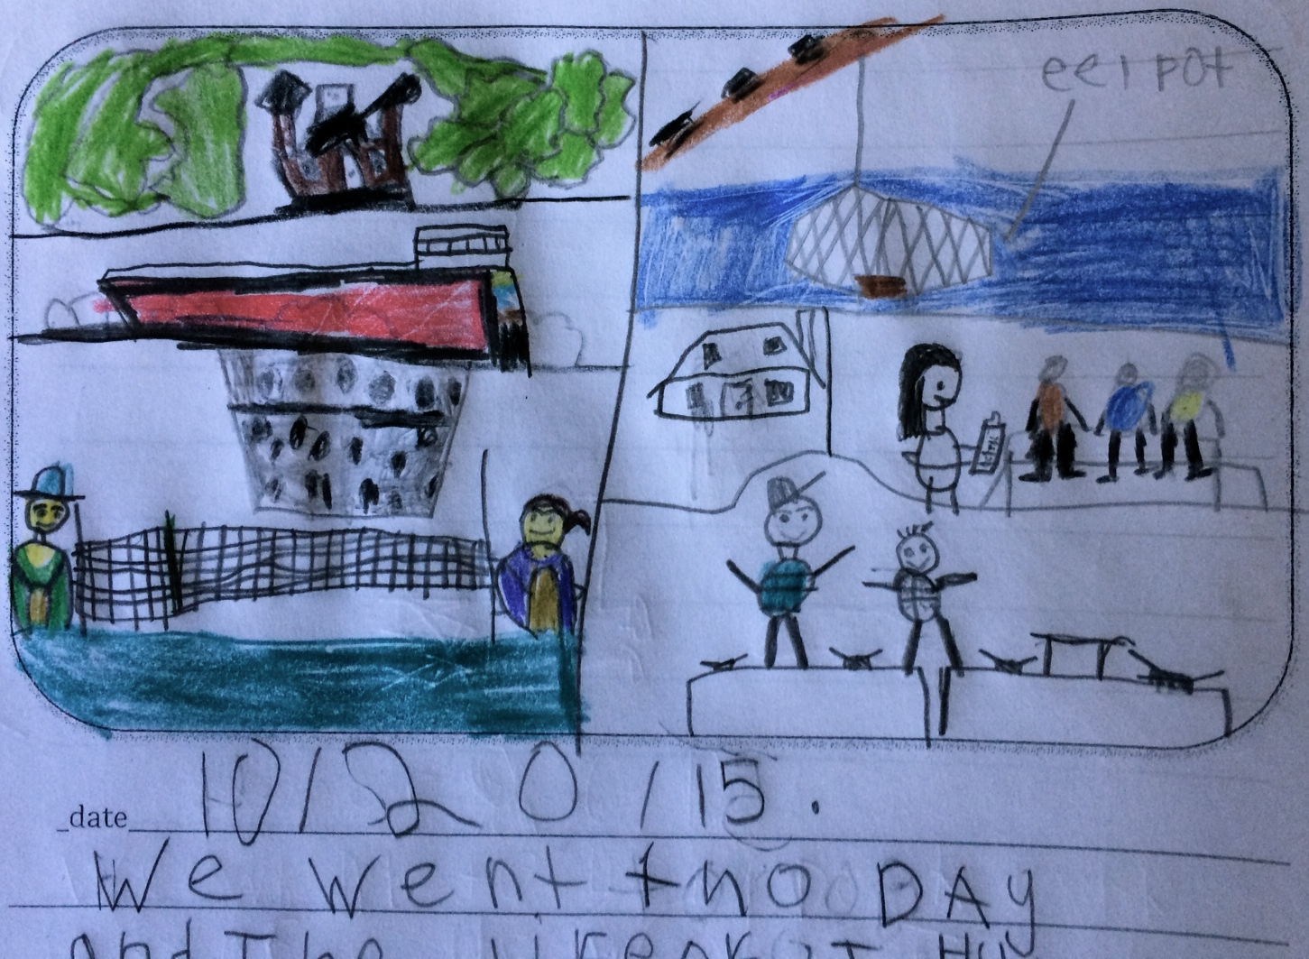 | 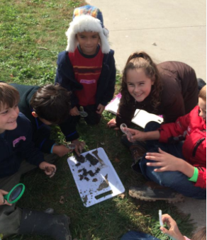 | 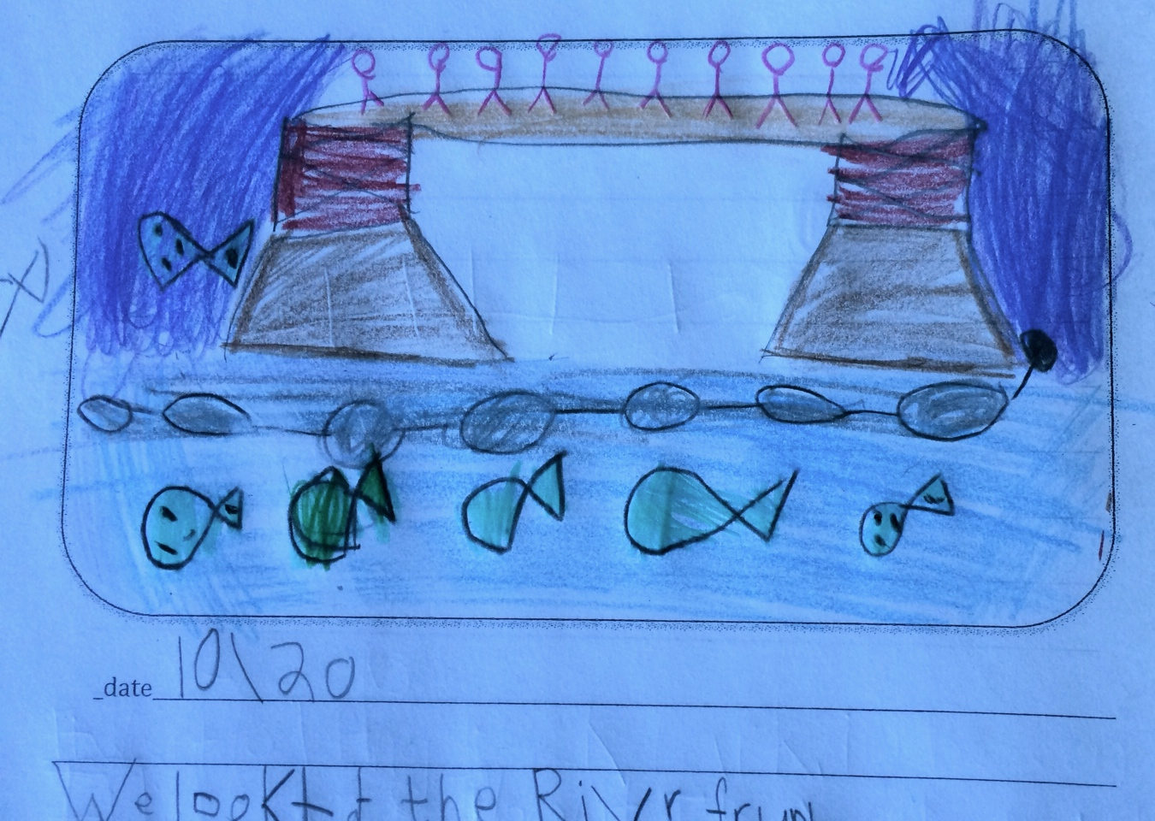
Location: Waryas Park, Poughkeepsie, New York.
Area: public park, pier, grassy, parking lot. Park used for fishing, small boat launch, another pier for small boat launching
Surrounding Land Use: 10 % urban/residential; 40% Industrial/commercial, 50% park area with grass and waterfront docks
Sampling Site: shoreline is riprap, vegetation, banks altered, pier, rocky
Plants in Sample Area: None
Shoreline: 100% rocky
River Bottom –rocky
ITEM | Time |  | Reading 1 | Reading 2 | Comments
Physical
Air Temperature | 11:03 AM  11:30 AM |  | 55 F  55 F | 12.8 C  12.9 C
Wind Speed | 11:25 AM |  | #3
Cloud Cover | 11:15 AM |  | Partly cloudy | 26-50%
Water | Calm
Weather | Dry
Weather last 3 days | Very cold last 2 nights (below 20 degrees F) and very dry stretch
Water Temp.-from 0.5 ft. of water in shade | 11:01 AM  11:32 AM | 16 degrees C  15 degrees C |  | 60.8 F  59 F |  | .
Turbidity – long site tube | 11:00 Am | 36 cm  34 cm |  |  |  | Average 35 cm
Chemical
DO - Drop Count | NR
pH – color match | 2:0 PM | 7.2
Salinity - | 11:05 AM | 1.5 value |  | 31 ppm Chl |  | 56 ppm TS
Fish Catch – 28 feet net | Number Caught | Species |  | Largest
12:30 PM –seine 1 | 1 | Striped Bass |  | 7.6 cm |  | DIV – 3  Catch - 15
 | 7 | Spottali Shiner |  | 10 cm
 | 7 | Y-o-y Shad |  | 7.6 cm
1:10 PM – seine 2 | 11 | Spottail Shiner |  | 10 cm |  | DIV – 1  Catch - 11
TOTAL DIV - 3 |  | TOTALS- 26
Tides | 10:40 AM | 26 cm/sec
 | 11:48 AM | 2 cm/sec |  | Drop of 24 cm in 68 mins |  | Ebb
Currents | 10:56 AM | 208 cm/30sec |  | 7cm/sec |  | 0.136 kts - Ebb
 | 11:29 AM | 230 cm/30sec |  | 7.6 cm/sec |  | 0.149 kts - Ebb
Core | Length of Core | Rare |  | Common |  | Abundant
10:40 AM | 7.6 cm |  |  | Clay  Mud  Sand  Gravel  Pebbles  Leaves  wood
Shipping – Commercial | Type/Name | Color |  | Direction |  | Loaded/ Light
11:00 AM | Mystic barges | White |  | Docked
11:00 AM | American Star | White |  | Docked
12:00 PM | Tug/Barge | Blue |  | Southbound |  | Light
Shipping Recreational
11:30 AM | Sailboat | Blue |  | Southbound
11:35 AM | Power Boat | Red |  | Southbound
Observations | Chestnut seeds | Geese |  | Seagulls

