Day in the Life of the Hudson River 10/20/15 Data
RIVER MILE 87
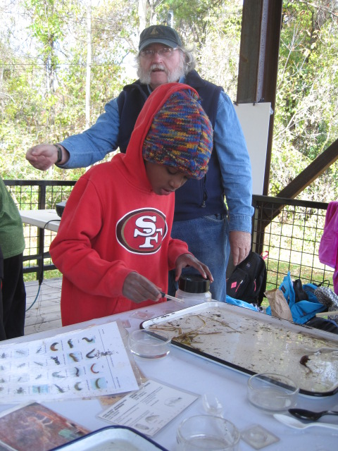
Eli Schloss & Esopus Meadows Environmental Center, Ulster Park, Ulster County
Donna Nageli, Robert Graves Elementary School – 4th grade – 44 students, 7 adults
 | 
Location: Beach Lighthouse Park, Esopus Meadows Preserve Town of Esopus. Ulster County
Area: A path along the beach with rising forested hills
Surrounding Land Use: Forested 85%, Beach 10%, 5% other
Sampling Site: Rocky shallow, sloping beach area covered with vegetation
Water depth: 2 ft.
River Bottom –rocky & muddy
Plants in area:
ITEM | Time |  | Reading 1 | Reading 2 | Comments
Physical
Air Temperature | 10:27AM |  | 13°C  55 °F | 11:00 AM | 14°C  59 °F
 | 12:45 PM |  | 16°C  60 °F
Wind Speed | 10:17 AM |  | Beaufort #2 | 4-6 kts | S
Cloud Cover | 10:17 AM |  | >75% cover | Overcast
Weather today | No rain
Weather recently | Cool
Water Temperature | 10:17 AM | 15°C  55 °F
 | 10:45AM | 16°C  60 °F
 | 11:09 AM | 15°C  57°F
Water
Turbidity -  Long Turbidity tube | 12:45 PM | 30 cm  30  30 |  | Average 30 cm
Chemical
DO  (drop count kit) | 12:45 PM  1:03 PM | 12.0 mg/L  11.0 mg/L |  | 15°C  15 | >100%  >100%
pH  Indicator sol. | 11:00 AM  12:45 PM  1:03 PM | 7.5  7.5  7.2 |  | 7.5  7.5  7.2
Salinity | NR
Fish Catch  25 ft.X 4 ft. X ¼ inch mesh – | Number Caught | Species |  | CPUE | Seine
Currents | 10:17 am | Ebb current
 | 10:45 am | Ebb current
 | 11:09 am | Ebb current
 | 12:54 PM | Ebb current
Traffic | 10:17 AM  11:09 AM  12:54 PM | Oil barge  Oil Barge  Oil Barge |  | S  S  N | Light  Light  Light

