Day in the Life of the Hudson River 10/20/15 Data
RIVER MILE 9
Pier 125
N 40, W-73
Diane Lennon, Columbia Secondary School, 31 students 11th grade, 2 adults
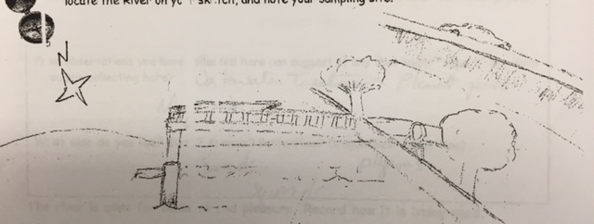
Location: Pier 125, is an educational pier used for boating and fishing
Area: Pier –sampled at mid pier away from street and bulkhead
Surrounding Land Use: 100% Industrial Commercial
Sampling Site: Recreational pier – rocks near the edge, banks altered – all hard edged concrete bulkhead, vegetation
Plants in area: No plants
Water: Calm but sometimes choppy

ITEM | Time |  | Readings
Physical
Air Temperature | 8:31AM  8:36 AM  8:41 AM |  | 11.7°C  10°C  10°C | 52°F  50  50
Wind Speed | 8:30 AM |  | Very windy |  | South
Cloud Cover | 8:32 AM |  | Clear | <25% cloud cover
Weather today | Clear |  |  | Water surface
Weather recently | Cold no rain
Water Temperature | 8:34 AM | 11°C  14°C  14°C |  |  | Average 13°C
Turbidity  Secchi | 8:30 AM | 90 cm
Turbidity short site tube | 9:20 AM | 10 JTU
Chemical | Time | ppm |  | Temp | % Sat
DO | 8:34 AM | 15ppm |  | 13°C | 140 % -
pH  kit as above | 8:35 AM | 7
Nitrates | 8:35 AM | 0.5 ppm
Phosphates | 8:35 AM | 0.61 ppm
Alkalinity | 8:35 AM | 141 ppm
Fish Catch | Time | Species |  | # caught | Size
Tides - water depth | NR
Currents | Time  8:30 AM | cm/30 sec  30.48 |  | Cm/sec  1.016 | Kts  0.0198
Shipping – Commercial | 8:27 AM  8:30  8:45 | Barge – black  Barge - black  Ferry - white |  | Not moving  Not moving  north - | Light  Loaded  ?
Shipping Recreational | 8:20 AM  8:43 AM | Too far to see speedboat- white |  | North  South
Observations | Wastewater treatment plant just north of the pier.  Saw seagulls, pigeons and squirrels

