Snapshot Day 10/20/15 Data
RIVER MILE 112 - Dutchman’s Landing, Catskill, New York
Latitude 42.21N Longitude 73.92W
Hudson River Clearwater
Jen Leibowitz, Catskill High School
3 Adults; 29 Children
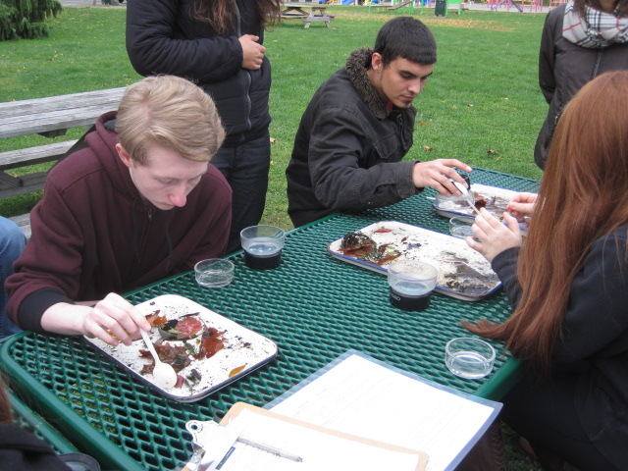 | 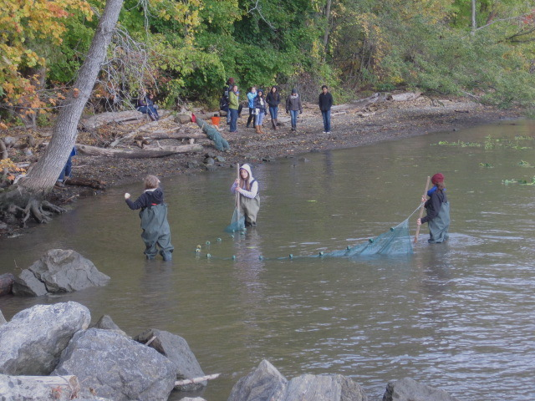

Location: Dutchman’s Landing, Catskill, Greene County NY,
Area: South of the Rip Van Winkle Bridge, Urban industrial area. park surrounded by old warehouses, stores, apartments
Surrounding Land Use: Public park with boat launch, grassy picnic area, playground, parking lot, short trail through forested area downslope of residential sites. Former dump site with much debris and broken glass.
Sampling Site: Pier, Forested, Grassy, Parking Lot, Rip Rap along park picnic area, covered in vegetation, banks altered, sampling area muddy and some rocks, concrete bulkhead. Invasive species in the area.
Shoreline: 22% sandy, 50% muddy, 28% rocky. Found mussels, brick, large stones and glass.
Plants in water: 25% tapegrass (Vallisnaria) 2% other sea grasses, 20% algae
River Bottom –muddy, rocky

ITEM | Time | Reading 1 | Reading 2 |  |  | Comments
Physical
Air Temperature | 11:15 AM | 50°F  10°C
Wind Speed | 10:08 AM | Beaufort #1 |  | SW | Gusts of #2
Cloud Cover | 10:08 AM  11:14 AM | Altostratus  same |  | 51-75%  same
Weather today | No rain, cool
Weather last 3 days | light flurries, hail, freezing temps.
Water Temperature | 12:17 PM | 52°F  11°C |  | 54°F  13°C | Average  53°F/12°C
Turbidity  Secchi off dock | 11:20 AM
Chemical
DO  Drop count | 12:17 PM  12:30 PM | 11 ppm  11 ppm |  | 11° C  13° C | 100%  100%
pH | NR
Salinity | NR
Fish Catch – total for day | Number Caught | Species
 | 7 | Spottail Shiners |  | 10 cm | DIV 3  TOTAL 14
 | 2 | Banded killi |  | 7.5 cm
 | 5 | White perch |  | 14 cm
Macroinvertebrates | Mayfly  Dragonfly  Caddisfly | Scuds  Snails |  | Midge larva | DIV 6
Tides | 9ish AM | 24 cm
 | + 15 mins | 20.3 cm |  | Falling
 | 11:07 AM | 12.7 cm |  | Falling
 | 11:22 AM | 8.89 cm |  | Falling
Currents | 10:08 AM |  |  | Slack
 | 11:00 AM |  |  | Ebb/  South
Commercial Traffic | 9:ish AM | Barge |  | Red & Black | Northbound/  Loaded
 | 10:37 AM | Bouchard |  | Red & black | Southbound/ light
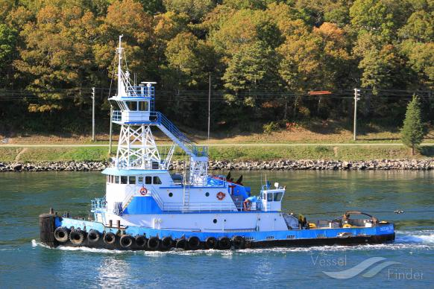 | 12:50 PM | Ocean Tower tug |  | Blue, white | South bound/ loaded w/ +2 bridge
Recreational Traffic | 9:ish AM | Speedboat |  | White | South/ light
 | 10:24 AM | Pleasure boat |  | White | South
 | 12 ish PM | Speedboat |  | Blue, White | North/ light
Other | Birds | Ducks |  | Seagulls | Bald eagle

