Day in the Life of the Hudson River 10/20/15 Data
RIVER MILE East River 1 West
Molly Thurman for the Lower East Side Ecology Center
Elizabeth O’Ferrall Ella Baker School
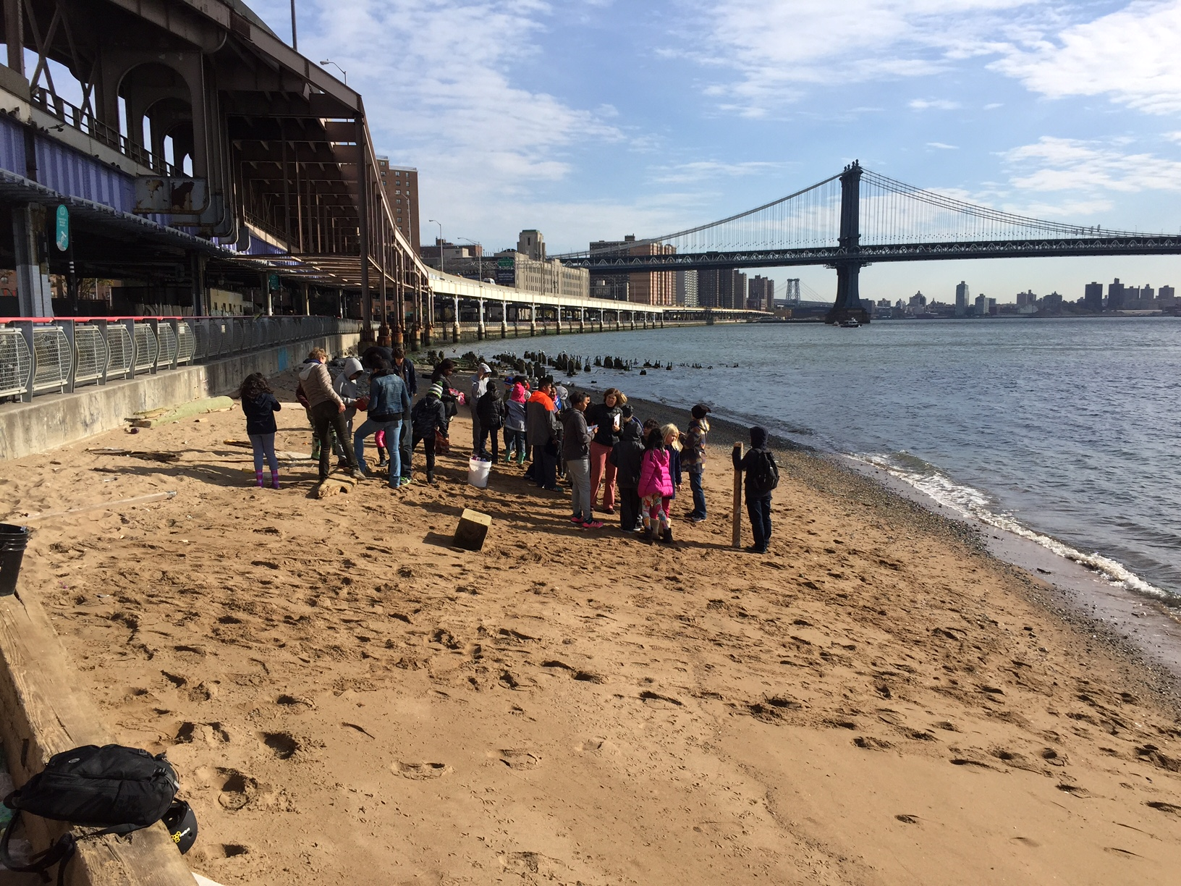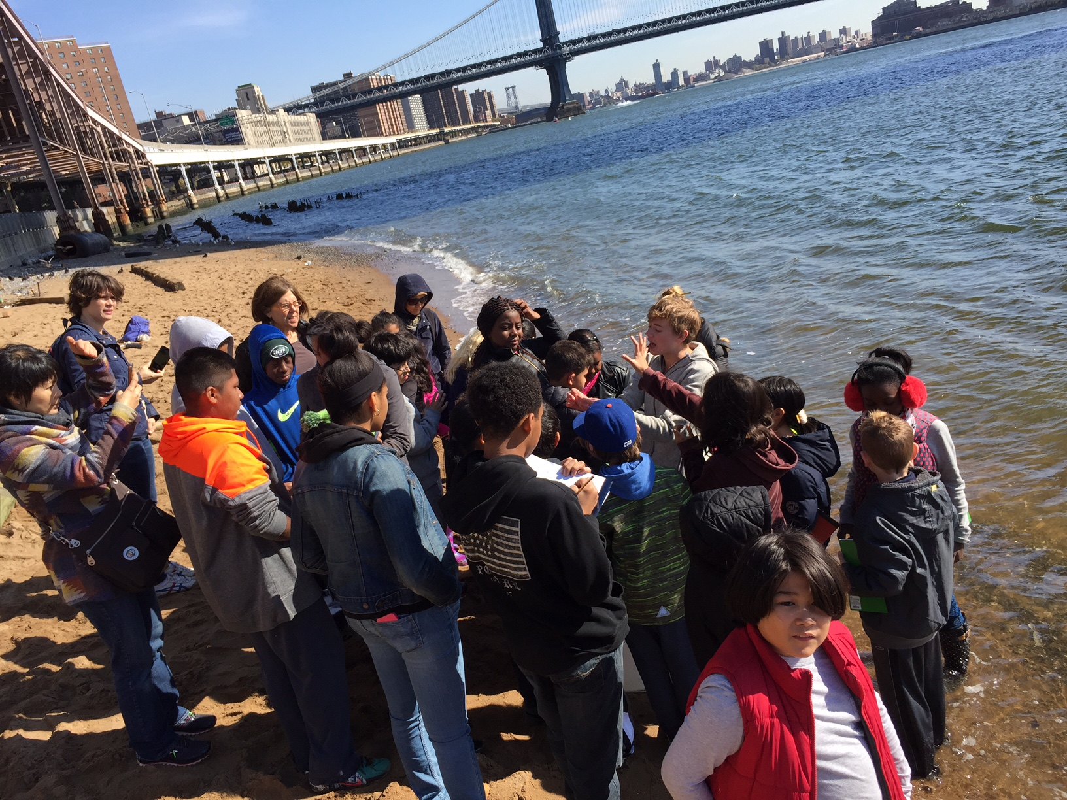
4th, 5th & 8th graders, 27 students, 6 adults
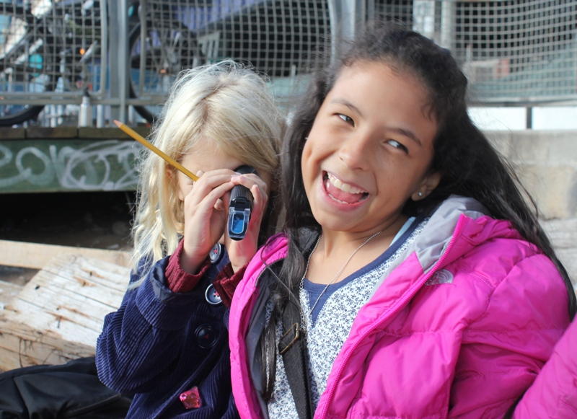 | 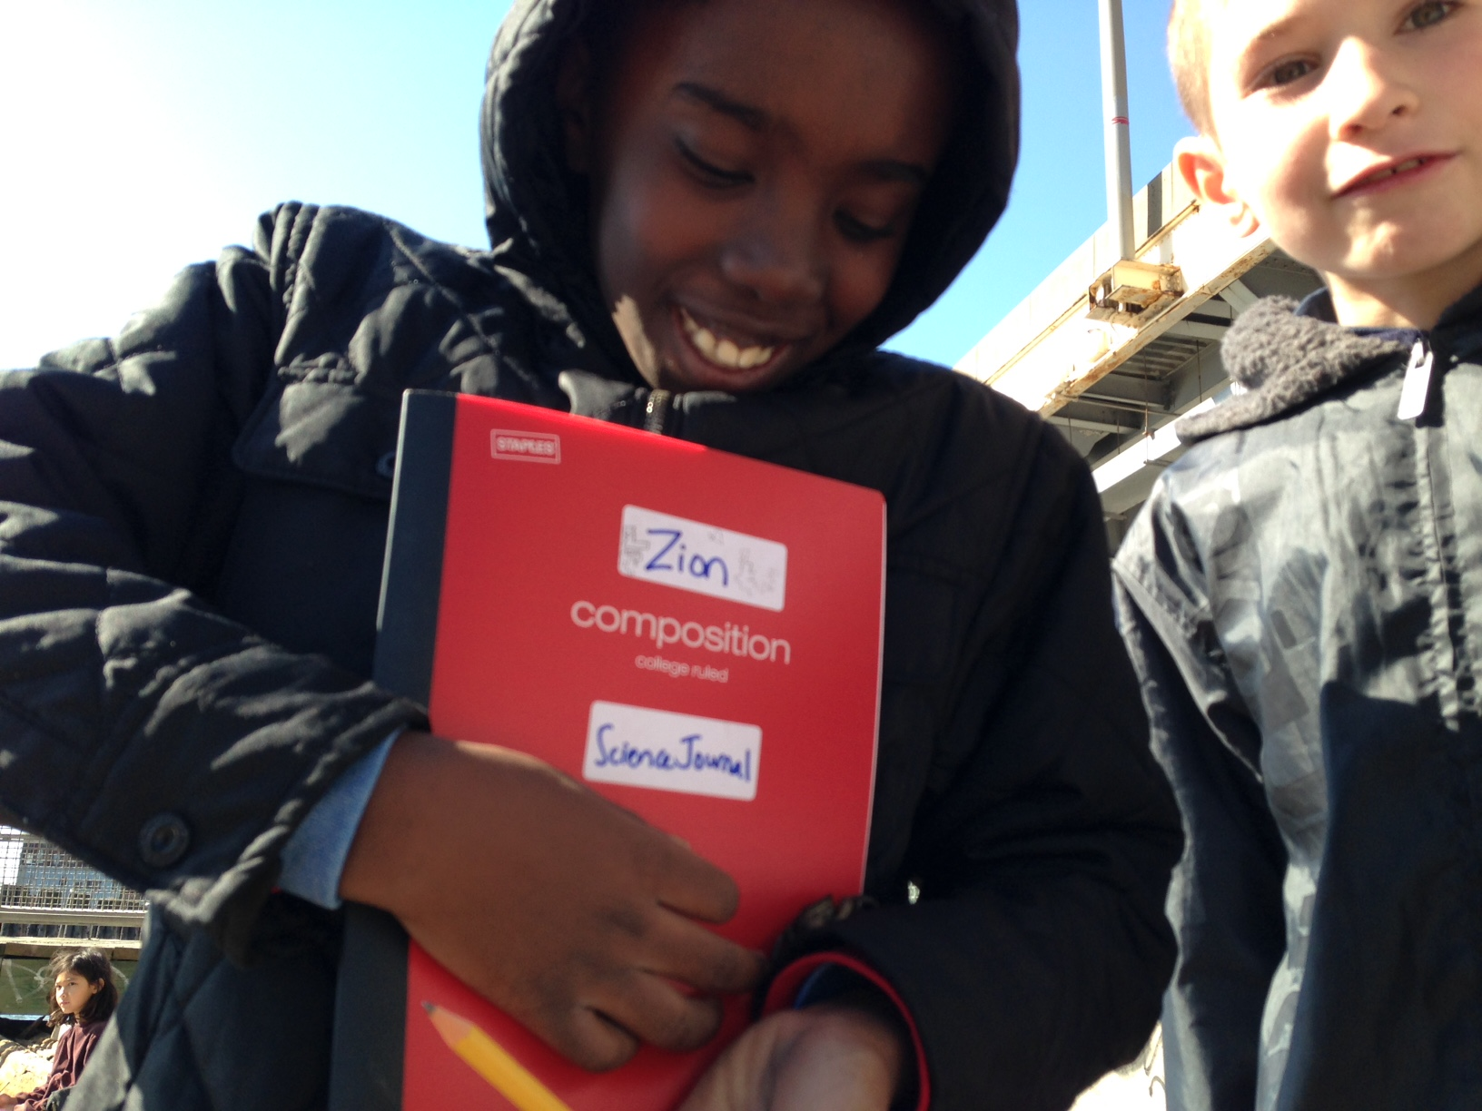
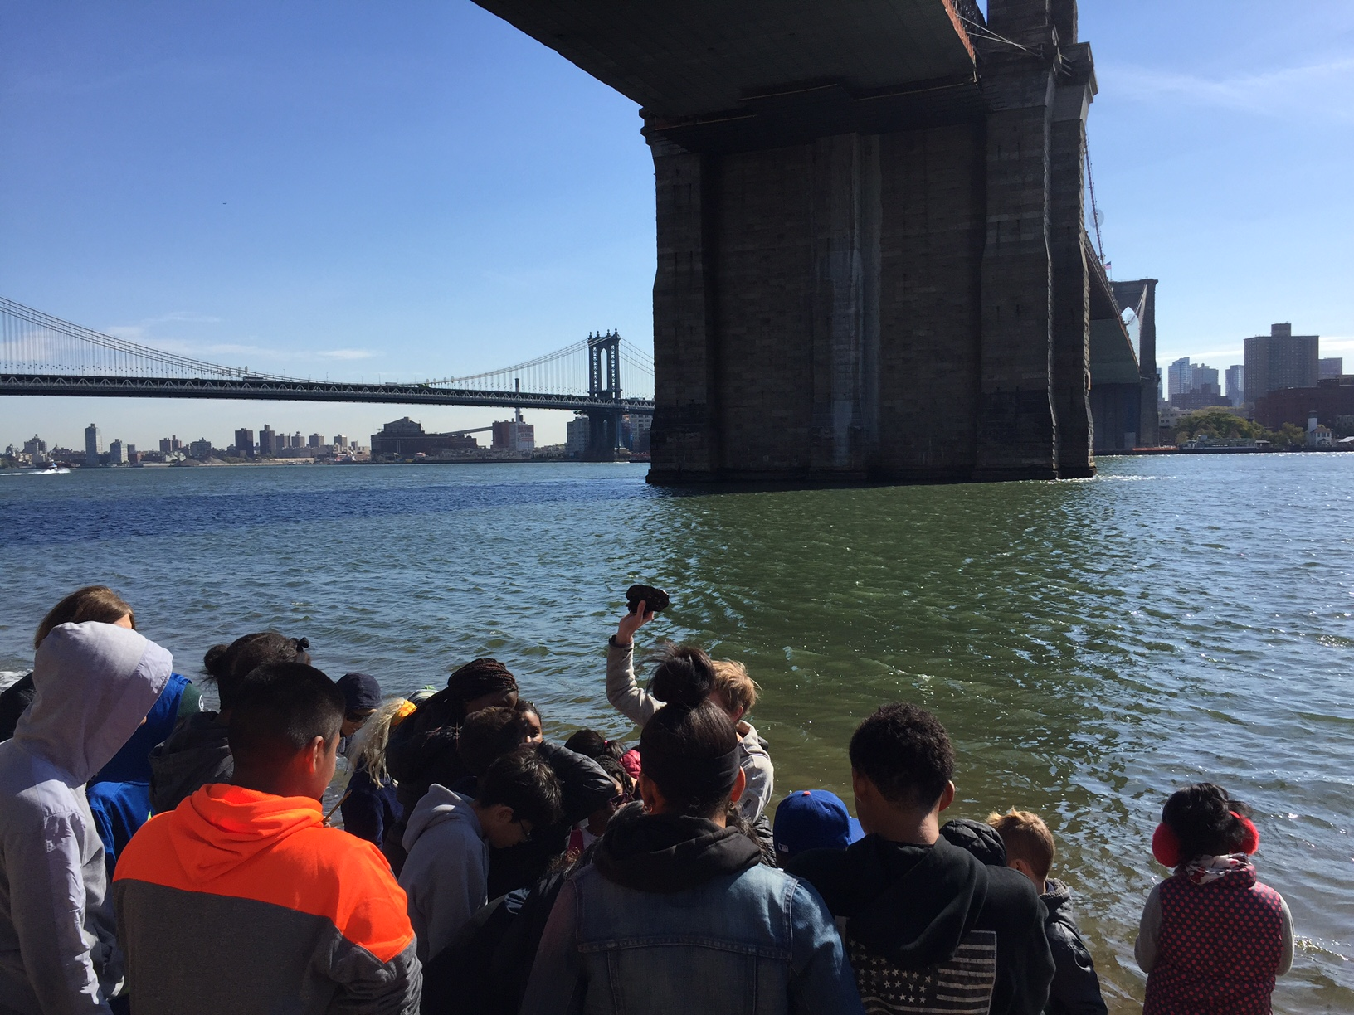
Location: Beach under the Brooklyn Bridge, 125 ft. North of Dover St., Manhattan side
Area: Pier and path for recreational walking, jogging, bike riding and fishing. The surrounding land is sandy with water – beach like. Water best used for fishing & boating. Lots of rocks and sand. Beach is opened to the public but no swimming. Also near a parking lot.
Surrounding Land Use: Urban/residential 60%; Forested 10%; Industrial/Commercial 20%; Beach 10%;
Sampling Site: Sandy, Beach, covered in vegetation, banks altered, bulkhead with timbers, RipRap. Piping entering river
Plants: 5% seaweed
Water Surface: choppy

ITEM | Time |  | Reading 1 | Reading 2 | Comments
Physical
Air Temperature | NR |  | °C
Wind Speed | NR
Cloud Cover | 26-50%
Weather today | No rain
Weather last 3 days | Cold
Water Temperature - | 11:10 AM | 16.68°C  62 F
Turbidity  Long site tube | 11:10 AM | 76.7 cm  84 cm  54 cm |  | 71.6 cm average
Chemical
DO - tablets | NR
Salinity – used two instruments | 11:00 AM | 26.4 ppt |  | Refractometer  Hydrometer
pH – color match |  | 6.0
Tides | 10:25 AM | Flooding
Currents | NR
Shipping – commercial | 10:40 AM | Red |  | Northbound | Light
 | 10:44 AM | Blue & White |  |  | Loaded
Observations | Lots of seaweed on the rocks, and large pieces of wood tossed up. Lots of seagulls.

