Snapshot Day 10/20/16 Data
Bronx RM 1.5
(Salt Front for Hudson ~ RM 80)
Concrete Plant Park, Bronx, NY
Kathalene Lamboy, Bronx River Alliance
Patrick Callahan, Bronx Center for Science & Math
15 students, 10-12th AP Environmental Science students, 2 adults
40.825506 Lat & -73.884777 Lon
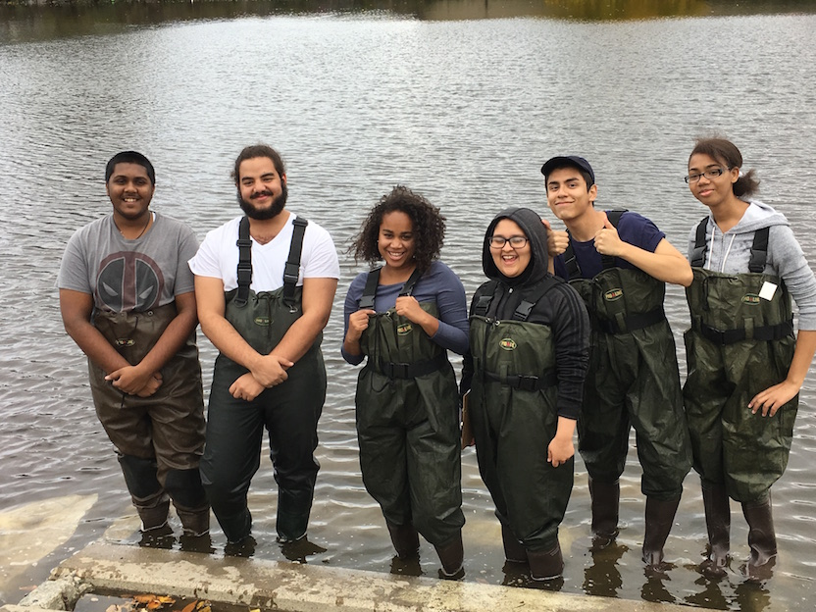 | 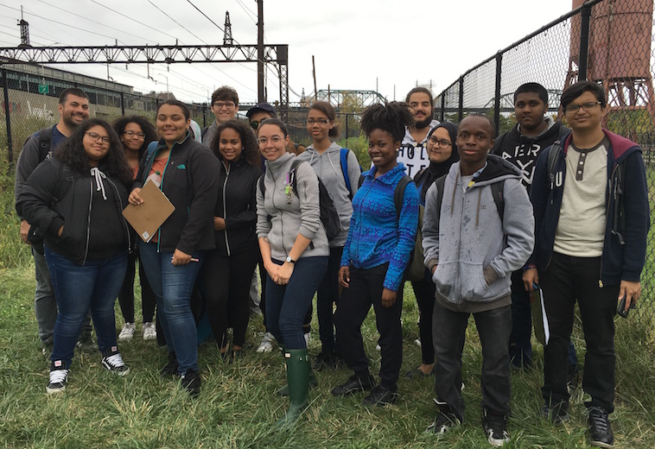

Location: Concrete plant, Bronx River
Area: Pier, Forested bank, grassy area with concrete bike path, RipRap, Concrete Bulkhead, pipe entering the water
Surrounding Land Use: 32% Urban/Residential, 2% forested, 60% Industrial/Commercial, 5% lawn/vegetation
Sampling Site: No plants in water, trash around
River Bottom: Muddy, Rocky
Plants in area: No plats in water

ITEM | Time – |  | Reading 1 | Reading 2 | Reading 3
Physical
Air Temperature | 10:00 AM  11:00 AM  11:40 AM |  | 75°F  68°F  69°f | 24°C  20°C  21°C
Wind Speed | 11:40 AM |  | 7 mph | Southerly
Cloud Cover | 11:40 AM |  | >75% overcast
Weather today | overcast
Weather last 3 days | Warmer than usual
Water Condition
Water Temperature | 10:45 AM  11:15 AM  11:28 AM | 20°C  20  19 |  | 68°F  68°F  66°F
Turbidity  secchi | 11:00 AM | 105.3 cm  91.2 cm  75 cm |  | Average 90.5 cm | Water very clear
 | Water became more turbid when the tide became higher.
Chemical
DO  (LaMotte drop count kit) | 10:45 AM  11:15 AM  11:28 AM | 4.2 ppm  4.1  5.3 |  | 20°C  20  19 | 28% satur.  29%  37%
pH - test strips, color match test kit | 11:24 AM  11:28 AM | 5, 5, 4  5, 4, 4 |  |  | 4.9  4.3
Salinity - hydrometer | Reading 1 ppt | Reading 2 ppt |  | Reading 3 ppt | Average – ppt
10:45 AM | 15 ppt
11:15 AM | 15 ppt
11:28 AM | 15 ppt
Fish Catch | Total | Fish |  |  | 3-4 seines
Div – 2  Total Catch - 83 | 81 | Silversides
 | 2 | Banded Killi
 | 4 | Shore Shrimp
Macro - Div – 2  Total Catch - 5 | 1 | Mud Crab
Tides
Currents - Time | Cm/30 secs | Cm/sec |  | Kts | E/F/S
10:51 AM |  |  |  | 3.8
Ships - commercial | 10:30AM | Red/Brown Barge |  | Southbound | loaded
Ships Recreational | 11:15 AM | Blue Canoes |  | Northbound | loaded
Other Observations | Seagulls, lots of trash, *dead fish in area.
*Note that there had been a report of dead fish in the Bronx. DEC team had checked it out before the event and noted that they felt it was from low D.O. levels in the river.

