Day in the Life of the Hudson River 11/20/16 Data
(Salt Front ~ RM 83)
RIVER MILE -11.2
Great Kills Gateway National Recreation Area, Staten Island
Mary Lee, St. Clare’s School, 70 Seventh graders and 10 adults
N 40°32.33.7’ - W-74°07.30.7 min
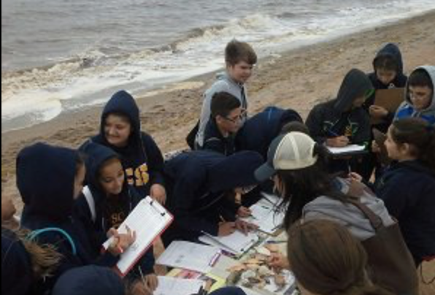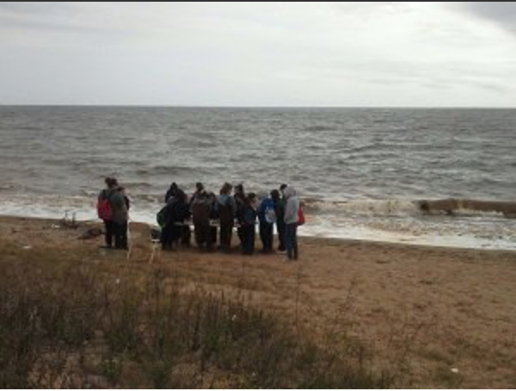
Location: Beach, Great Kills Gateway National Recreation Area, Staten Island
Sampling Site: Open beach, Shoreline is 100 % beach (urban park), <5% forested,
Surrounding Area: Beach and riprap, sandy and rocky. Debris on the beach (plastic and Styrofoam)
Water Depth: 2-3 ft.
River Bottom: sandy
Plants in area: No plants

ITEM | Time |  | Readings
Physical
Air Temperature | 10:30 AM  12:03 PM |  | 21°C  20 | 70°F  68
Wind Speed | Throughout AM - NE |  | Beaufort  3 and 4 | OR  8-12 mph | Anemometer 17 mph
Cloud Cover | Overcast >75 %
Weather today | Predicted rain for the day |  | Increasing cloud cover during day | Water surface | Very choppy
Weather recently | Warmer than normal, dry
Water Temperature | 10:10 AM  10:35 AM 11:07 AM  11:37 AM  11:50 AM | 20 °C  20  20  20  20 |  | 68°F  68°F  68°F  68°F  68°F
Turbidity  Turbidity tube | 10:09 AM  10:38 AM | 12 cm  6.5 cm |  | 8.25 cm avg
Chemical | Time | ppm |  | Temp | % Sat
DO – multiple readings – tablets -  Estuary Wide Kit – | 11:00 AM | 4, 6, 5, 4, 4 ppm |  | 20° C | 50%
pH  tablets - LaMotte | 10:10 AM | 7 X 3 |  | 7 average
Salinity - hydrometer | 11:09 AM | 27.5 ppt  27.5  31.0  27.5  29.0 |  | 28.5 ppt
Fish Catch – seine 15 ft. net – 6 ft. pull | Time | Species |  | Number
Macroinvertebrates |  | Blue crabs  Mussels  HS crabs  Calico crab  Spider crab  Slipper shells  Angel wings |  | All specimen dead at tide line – nothing living collected
Tides (from pier to water) | Time | Rising/Falling |  | Height in cm | Rate of change
 | 9:45 AM | Rising |  | 40 cm | n/a
 | 10:07AM | Rising |  | 45 cm | 5 cm/15 min
 | 10:23AM | Rising |  | 50 cm | 5 cm/15 min
 | 10:38 AM | Rising |  | 70 cm | 20 cm/15 min
 | 10:55 AM | Rising |  | 80 cm | 10 cm/15 min
 | 11:05 AM | Rising |  | 90?
*tide pole lost due to incoming tide | 11:24 AM | Rising
Currents - Time | Cm/30sec | Cm/sec |  | Knots | Ebb/Flood
10:15 AM | 500 | 16.7 |  | 0.32 | F
10:31 AM | 900 | 30 |  | 0.58 | F
10:45 AM | 440 | 14.7 |  | 0.29 | F
11:05 AM | 250 | 8.3 |  | 0.16 | F
11:34 AM | 2220 | 74 |  | 1.44 | F
12:05 PM | 440 | 30.03 |  | 0.59
Core Sample | Length | Abundant |  | Common
11AM  2 ft. water depth | 16.5 cm | Sand  Gravel
Shipping – Time | Type | Name |  | Color | Direction
11:10 AM | MCP | Container |  | Southbound | Loaded
12:00 PM |  | Container |  | Southbound | Loaded

