Day in the Life of the Hudson River 10/20/16 Data
(Saltfront ~ RM 83)
RIVER MILE -5
Bayridge American Veterans’ Memorial Pier
N 40. 38’22.-416 , W-74 .2’18.4308
Alicia Smith & International School of Brooklyn
30 Fifth graders, 4 adults
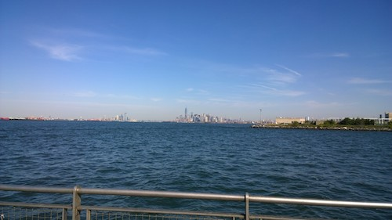
View from the pier. Owl Sewage treatment plant visible in the foreground.

Location: Pier American Veterans’ Memorial Pier, by highway, Park, 2 water treatment plants
Area: Pier – bulkhead – mainly concrete & wood. Two parks – Owl’s head and Shore Road Park. Water treatment plant <0.5 miles to the NE
Surrounding Land Use: 85% urban/residential, 5% Industrial Commercial, 5% park, 5% highway
Sampling Site: Recreational pier with bulkhead– rocks near the edge, banks altered /riprap, all hard edged, steep wall dividing water from land, pipe entering water from treatment plant
Shoreline: Rocky
Depth: ~ 20 ft.
Plants in area: No plants
Bottom: could not see to tell
ITEM | Time |  | Readings
Physical
Air Temperature | 12:00 PM  12:45 PM |  | 24.5°C  23 °C | 76.1°F  73.4°F
Wind Speed | 11:21 AM |  | Beaufort 3 | 9 kts | W
Cloud Cover | 12:00-12:45 PM |  | Mostly cloudy | 51-75% | cloud cover all day
Weather today | Overcast -> partly cloudy -> overcast |  |  | Water surface | choppy
Weather recently | Unusually warm temperatures, sunny skies, humid
Water Temperatures & averages | 11:40 AM  12:07 PM  12:30 PM | 19, 19, 19°C  20, 19°C  20, 19°C |  | 66.2 X 3 °F  68, 66.2 °F  68, 66.2 °F | 19C/66.2F  19.5C/67.1F  19.5C/67.1F
Turbidity | 12:10 PM | 96.6 cm  119.2 cm  120 cm |  |  | Avg. 111.9 cm
Chemical | Time | ppm |  | Temp | % Sat
DO  Drop count kit | 12:18 PM | 6.4 |  | 23°C | 74%
pH  meter | 11:45 PM  12:15 PM  12:30 PM | 7.70  7.71  7.77 |  |  | Avg. 7.71
Salinity -hydrometer | 11:45 PM  12:15 PM  12:30 PM | 28 ppt  28 ppt  28 ppt |  |  | 28 ppt
Fish Catch | Time | Species |  | # caught | Size
*Tides - water depth | Time | *Distance to water |  | *Rate of change | *Flood or Ebb
Measuring down from pier using a secchi disk | 12:00 PM  12:24 PM  12:40 PM | 150 cm  200 cm -fall  150 cm - rise |  | N/A  -50 cm  +50 cm | -2.08 cm/m  +2.08 cm/m
*For the short period of time it seems as if the 12:24 PM measurement might have been a ‘swell’ of water moving through the area not a tidal change. We would expect to see a ‘still’ or ‘slack’ period of some sort between tidal changes and matching tides to currents we do see that there is a slack period during this timeframe.
Currents  Time | Cm/30 sec | Cm/sec |  | Kts | Ebb/Flood N/S
12:00 PM | 304.8 | 10.16 |  | 1.1977kts | NE - flood
12:45 PM | 251.46 | 8.38 |  | 0.1631kts | W - slack
Comment noted on the recording sheet: Data was collected from a pier that jets out into the upper NY bay. As tides change, there is a swirl in the bay. The tide data shows that the tides was shifting between 12:00 PM and 1:00 PM which supports a more swirling current.
Shipping Traffic- Commercial | 12:00-12:20 PM | ~ 30 ships |  | Almost all commercial | 1 sailboat
 | 12:20-12:45 PM | ~ 25 ships |  | Almost all commercial | 1 sailboat
Observations | Observed large flock of birds near the treatment plant floating in water about ½ mile from test site.

