Day in the Life of the Hudson River 10/20/16 Data
(Saltfront ~RM 83)
RIVER MILE 100.5
South Cove at Falling Waters, Glasco, Ulster County
Brian Robinson, Saugerties High School, 13 AP Env. Sci. 11th-12th grade students and 2 adults
N 42. 046752, W-73.939081
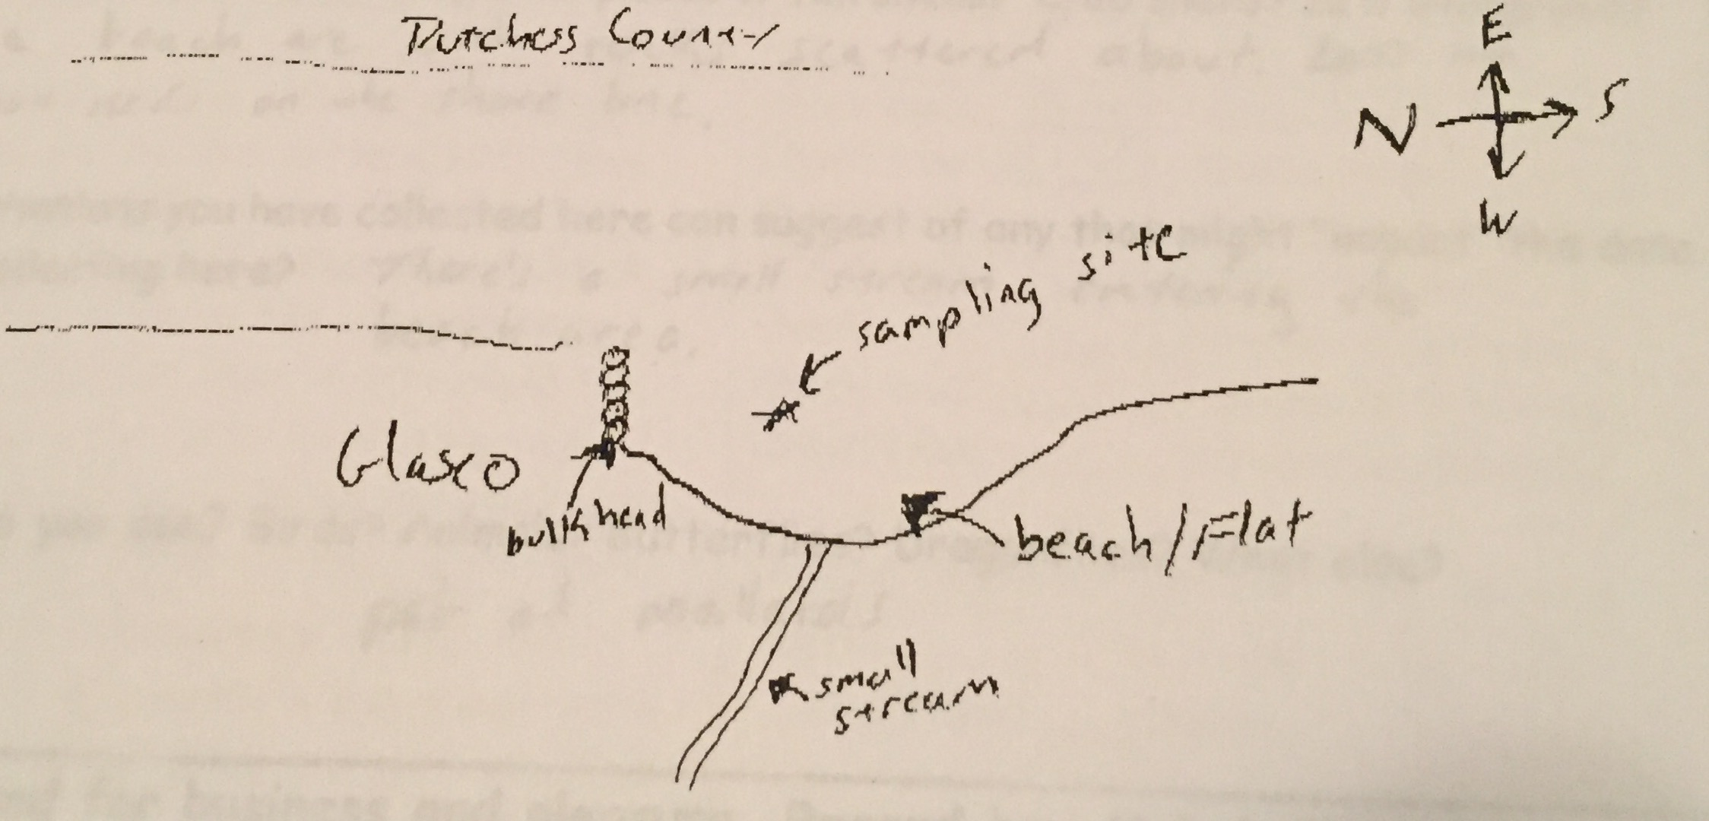

Location: Falling Waters protected area, South Cove, Glasco, Ulster County
Area: Forested, cove with a shallow beach
Surrounding Land Use: 100% forested
Sampling Site: Parkland, beach covered in vegetation, concrete bulkhead
Shoreline: Sandy, muddy, rocky
Depth: could not see bottom
Plants in area: water is 40% covered with water chestnut
Site Observations: Old brick pieces on the ground names on bricks are Wasburn, Lent, …Bury, lots of old washed up logs, seaweed
Bottom: Sandy, muddy
Water: Choppy

ITEM | Time |  | Readings
Physical
Air Temperature | 10:45 AM |  | 17°C | 62 °F
Wind Speed | 10:42 AM |  | Beaufort 3
Cloud Cover |  |  | Overcast | >75%
Weather today | Cloudy |  |  | Water surface
Weather recently | Warm and dry
Water Temperature | 10:45 AM | 17.6°C |  | 63.7 °F | 2 ft. depth,
Turbidity | NR
Chemical | Time | ppm |  | Temp | % Sat
DO  Drop count kit | 11:10 AM | 17.6 ppm* |  | 20°C | *Too high – must have been an air bubble
pH  color match test | 10:45 AM | 8
Salinity –titration strips | 10:45 AM | 1.2 strip |  | 32 ppm Chl | 58 ppm TS
Alkalinity | 10:45 AM | 80 ppm
Nitrates | 10:51 AM | 8.8 mg/L
Phosphates | 11:00 AM | 2 mg/L
Fish Catch – 30 ft. | Species | # caught |  | Length of largest | TOTALS
11:00 AM | Blueback herring | 1 |  | 45 mm | DIV 6  TOTAL 9
 | Spottail Shiner | 1 |  | 40 mm
 | White Perch | 1 |  | 90 mm
 | Bluegill Sunfish | 2 |  | 80 mm
 | Pumpkinseed Sunfish | 3 |  | 130 mm
 | Tesselated Darter | 1 |  | 60 mm
Tides - water depth | Time | Distance to water |  | Rate of change | Flood or Ebb
 | 10:44 AM  11:10 AM | 13 cm  6 cm |  | 7 cm drop | Ebb
Currents | Time | Cm/30 sec |  | Cm/sec | Knots &  Ebb/Flood
 | NR
Commercial Shipping | 11:00 AM | UBC Ship |  |  | Southbound
 | 11:10 AM | Barge & Tug |  |  | Northbound
Observations | Beach area with rocks scattered around and lots of chestnut seeds on the shoreline.  Pair of mallards

