Day in the Life of the Hudson River 10/20/16 Data
(Salt Front ~ RM 83)
RIVER MILE 11.5 – Fort Washington Park
Katie White, Marymount School of New York
51 students 7th grade, 7 adults, 8 adults
Latitude 40°50’46.42444” N - Longitude -73.°56’46.914”W
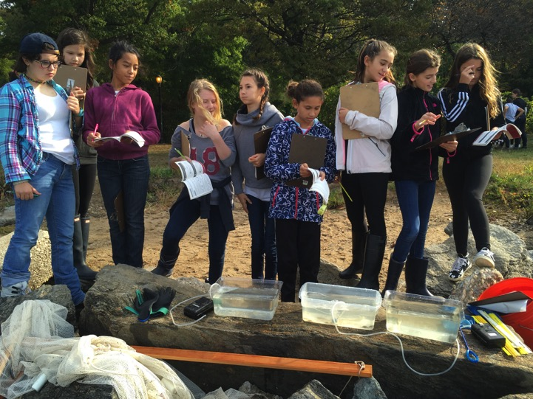
Location: Fort Washington Park just South of the George Washington Bridge
Area: Site is a sandy beach with rip rap adjacent to a paved jogging trail within a grassy park. Some trees on far side of jogging trail but none next to water. Very little aquatic vegetation.
Surrounding Land Use: : 14% forested, 85% grass park land, 1% beach,
Sampling Site: Park with a lot of trees, picnic tables, covered with vegetation, lots of riprap shore, collected wood debris. Large outflow pipe directly south of site <100 meters
Plants in water: None
Water depth: 2-4 ft.
River Bottom –mainly sandy and rocks, no mud this year (past years yes)

ITEM | Time | Reading 1 | Reading 2 | Comments
Physical
Air Temperature | 9:51 AM  10:16 AM  10:59 AM  1:00 PM  1:43 PM | 20°C  21  22  25  25
Wind Speed – | Time | Clouds | Beaufort # | Wind m/s
 | 9:53 AM | mostly cloudy | 3 - SW | 8.7
 | 10:14 AM | mostly cloudy | 2 - SW | 6
 | 11:01 AM | mostly cloudy | 3 - SW | 8.3
 | 1:05 PM | mostly cloudy | 2 - SW | 7.1
 | 1:24 PM | mostly cloudy | 1 - SW | 2.9
Cloud Cover | 10:06  10:26  10:55  12:24  12:52 | Partly cloudy Mostly  Mostly  Clear  Clear | 25-50 %  51-75  51-75  <25  <25
Weather today | No rain | Consistent weather throughout day
Weather last 3 days | Weather for past 3 days: Warm (low 80s) and dry (no rain)
Water | Water mainly calm, some small wavelets
Water Temperature | 9:49 AM  10:23 AM  10:48 AM  12:18 PM  12:51 PM | 11°C  12°C  14°C  18°C  15°C
Turbidity - Long site tube | 9:46 AM  10:22 AM  11:00 AM  12:58 PM  1:30 PM | 57.4 cm  63.22cm  59.2 cm  17.9 cm  13.1 cm |  | Tide was very high in the PM & mixing with sand on the beach ⬆ turbidity
Chemical
DO  Salifert Kit  (each measurement is avg. of 4-5) | 9:46 AM  10:21 AM  10:55 AM  12:41 PM  1:26 PM | 18.5°C  17.5  20  19.5  20 | 6.8 ppm  5.6  5.8  4.2  5.5 | 70% saturation  60%  60%  43%  60%
pH  color match test kit - (each measurement is avg. of 4-5) | 9:46 AM  10:21 AM  10:55 AM  12:41 PM  1:26 PM | 7.6  7.4  7.6  7.6  7.7
Salinity |  | refractometer | hydrometer
 | 9:36 AM  10:20 AM  10:50 AM  12:50 PM  1:10 PM | 21.6 ppt  20.8  20  21.5  23.8 | 30 ppt  26.4  20.4  22.6  22.8 | Average 21.54  *Bolded values are outliers – refractometer is more accurate.
Fish Catch – 9 ft. 30 ft. pull -  22 seines – 8 with no catch | Time | Fish Species | # caught | Length cm
Seine #3 | 9:51 AM | Atlantic Silversides | 9 | 8.5
#4 | 9:55 AM | Atlantic Silversides | 15 | 10.5
#6 | 10:20 AM | Striped Bass | 1 | 9
#7 | 10:30 AM | Atlantic Silversides | 8 | 12.5
#10 | 10:55 AM | Bluefish | 1 | 15.5
#21 | 1:21 PM | Atlantic Silversides | 1 | 10.5
#22 | 1:35 PM | Bay Anchovy | 1 | 6
TOTAL DIV - 3 | TOTAL CATCH 36
Macroinvert | Number | Macros | Number | Additional Info
Seine #2 | 9:38AM | Portunid crab | 4 | All Male
 |  | Hydroid Medusa | 1
#4 | 9:55 AM | Portunid crab | 4 | All Male
#5 | 10:14 AM | Portunid crab | 1 | Male
#10 | 10:55 AM | Portunid crab | 1 | Male
11 | 11:15 AM | Ctenaphore | 2
#12 | 11:18 Am | Hydroid Medusa | 1
 |  | Portunid crab | 2 | 1 M, 1F
#14 | 12:47 PM | Portunid crab | 1 | F
#18 | 12:59 PM | Hermit Crab | 1
#19 | 1:07 PM | Portunid crab | 1 | M
#20 | 1:17 PM | Hermit Crab | 2
 |  | Ctenaphore | 2
 |  | Hydroid Medusa | 8
Macro – Div. 4 | Totals 31
Tides | 9:45 AM | Rising | 27 cm | ---
Data collected | 10:24 AM | Rising | 40 | 0.33
With stick in | 10:45 AM | Rising | 55 | 0.71
the sand | 11:15 AM | Rising | 60 | 0.17
 | 12:52 PM | Rising | 85 | 0.27
 | 1:15 PM | Rising | 83 | -0.09
Currents | Cm/Sec | Ebb/Flood/Still | Note
9:45 AM  10:24 AM  10:45 AM  12:52 PM  1:15 PM | 17 cm/s  4.6  6.1  7.7  4 | Ebb  Ebb  Ebb  Ebb  Ebb | We threw orange as far as possible but caught in side current. We expected flood based on tide
Shipping – Commercial | 10:08AM | Tug | Course of America | N - Light
 | 11:06 AM | Cargo | BBC Alabama | N - Light
Recreational | 9:45 AM | Speed boat | n/a | South
 | 10:04 AM | Sail boat | L'aeuse aux Fraises | South
 | 10:31 AM | Speed Boat | n/a | South then North
 | 12:39 PM | Yacht | n/a | North
 | 12:39 PM | Sail boat | n/a | South
 | 12:39 PM | Sail boat | n/a | South
 | 12:54 PM | Sail boat | n/a | South

