Day in the Life of the Hudson River 10/20/16 Data
(Salt Front ~ RM 83)
RIVER MILE 117.5 – Athens Riverside Park
Elisa Futia, Edward J. Arthur Elementary School
15 second grade students, 3 adults
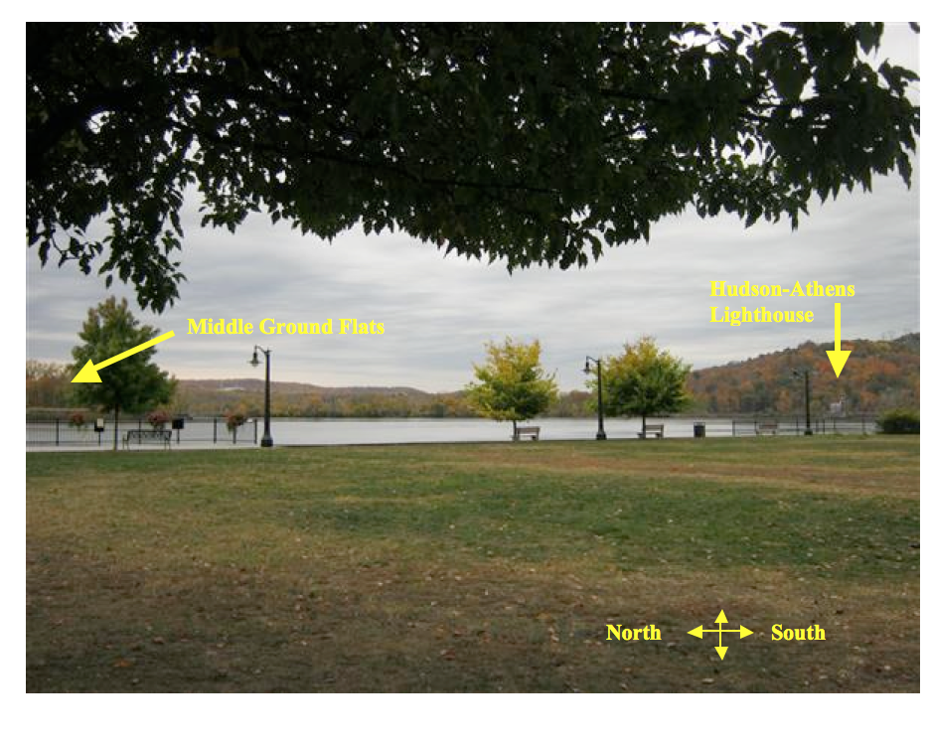
Location: Riverfront Park, waterfront of Athens, Greene County across from Middle Ground Flats
Area: Grassy Park area with benches and lookout. Vegetated coverage – grassy, parking lot, used for picnics, boating, fishing
Surrounding Land Use: 85% residential, 5% beach, 10% industrial commercial Shoreline: Bulkhead and riprap
Plants in water: Water chestnut extracted from the current but not covering water
ITEM | Time | Reading 1 | Reading 2 | Comments
Physical
Air Temperature | 10:34 AM | 20°C | 68°F
Wind Speed | Beaufort 1
Cloud Cover | Overcast
Weather today | overcast
Weather recently | Unusually hot for October – near record breaking temperatures
Water Temperature | 11:00AM | 15.5°C  60°F
Water Surface | Calm
Turbidity | 10:30AM | 61 cm | 92 cm | Average 76.5 cm
Chemical
Salinity - Quantabs | 11:00 AM | 39 ppm Cl- | 70 ppm TS | 1.4 units, 0.007
Fish Catch  Minnow trap | Total # | Species – | Size | Totals
FISH – nothing caught but active school by the riprap
Tide – converted from inches | 10:26 AM  10:34 AM  10:42 AM | 173.99 cm  177.8 cm  180.34 cm | Falling  Falling | *68.5 inches  70 inches  71 inches
Currents | 10:30 AM |  | South | Ebb
Boating - | 10:17AM  10:23AM | Tug/barge  Speedboat | South  South | (kids said police boat)

