A Day in the Life of the Hudson River 10/20/16 Data
(Saltfront ~ RM 83)
RIVER MILE 123
River Front Park, Coxsackie
Jen Rausch, Coxsackie Elementary – 50 students 4th graders, 25 adults
Latitude N 42 degrees 22.2' Longitude W 73 degrees 47.756"
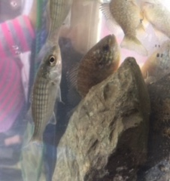
Location: River front park with parking area, boat launch, picnic
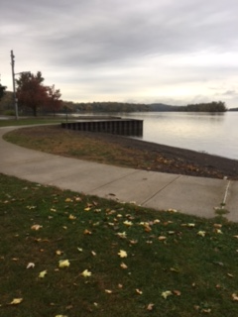
Area: Parking area and cement boat launch with fishing and picnic area
Surrounding Land Use: Forested 15%, Beach 30%, parking area, cement boat launch, picnic area and fishing 55%
Sampling Site: Beach, covered with vegetation, rip rap altered banks, melt bulkheads
Plants in area:
Water depth:
River Bottom –rocky bottom

ITEM | Time |  |  | Comments
Physical
Air Temperature | 10:20 AM  10:45 AM  11:30 AM | 59.2°F  61.6 °F  60 °F | 15°C  16.4°C  15.5
Wind Speed | 10:20 AM | 0.6 mph | N
Cloud Cover | 10:20 AM  partly cloudy  26-50% | 12:15 PM  overcast  >75% | Water | Calm
Weather today | overcast
Weather recently | Dry and warm
Water Temperature | 9:57 AM  11:00 AM  11:30 AM | 18°C  18  18 | 64°F  63  64
Turbidity-  Long Tube | 53 cm  57 cm  43 cm | Avg – 51 cm
Chemical
DO (Hach drop count) | 9:57 AM  10:27 AM  11:30 AM | 8 ppm  12 ppm  13 ppm | 18 C  18C  18C | 85 %  120 %  120 %
pH | NR
Salinity YSI meter | 10:30 AM  11:00 AM | 0.1 ppt  0.1 ppt | 100 ppm  100 ppm | 1.4 on LR quantabs  61 ppm TS
Fish Catch | Number | Species | Length
10:20-11:40 AM | 1  1  2  6  62 | Red breasted sunfish  Shiner  Striped Bass  Pumpkinseed  Killifish | 12 cm  9 cm  7 cm  5-7 cm  4-8 cm | DIV 5  TOTAL 72
Tides – | 10:20 AM  10:57 AM  12:09 PM | 61 cm  47 cm  5 cm | Falling  Falling
Currents - Direction | 10:20 AM  10:45 AM  10:57 AM  11:30 AM | 198 cm/30secs  91 cm/30 secs  104 cm/30 sec  91 cm/30 secs | 6.6 cm/sec  3 cm/sec  3.5 cm/sec  3 cm/sec | Ebb  Ebb  Ebb  Ebb
CORE | Condition | Rare | Common | Abundant
4 cores – average length 15 cm | H2S smell  15 cm | Pebbles  Leaves  Wood  Shells | Clay - bottom  Mud - top  Sand  Gravel
Observations | Water chestnut seeds, bits of brick on beach  Few seagulls, flock of geese flying over going south
Commercial Shipping | 8:46 AM | UBC |  |  | South – light
 | 9:38 AM | Tug pushing barge | White and teal |  | South - loaded
Recreational Shipping | 10:10 AM | Speedboat | Black |  | South

