Snapshot Day 10/20/16
(Saltfront ~RM 83)
RIVER MILE 14
Inwood Hill Park Nature Center, NYC
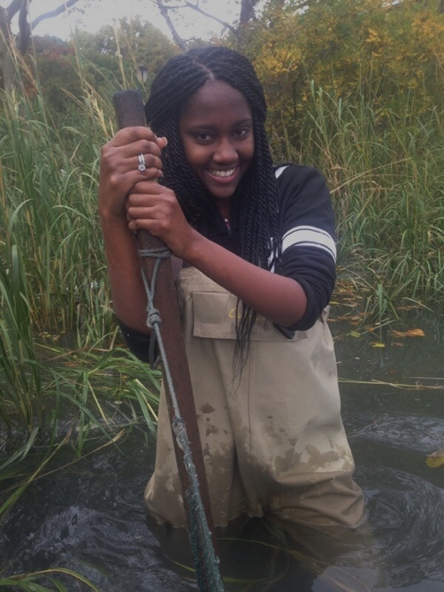
Carolina Castro – Riverdale Kingsbridge Academy - 10th grade –
30 students, 4 adults
Latitude 40°50’N/ Longitude 73°55 W
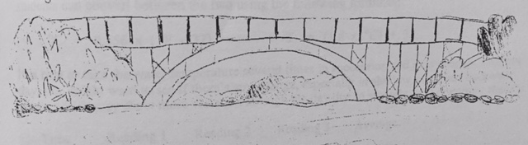

Location: In the cove of Inwood Hill Park
Area: Forested
Surrounding Land Use: Forested 60%; urban residential 40%; park/recreation; Pier, bulk-headed, rip rap shoreline. Forested and used by people for picnics, jogging, sitting on park benches.
Sampling Site: large riprap on shoreline, drainage pipes in area, vegetation
Plants in area:
Water depth: 3-4 feet
River Bottom – muddy
ITEM | Time |  | Reading 1 |  | Comments
Physical
Air Temperature | 10:30 AM |  | 63 F  17.2 C
Wind | 10:30 AM |  | Beaufort 1.5
Cloud Cover | 26-50% |  | Partly cloudy
Weather today | No rain
Weather recently | Warm and dry
Water surface: | calm
H2O Temperature | 11:04 AM | 20 C  20  20 |  | Average 20 C
 | 12:02 PM | 20 C  20  20 |  | Average 20 C
 | 12:15 PM | 20 C  20  20 |  | Average 20 C
Turbidity  (long site tube) | 11:00 AM | 15 cm  16 cm  13 cm |  | Average 14.3 cm
Chemical
DO  Drop Count test kit | 12:00 PM | 2 ppm – cited possible error |  | 20 C | 22% saturated
pH | 11:35 AM | 7  7  7 |  | 7 Average
Salinity – refractometer | NR
Fish Catch | Number Caught | Species |  | CPUE | Seine
Seine 12:00 PM | 2 | Atlantic Silverside |  |  | DIV 1  TOTAL 2
Tides | Time | Height |  | Rise/Fall/Unch | Rate of Change
 | 10:39 AM | 92.4 cm |  | Rising | Start
 | 11:00 AM | 102.3 cm |  | Rising | 0.495
 | 11:20 AM | 111 cm |  | Rising | 0.435
 | 11:40 AM | 119.4 cm |  | Rising | 0.42
 | 12:00 PM | 129 cm |  | Rising | 0.48
Currents | Cm/30 sec | Cm/sec |  | knts | N/S Ebb/Flood
10:50 AM | 250/30 | 8.3 |  | 0.161 | N still
11:20 AM | 111/30 | 3.7 |  | 0.072 | N still
11:49 PM | 500/30 | 16.67 |  | 0.324 | N flood
Measured on the left channel not main body
Shipping | Circleline | Northbound |  | Loaded with people | No time listed

