Day in the Life of the Hudson River 10/20/16 Data
(Saltfront ~ RM 83)
(Above the Troy Dam and the Head of Tide)
RIVER MILE 154
Peebles Island State Park, Waterford, NY
Becky Zimmerman, Angela Jones and Raquel Santiago-Parker
Pine Hills Elementary School
64 students – 4th grade, 11 adults total
42°47.051’N and 73°40.706 W
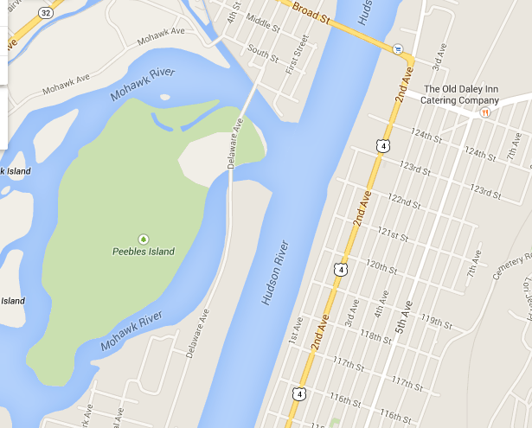
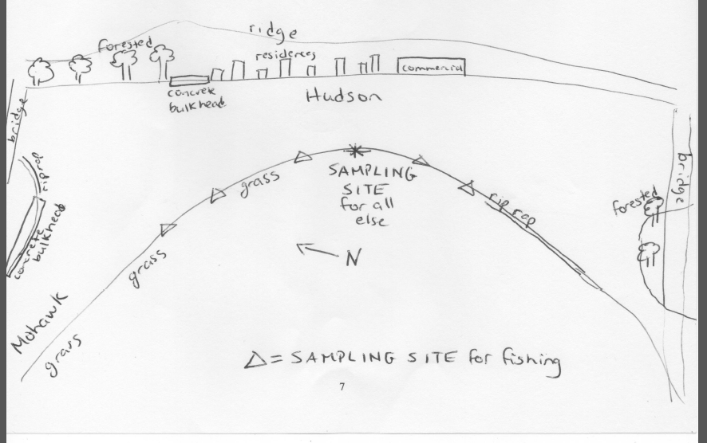

Location: Pavilion at Pebbles Island Park at the confluence of the Hudson River and the Mohawk River, Waterford, NY
Area: Park just north of the Troy dam at the pavilion, grassy embankment, rip rap – sampled by the pavilion area
Surrounding Land Use: 75% grassy, 25% riprap
Sampling Site: Park area
Shoreline: riprap
Plants in area: none
Water depth: 12 - 36 inches
River Bottom description: muddy

 | Time |  | Reading 1 | Reading 2 | Comments
Physical
Air Temperature | 10:27 AM  12:50 PM |  | 60°F  58°F | 15.6°C  14.4°C
Wind Speed | 10:27 AM  11:16 AM  11:54 AM  12:50 PM |  | Beaufort 1  Beaufort 1  Beaufort 2  Beaufort 3 | Anenometer kts. | 0.9 m/s  1.6 m/s  3.0 m/s  3.6 m/s
Cloud Cover | Started as mostly cloudy |  | Then became overcast | Then began to rain steadily
Weather today | Steady rain
Weather recently | No rain, warm
Water surface | Calm
Water Temperature | 10:27 AM  11:16 AM  11:54 PM  12:50 PM | 16°C  16  16  16 |  | 60°F  60  60  60
Turbidity –  long site tube  averages & standard deviation | 10:27 AM -  12:50 PM | Completely clear – no reading possible
Chemical | Time | Water Temp |  | ppm | saturation
DO - Lamotte Earth Force Low test water monitoring kit | 10:27 AM – 12:50 PM | 16 C |  | 2.7 ppm | 26 % sat.
pH – indicator solution | 12:27 PM | 7  7  8.8 |  |  | Average 7.5
Fish Catch – 10 ft. net | Number | Species |  | Size largest
10ft - 1 cm mesh- 10m pull | 75 | Banded killifish |  | 96 mm
10:27 AM -12:50 PM | 122 | Spottail shiner |  | 62 mm
 | 5 | Darter |  | 45 mm
 | DIV 3 | TOTAL |  | 202
Water Level | Time | Height |  | Change | Change Rate
This is above the head of tide. Water level changes have to do with releases that occur from hydro plant that empties into the river below Cohoes Falls. | 10:27AM | 22.5 cm
 | 11:16 AM | 20 cm |  | Falling | 0.05 cm/min
 | 11:54 AM | 15 cm |  | Falling | 0.13 cm/min
 | 1250 PM | 13.8 cm |  | Falling | -0.02 cm/min
Water Flow Velocity | Time | Rate of flow |  | All flow is South
This is not a tidal current just flow. At the confluence of two waterways the water direction can change. | 10:27 AM | 10.2 cm/sec
 | 11:16 AM | 1.6 cm/sec
 | 11:54 AM | 3.4 cm/sec
 | 12:50 PM | 4.2 cm/sec
Boat Traffic | 1:09 PM | BARGE |  | North | Empty (C)
 | 10:37 AM |  |  | South | Recreational
Other | hawks | Seagulls |  | Sandpiper | ducks

