**Day in the Life of the Hudson River 10/20/16 Data**

**(Salt Front ~RM 83)**

**RIVER MILE 18.3**

**Vicki Garufi - Sarah Lawrence College Center for the Urban River @ Beczak**

**Kathleen Ruen, Sarah Lawrence College and 7 Graduate Students in the Art of Teaching**

**Sarah Curtis, St. Ann’s School, 20 second graders, 4 adults total**

**Latitude – N 40.93813129121615 Latitude – W -73.90288889408111**

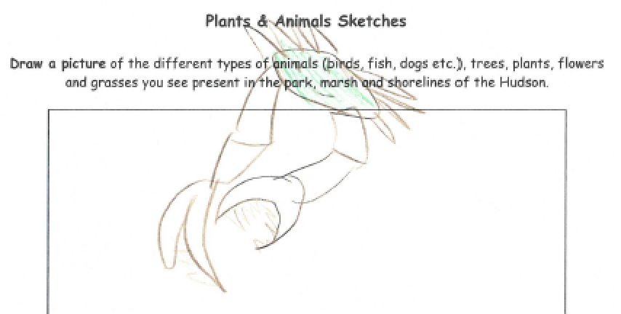

**Location:** Habirshaw County Park, Seining beach, SLCC@ Beczak, Yonkers, Westchester County

**Area:** 2 acreriverfront county park covered mostly by a grass lawn leading down to the river where it meets a tidal wetland and sandy beach. Propertyused for fishing, boats, seining, field trips and education programs – Park and some urban – 75% urban residential, 25% waterfront/beach,

**Surrounding Land Use:** Beach – 2 acre park

**Sampling Site shoreline:** sandy beach, tidal marsh area covered with vegetation, banks altered, large riprap on shoreline, collected wood/debris in area,

**Plants in area:** no plants in the shoreline waterfront however in the marsh area there is:

mud wort, reed grass, saltwater cordgrass, big cordgrass

**Water depth –**

**River Bottom** – muddy

|  |  |  |  |  |  |
| --- | --- | --- | --- | --- | --- |
| ***ITEM*** | ***Time*** | | ***Reading 1*** | ***Reading 2*** | ***Comments*** |
| ***Physical*** |  | |  |  |  |
| Air Temperature | 10:30 AM | | 21°C | 70°F |  |
| Wind Speed |  | | 6.3mph |  |  |
| Weather today | Partly cloudy 26-50%, No rain | | | | |
| Weather recently | Warm and sunny | | | | |
| Water calm | calm | | | | |
| ***Water Temperature –*** | 11:00 AM | 68°F - thermometer | | 19°C probe |  |
| ***Turbidity –*** | ***Sight tube –***  11:15 AM | 27 cm  26 cm  21 cm | | Avg 24.6 cm | ***Digital Probe***  13.8 NTU |
| ***Chemical –*** | **Time** | ***Digital Probe*** | | **H2O Temp** | **% saturated** |
| DO – probe | 12:15 PM | 7.65 ppm | | 19°C | 80% satur. |
| pH – indicator solution | 11:30 AM | 7.5  8 | | Avg – 7.75 | ***Digital Probe***  7.2 |
| Salinity – hydrometer | 12:00 PM – | 18 ppt  14 ppt  20 ppt | | Avg - 17.3 ppt | ***Digital Probe***  14.79 ppt |
| ***Fish Catch -***  Seine net 30 feet X 4 ft., 1.4 inch mesh- | ***Number Caught –*** | ***Species*** | | ***Size of largest*** | ***Notes*** |
| **FISH** | 3 | Atlantic Silverside | |  |  |
|  | **1 FISH DIVERSITY** | **3 TOTAL FISH** | |  |  |
| **MACRO INV** | 5 | Moon Jelly | |  |  |
|  | **1 OTHER DIVERSITY** | **5 TOTAL OTHER** | |  |  |
| ***Tides*** | 10:00 AM | Rising | |  |  |
| *dead low  7:04 AM  High Tide 1:21 PM | 10:30 AM | Rising | |  |  |
| 11:00 AM | Rising | |  |  |
| 11:30PM | Rising | |  |  |
| 12:00 PM | Rising | |  |  |
| ***Currents*** | NR |  | |  |  |
| ***Shipping*** | ***Time*** | ***Ship*** | | ***notes*** | ***N/S*** |
|  | 11:25 AM  11:36 AM  11:44 AM | Pilot Boat  Cruise Ship  Tug & Barge  Tug & Barge | | Docked @ Yonkers | North  South |
| ***Other*** | Plastic bottles, glass bottles, balloons, cigarettes, trash, wrappers | | | | |
|  | Bumble bee, lady bug, aphids, yellow flower, red berries | | | | |